-PHP Course
Php is a server scripting language, and a powerful tool for making dynamic and interactive web pages .
Php is a widely-used,free, and efficient alternative to competitors such as Microsoft’s ASP

PHP introduction

What is PHP ?
- PHP Is an acronym for “PHP : “ HyperText preprocessor”
- PHP is a widely-used, open sorce scripting language.
- Php scripts are executed on the server
- Php is free to downlaod and use

What is a PHP File ?
- Php fles can contain text, HTML , CSS , js , and php code
- Php code is executed on the server, and the result is returned to the browser as plain HMTL
- Php files have extension “.php”

What Can PHP do ?
- Php can generate dynamic page content
- Php can create , open , read, write, delete, and close files on the server
- Php can collect form data
- Php can

Php data types
Variables can store data of different tpes, and different data types can do different things .
Php support the following data types
- String
- Integer
- Float
- Boolean
- Array
- Object
- Null
- Resource
Getting the data type
You can get the data type of any object by using the var_dump() function
You can get the data type of any object by using the getype() function

Php String
$x = "Hello world!";
$y = 'Hello world!';

var_dump($x);
echo "<br>";
var_dump($y);

PHP Integer
An integer ype is a non-decimal number between -2,147,483,648 and 2,147,483,647.
Php Float
A float (floating point number) is a number with a decimal point or a number in expontial form.
In the following example $x is a float. The PHP var_dump() function returns the data type and value :
$x = 10.365;
var_dump($x); // float(10.365)

php Array
an array sotores values in one single variable .
$cars = array("Volvo","BMW","Toyota");
var_dump($cars);
// array(3) { [0]=> string(5) "Volvo" [1]=> string(3) "BMW" [2]=> string(6) "Toyota" }

PHP Object
Classes and objects are the two main aspects of object-oriented programming .
Classes and objects are the two main aspects of object-oriented programming.
A class is a template for objects, and an object is an instance of a class.
When the individual objects are created, they inherit all the properties and behaviors from the class, but each object will have different values for the properties.
Let's assume we have a class named Car that can have properties like model, color, etc. We can define variables like $model, $color, and so on, to hold the values of these properties.
When the individual objects (Volvo, BMW, Toyota, etc.) are created, they inherit all the properties and behaviors from the class, but each object will have different values for the properties.
If you create a __construct() function, PHP will automatically call this function when you create an object from a class.
class Car {
public $color;
public $model;
public function __construct($color, $model) {
$this->color = $color;
$this->model = $model;
}
public function message() {
return "My car is a " . $this->color . " " . $this->model . "!";
}
}

$myCar = new Car("red", "Volvo");
var_dump($myCar);

php NULL Value
Null is a special data type which can have onlyone value : NULL
A variable of data ype NULL is a variable that has no value assigned to it.
Tip : if a variable is created wihout a value, it is automatically assigned a value of NULL
$x = "Hello world!";
$x = null;
var_dump($x); // NULL

Change Data Type
If you assign an integer value to a variable, the type will automatically be an intger.
If you assign a string to the same variable, the type will change to a string :
$x = 6;
var_dump($x); // int(6)
echo "<br>";
$x = "Hello";
var_dump($x); // string(5) "Hello"

PHP Strings
A string is a sequence of characters, like “Hello world!”
Note there is a big diffferece between double quotes and single quotes in php .
Double quotes precess special characters, single quotes does not.

Double or Single Quotes ?
You can use double or single quotes, but you should be aware of the differences between the two.
Double quoted strings perform ation on special characters.
E.g when there is a variable in the strings, it returns the value of the variable
Example
Double quoted string literlas perform operations for special characters :
$x = "John";
echo "Hello $x"; // Hello John
Single quoted strings does not perform such actions, it returns the stirng like it was written , with the varialbe name :
Example :
Single quoted string literals returns the strings as it is :
$x = "John";
echo 'Hello $x'; // Hello $x

String length
The PHP strlen() function retunrs the length of a string.
Example : return the length of the string “Hello World!”
echo strlen("Hello world!");// 12

Word Counts
The PHP str_word_count() function counts the number of words in a string.
Example :
Count the number of word in the string “Hello world!”
echo str_word_count("Hello world!"); // 2

Accessing String using indexing
$str = "Elzero";

echo "First Letter: " . $str[0] . "<br>";
echo "4th Letter: " . $str[3] . "<br>";
echo "Number of Letters: " . strlen($str) . "<br>";
echo "Last Letter: " . $str[strlen($str) - 1] . "<br>";
echo "Last Letter: " . $str[-1] . "<br>";
echo "before last letter : ".$str[-2]."<br>";

echo $str."<br>";
$str[0] = "A";
echo $str."<br>";

lcfirst()
The lcfirst() make the first letter of the first word lowercase
syntax : lcfirst(String[Required])

ucfirst()
The ucfirst() make the first letter of the first word lowercase
syntax : lcfirst(String[Required])

Upper Case
The strtoupper() function returns the string in upper case :

Lower Case
The strtoupper() function returns the string in upper case :

Ucwords
The ucwords() function make each first letter of a word in a string uppercase
Syntax : ucword(string[required], Delimeter[optional])

Example for the last function
echo lcfirst('Hello World'). "<br>"; // hello World

echo ucfirst('hello world'). "<br>"; // Hello world

echo strtoupper('hello world'). "<br>"; // HELLO WORLD

echo strtolower('HELLO WORLD'). "<br>"; // hello world

echo ucwords('elzero web school'). "<br>"; // Elzero Web School

echo ucwords('elzero web | school', "|"). "<br>"; // Elzero web | school

implode
The implode() can join array elements and transform them into a string.
The join () is an ilias for implode
Syntax :
Implode (Seperator [Optional], Array [Required])
$names = ["Bilal","Ossama","Ali","Ahmed"];

echo implode(" ",$names); // Bilal Ossama Ali Ahmed
echo "<br>";
echo implode(" | ",$names); // Bilal | Ossama | Ali | Ahmed
echo "<br>";
echo implode ($names); // BilalOssamaAliAhmed

Explode
The explode () function can turn a string to an array
Syntax :
explode( Separator [Required], String [Requied], Limit (Optinal] )
$str = "Elzero Web School Is Cool";

echo "<pre>";
print_r(explode(" ", $str));
echo "</pre>";
/*Array
(
[0] => Elzero
[1] => Web
[2] => School
[3] => Is
[4] => Cool
)
*/

To be honest : Limit mean how much element I want in the my array, the function will it arrive to limit – 1 , and find another sepreator , it add it in one element, although there is anoter seperators , take a look to the following code :
echo "<pre>";
print_r(explode(" ", $str, 2));
echo "</pre>";
/*Array
(
[0] => Elzero
[1] => Web School Is Cool
)
*/

Str_shuffle
The str_shuffle() function shuffle , shuffle string letters
$str = "Elzero";
echo str_shuffle($str); // mix the letters of the string

Str_Reverse
The str_reverse function, reverse string
$str = "Elzero";
echo str_reverse($str); //ozreleZ

trim – ltrim – rtrim
The trim () remove space before and after a strring
$str = " Elzero ";
echo strlen($str); // 11
echo "<br>";
echo strlen(trim($str)); // 6
// trim($str) = ltrim($str) + rtrim($str);
Syntax :
Trim (String[Required], CharList[optional])
The trim function remove the following whitespace characters:
- Space ()
- Tab (\t)
- Newline (\n)
- Carriage return (\r)
- Vertical tab (x\x0B)
- Null (\x00)
And also you can specify manualy what you want trim to remove for you :
echo trim("#@@Elzero@@@###","#@"); // Elzero
// it will not remove just #@ but will remove all @ and all #

Chunk_split ()
Chunk_split () is a php function that splits a string into smaller chunks of a specified length, with an optional end string.
// syntax
chunk_split(string $body, int $chunklen, string $end = "\r\n")

example :
echo chunk_split("Elzero Web School",3,"&");
// Elz&ero& We&b S&cho&ol&
// do not forget that space between the words is important

Str_split ()
Str_split() is a funciton that splits a string into an array of characters.
str_split ( string $string [, int $split_length = 1 ] )
it takes 2 paramters :
- $string : the input string to split
- $split_length : the length of each chunk (optional, default is 1 )
example :
echo "<pre>";
print_r(str_split("Hello World"));
echo "</pre>";
/*
(
[0] => H
[1] => e
[2] => l
[3] => l
[4] => o
[5] =>
[6] => W
[7] => o
[8] => r
[9] => l
[10] => d
)
*/
Use the split length parameter :
echo "<pre>";
print_r(str_split("Hello World",3));
echo "</pre>";
/*
(
[0] => Hel
[1] => lo
[2] => Wor
[3] => ld
)
*/
Strip_tags
Strip_tags is a function that remove HTML and PHP tags from a string :
Syntax:
string strip_tags ( string $str [, string $allowable_tags ] )
it takes two parameters :
- $str : the input strng to strip tags from
- $allowable_tags: a string of tags that should not be stripped (optional)
If $allowable_tags is not specified,all HTML and PHP tags will be removed. If it is a specified, only the tags listed $allowable_tags will be preserved .
$string = '<p>Hello, <b>world!</b></p>';
echo $string; // Output: <p>Hello, <b>world!</b></p>

echo "############ <br>";

$stripped = strip_tags($string);
echo $stripped; // Output: Hello, world!

echo "<br>############ <br>";

$allowed_tags = '<b>';
$stripped = strip_tags($string, $allowed_tags);
echo $stripped; // Output: Hello, <b>world!</b>

nl2br()
nl2br() is a function that inserts HTML line breaks ( <br> ) before all newline characters (\n) in a string .
syntax:
string nl2br ( string $string )
it takes one parameter :
- $string : the input string to convert
The function returns the modified string with HTML line breaks inserted before all newline charactes:
$string = "Hello\nWorld!";
$converted = nl2br($string);
echo $converted; // Output: Hello<br>World!
This is useful when you want to display text that contains newline characters in a web page, but you want to preserve the line breaks .
Note : that nl2br() does not remove the original newline characters, it simply inserts HTML line breaks before them. If you want to remove the original newline characters, you can use the str_replace() function

Search For Text Withing a String
The PHP strpos() function searches for a specific text withing a string.
If a match is found, the function returns the character position of the first match. If no match is found, it will return False.
Syntax :
int|false strpos ( string $haystack , string $needle [, int $offset = 0 ] )
it takes 3 parametrs :
- $haystack : the string to search in
- $needle: the substring to search for
- $offset : the position to start searching from (optional, default is 0 )
Note: strpos() is case sensitive
var_dump(strpos("Hello World", "W")); // int (6)
echo "<br>";
var_dump(strpos("Hello and Hello", "H",1)); // int (10)
echo "<br>";
var_dump(strpos("Hello and Hello", "h",1)); // bool(false)
echo "<br>";
var_dump(strpos("Hello and Hello", "H",-2)); // bool (false)
// negative index means from the end of the string, and then searches for the last occurrence of the given string in the normal string direction

Strrpos ()
Strrpos () is a function that finds the postion of the last occurrence of a substring in a stirng .
Syntax :
int|false strrpos ( string $haystack , string $needle [, int $offset = 0 ] )
it the same the previous one
var_dump(strrpos("Hello Hello", "H")); // int (6)

stripos ()
stripos ( ) is a function that finds the position of the first occurrence of a substring, in a case-insensitive manner .
syntax
stripos (String[Required], Value[Required], Start Position [Optional] )
var_dump(stripos("Hello World","w")); // int (6)

strripos ( )
The same but give the last one

Substr_Count ()
Substr_count ( ) is a function that counts the number of occurences of a substring in a string .
Syntax :
Substr_count ( String[Required], value [Required], Start Position [optional] , Length [optional])
Focus in the last line :
var_dump(substr_count("Hello Hello","He")); // int (2 )
echo "<br>";
var_dump(substr_count("Hello Hello","He",1)); // int (1 )
echo "<br>";
var_dump(substr_count("Hello Hello","He",1,7)); // int (6 )
// we specified the start point and the end point
echo "<br>";
var_dump(substr_count("abcdabcda","abcda")); // int (1 )

The substring "abcda" appears to match the string "abcdabcda" twice, but the substr_count() function returns only 1.
This is because the substr_count() function does not count overlapping occurrences of the substring. In other words, once it finds a match, it does not continue searching for another match within the same position.

Parse_str ( )
Parse_str ( ) is a function that parses a string into variables .
Syntax :
Parse_str ( String [Required] , Array [Required] )
It takes two parameters :
- $str : the string to parse
- $arr : an array to stroe the parsed variabls ( optoinal )
The function parses the string into varaibles, using the = character to separate the variable name for its value. The varaibles are then stored in the $arr array, or in the global scope if $arr is no provided.
$string = "name=John&age=30";
parse_str($string, $arr);
echo $arr["name"]; // Output: John
echo $arr["age"]; // Output: 30

quotemeta ( )
quotemeta ( ) is a function that escapes all special characters in a string with a backslash ( \ )
it takes one parameter :
- Str : the string to escape
Note that quotemeta ( ) only escapes the following special characters :
- . (dot)
- ^ (caret)
- $ (dollar sign)
- * (asterisk)
- + (plus sign)
- ? (question mark)
- { (left curly bracket)
- } (right curly bracket)
- [ (left square bracket)
- ] (right square bracket)
- ( (left parenthesis)
- ) (right parenthesis)
- | (vertical bar)
- \ (backslash)

Str_pad ( )
Str_pad ( ) is a function that pads a string with a specified character or characters to a specified length .
Syntax :
Str_pad ( String[Required] , Length [Required], string [optional] , pad flag [optional] )
echo str_pad ("12",8,0 ,STR_PAD_BOTH)."<br>"; // 0012000
echo str_pad ("321",8,0 ,STR_PAD_BOTH)."<br>"; // 00321000
echo str_pad ("1313",8,0 ,STR_PAD_LEFT)."<br>"; // 00001313
echo str_pad ("15435",8,0 ,STR_PAD_LEFT)."<br>"; // 00015435
echo str_pad ('500432', 8 , 0 , STR_PAD_RIGHT)."<br>"; // 500432000
in the second example the flag was both : so as we said the right win

strtr ( )
strtr ( ) is a function that translates certain characters in a string
echo strtr ("E@zero Web Schoo@" , "@","l"); // Elzero Web School
the function takes 2 parameters :
- $str : the string to translate
- $replace_pairs : an array of replacement pairs
The function returns the translated string .
Example:
$string = "Hello, world!";
$replace_pairs = array(
"H" => "J",
"w" => "W"
);
$translated = strtr($string, $replace_pairs);
echo $translated; // Output: Jello, World!
Note that the $replace_pairs array should be in the format of :
array(
"original_char" => "replacement_char",
"original_char" => "replacement_char",
...
)
You can also use the strtr ( ) function with a string of replacement pairs, where each pair is separated by a vertical bar

Str_replace ( )
Str_replac ( ) is a function that replaces all occurrences of a substring with another substring in a string .
Syntax :
Str_replace ( find[Required], Replace with [Required], Data [Required], Replace count [optional] )
Its case sensitive
echo str_replace("@","o","Elzer@ Web Sch@@l",$r); // Elzero web School
echo "<br>";
echo "Replaces Count is $r"; // Replaces Count is 3
if you have more than one character you can use array :
echo str_replace(["#","@"],"o","Elzer@ Web Shc#@l",$r); // Elzero web School
echo "<br>";
echo str_replace(["#","@","_"],["o","e"," "],"Elz@r#_W@b_Shc##l",$r); // Elzero web School
note : str_replace return the replaced string
you can modify also array :
echo "<pre>";
print_r(str_replace("one",1,["one","two","one","one"]));
echo "</pre>";
// Array
// (
// [0] => 1
// [1] => two
// [2] => 1
// [3] => 1
// )

echo "<pre>";
print_r(str_replace(["one","two"],[1,2],["one","two","one","one"]));
echo "</pre>";
// Array
// (
// [0] => 1
// [1] => 2
// [2] => 1
// [3] => 1
// )
echo "<pre>";
print_r(str_replace(["one","two","three"],[1,2],["one","two","three","one","One"]));
echo "</pre>";
// Array
// (
// [0] => 1
// [1] => 2
// [2] =>
// [3] => 1
// [4] => One
// )
// if there is no character to replace with, it will replace by empty string
As you see the last “one “ has not been replaced, because str_replace ( ) is case-sensitive

Str_ireplace ( )
The same as str_replace( ) but this function is case-insencition
Ireplace = insensitive replace

Substr_replace ( )
Substr_replace ( ) is a function that replaces a portion of a string with another string .
echo substr_replace ( "OneTwo", 1,0 ); // 1
echo "<br>";
echo substr_replace ("OneTwo",2,3); // One2
echo "<br>";
echo substr_replace ("OneTwo",2,-3); // One2
echo "<br>";
echo substr_replace ("OneTwo",2,1,4); // O2o
echo "<br>";
echo substr_replace ("Elzero_Web_School","A",7,-2);// Elzero_Aol
when the length parameteris negative, it means :
- Stop replacing at the specified distance from the end of the string
- Negative nmber : characters left at the end after replacement
Focus on example above to understand
When the length equal 0 insert instead or replace
echo substr_replace ( 'Elzer_Web_School' , 'o' ,5,0 ) ;
// Elzero_Web_School
And also you can use this funciton to replace an array
echo "<pre>";
print_r(substr_replace(["OneTwo","ThreeFour"],1,0));
// Array
// (
// [0] => 1
// [1] => 1
// )

Wordwrap ( )
Wordwrap ( ) function is used to wrap a string of text into multiple lines bases on a specified width
Syntax :
Wordwrap ( String[Required], Width[optional = 75], Break_char[optional = ‘\n’] , Cut_Long [optional = false] )
$str = "Welcome To Elzero Web School Website";
echo wordwrap($str,8, "<br />");
// Welcome <br />To <br />Elzero <br />Web <br />School <br />Website

echo "<br /> ################## <br />";

$str = "Welcome To To To Elzero web scho";
echo wordwrap($str,8, "<br />");

// Welcome
// To To To
// Elzero
// web scho

echo "<br /> ################## <br />";

$str = "Welcome To Elzero Web very_very_very_very_long website";
echo wordwrap($str,8, "<br />");
// Welcome
// To
// Elzero
// Web
// very_very_very_very_long
// website

echo "<br /> ################## <br />";
echo wordwrap($str,8, "<br />", true);
// Welcome
// To
// Elzero
// Web
// very_ver
// y_very_v
// ery_long
// website
The funciton takes 4 parameters :
- $str : the string to be wrapped
- Width : the width of the lines
- Break : the character to use for line breaks (default is “\n”)
- Cut : whether to cut words at the specified width “default is false).

Ord ( )
The ord function return the ASCII value of a character .
$char = 'A';
$ascii_value = ord($char);
echo $ascii_value; // Output: 65

chr ( )
the chr functin returns a string containing the character specified by the ASCII value .
$ascii_value = 65;
$char = chr($ascii_value);
echo $char; // Output: A

similar_text
the similar_text function calculates the similarity between two strings .
$percent;
$string1 = "Hello World";
$string2 = "Hello Universe";
$similarity = similar_text($string1, $string2, $percent);
echo $percent; // Output: 56 (the percentage of similarity)
the similar_text function takes 3 paramters :
- First : the first string to compare
- Second : the second string to compare
- Parcent : A varaible that will be poplulated with the percentage of similarity between the two strings .

Stristr ()
The same as the previous but it case insensitive
Stristr = string case-insensitive string
echo strstr ("Elzero Web ", "W"). "<br>";
// web

echo strstr ("Elzero Web ", "w"). "<br>";
// Elzero Web : not found ,strstr is case sensitive

echo strstr ("Elzero Web ", "W", true). "<br>";
// Elzero

Number_format ( )
The number_format ( ) functin in PHP is used to format a number with grouped thousands and optional decimal places.
Syntax :
number_format(number, decimals, decimalpoint, separator)
the function takes 4 params:
- Number : the number to be formatted
- Decimals: the number of decimal places to round to. Default is 0
- Decimalpoint : the character to use as the decimal point. Default is a period (.)
- Seperator: the character to use as the thousands seperator. Default is a comma (,)
// syntacthic sugar

echo 10_000_000; // Output: 10000000

echo "<br>";

echo number_format(10000000.1564789); // Output: 10,000,000

echo "<br>";

echo number_format(10000000.1564789,2); // Output: 10,000,000.16

echo "<br>";

echo number_format(10000000.1564789,3,"@","#");
// 10#000#000@156

Type Juggling And automatic Type Conversion
Just focus in the code :
echo '<br>';
echo true + true ;
echo '<br>';
echo 5 + '5 lessons'; // warning
echo '<br>';
echo gettype(5 + '5 lessons'); // warning

Heredoc & Nowdoc

Heredoc
Heredoc is a way to specify a string in PHP using a syntax that allows you to create a multiline string without having to escape newline characters. It’s called “heredoc” because it’s “here document” -a document that’s defined right here in the code.
Note : for line respecting use commend line
Php fileName
Here’s how it works :
- <<< is the heredoc operator.
- IDENTIFIER is a string that marks the beginning and end of the heredoc. It can be any string, but it’s usually a short word or phrase.
- String contents is the actual string that you want to output.
- The IDENTIFIER at the end of the string marks the end of the heredoc
Some important things to note about heredoc:
- The INDENTIFIER must be followed by a newline character
- The IDENTIFIER at the end of the string must be on a line by itself, with no other characters before or after it.
- You can use variables and expressions inside the heredoc string, and they will be evaluttedd as if they were part of a double-quoted string.

$name = 'John';
echo <<< GREETING
Hello, $name!

Goodbye, $name!
GREETING;
// output: Hello, John!
//
//
// Goodbye, John!

Nowdoc
Nowdoc is similar to hereoc, but it’s used to specify a string that’s not parsed for variables or expressions. It’s called “nowdoc” because it’s a “now document” -a document that defined right now, without any parsing
echo <<< 'IDENTIFIER'
string contents
IDENTIFIER;
Notice the single quotes around the INDENTIFIER. This is what ditinguishes nowdoc from heredoc.
Some important things to note about nowdoc:
- Nowdoc stirngs are not parsed for variables or expressions.
- Nowdoc strings are not subject to the same rules as heredoc string – you don’t need to worry about escaping newline characters or using specifec IDENTIFIER .
- Nowdoc strings are useful when you need to output a string that contains special characters or syntax that would be interpreed by PHP

echo <<< 'EXAMPLE'
This is a string with $variables and \special characters.
EXAMPLE;

// This is a string with $variables and \special characters.
echo <<< "navlinks"
<ul>
<li>item 1</li>
<li>item 2</li>
<li>item 3</li>
</ul>
navlinks;
// Parse error: Invalid body indentation level (expecting an indentation level of at least 5) in C:\xampp\htdocs\testing\app.php on line 12
We have this error , because navlinks have some space before it , so it does not preserve indentation level .

Arrays
An array stores multiple values in one single variable:
$cars = array("Volvo", "BMW", "Toyota");

What is an Array ?
An array is a special variable that can hold many values under a nsingle name, and you can acces the values by referring to an index number or name.
PHP Array Types
In PHP, there are 3 ypes of arrays:
- Indexed arrays – Arrays with a numeric
- Associative arrays – Arrrays with named keys
- Multidmensional arrays – arrays containing one or more arrays
Woring with arrays
In this tutorial you will learn how to work with arrays, including:
- Create arrays
- Access arrays
- Update arrays
- Add array items
- Remove array items
- Sort arrays

Array items
Array items can be of any data type.
The most common are stirngs and numbers (int, float), but array items can also be objects, functions or even arrays.
You can have different data types in the same array .
$myArr = array("Volvo", 15, ["apples", "bananas"], myFunction);

Array Functions
The real strength of PHP are the built-in array functions, like the count() function for counting array items:
Example :
How many items are in the $car array :
$cars = array("Volvo", "BMW", "Toyota");
echo count($cars); // Outputs 3

PHP Indexed Arrays

PHP Indexed Arrays
In indexed array each item has an index number.
By default, the first item has index 0, the second item has item1 , etc.
$cars = array("Volvo", "BMW", "Toyota");
var_dump($cars);// array(3) { [0]=> string(5) "Volvo" [1]=> string(3) "BMW" [2]=> string(6) "Toyota" }

Access Indexed Arrays
To access an array item you can refer to the index number.
Example : Display the frst array item
$cars = array("Volvo", "BMW", "Toyota");
echo $cars[0]; // Output: Volvo

Change Value
To change the value of an array item, use the index number:
Example : chagne the value of the second item
$cars = array("Volvo", "BMW", "Toyota");
$cars[1] = "Ford";
var_dump($cars);// output: array(3) { [0]=> string(5) "Volvo" [1]=> string(3) "BMW" [2]=> string(6) "Toyota" }

Loop Through an index array
To loop throgh an dprint all the values o f an indexed array, you could use a foreach loop, like this :
Example : Display all array items
$cars = array("Volvo", "BMW", "Toyota");
foreach ($cars as $x) {
echo "$x <br>";
}

Index Number
The key of an indexed array is a number, by default the the first item 0 and the second 1 ect., but there are exceptions.
New items get the next index number, meaning one higher than the highest existing index.
And if you use the array_push() function to add a new item, the new item will get the index 3
$cars = array("Volvo", "BMW", "Toyota");
array_push($cars, "Honda");
var_dump($cars); // Output: array(4) { [0]=> string(5) "Volvo" [1]=> string(3) "BMW" [2]=> string(6) "Toyota" [3]=> string(5) "Honda" }

PHP Associative Arrays

PHP associative Arrays
Associative arrays are arrays that use named keys that yo assing to them.
$car = array("brand"=>"Ford", "model"=>"Mustang", "year"=>1964);
var_dump($car);

Access Associative Arrays
To access an array item you can refer to the key name.
Example : Display the model of the car :
$car = array("brand"=>"Ford", "model"=>"Mustang", "year"=>1964);
echo $car["model"]; // Mustang

Change Value
To Change the value of an array item, use the key name:
Example : change the year item
$car = array ("baran"=>"Ford","model"=> "Mustang","year"=> 1964);
$car["year"]= 2024;
var_dump($car);// will output: array(3) { ["baran"]=> string(4) "Ford" ["model"]=> string(6) "Mustang" ["year"]=> int(2024) }

Loop Through an associative array
Example : Display all array items, keys and values :
$car = array ("baran"=>"Ford","model"=> "Mustang","year"=> 1964);

foreach ($car as $x => $y){
echo "$x : $y <br>";
}
// baran : Ford
// model : Mustang
// year : 1964

PHP Create Arrays

Create Array
You can create arrays by using the array() function :
$cars = array("Volvo", "BMW", "Toyota");
You can also use a sqhorter syntax by using the [] bracket:
$cars = ["Volvo", "BMW", "Toyota"];
Multiple lines
Line breaks are not importat, so an array delclaration can span multiples lines
$cars = [
"Volvo",
"BMW",
"Toyota"
];

Trailing Comma
A comma after the last item is allowed
$cars = [
"Volvo",
"BMW",
"Toyota",
];

Array Keys
When Creating indexed array the keys are given automatically, starting at and inscreased by for each item, so the array above could also be created with keys.
$cars = [
0 => "Volvo",
1 => "BMW",
2 =>"Toyota"
];
As you can see, indexed arrays are the same as associative arrys but associative arrays have names instead of numbers:
$myCar = [
"brand" => "Ford",
"model" => "Mustang",
"year" => 1964
];

Declare Emty Array
You can declare an empty array first,and add items to it later
$myCar = [];
$myCar["brand"] = "Ford";
$myCar["model"] = "Mustang";
$myCar["year"] = 1964;

Mixing arrays keys
You can have array with both indexed and named keys:
$myArr = [];
$myArr[0] = "apples";
$myArr[1] = "bananas";
$myArr["fruit"] = "cherries";

var_dump($myArr); // array(3) { [0]=> string(6) "apples" [1]=> string(7) "bananas" ["fruit"]=> string(8) "cherries" }

PHP Access Arrays

Access Array item
To access an array item, you can refer to the index number for indexed array, and the key name for associative arays.
Note : you can use both double and single quotes when accessing array

Execute a Function Item
Array items can be of any data type, including function
function myFunction() {
echo "I come from a function!";
}

$myArr = array("car" => "Volvo", "age" => 15, "message" => myFunction());

$myArr["message"]; // this will output "I come from a function!"

PHP update array items
Update Array items in a Foreach loop
There are different techniques to use when chnaging item values in a foreach loop.
On way is to insert the & character in the assingment to assign the item value by reference, and therby (bitali) making sure that any changes done with the array item inside the loop will be done to the original array:
Example : change ALL item values to “Ford” :
$cars = array("Volvo", "BMW", "Toyota");
foreach ($cars as &$x) {
$x = "Ford";
}
unset($x);
var_dump($cars);
// array(3) { [0]=> string(4) "Ford" [1]=> string(4) "Ford" [2]=> string(4) "Ford" }
Explanation
The problem : when you iterate over an array using foreach, the loop varaible $x is a copy of the origial array value.
This means that if you modify $x inside the loop, the changes won’t affect the original array.
The solution : by adding the & character before the loop varable $x, you’re telling PHP to pass the value by reference instead of by value. This means that $x becomes an ilias for the original array value, and any changes you make to $x will affect the original array.
Here’s a step-by-step explnation :
- $cars = array (“Volvo”, “BMW”, “Toyota”); creates an array with 3 values .
- Foreach ($cars as &$x) starts the loop, and the & character tells PHP to pass the value by reference. This means that $x is not a copy of the original value, but rather an alias for it.
- Inside the loop, $x=”Ford” assings the new value “Ford” to the original array value
Note : remember to add the unset() function after the loop
Without the unset($x) function, the $x variable will remain as a reference to the last array item.
To demonstrate this , see what happens when we change the value of $x after the foreach loop:
$cars = array("Volvo", "BMW", "Toyota");
foreach ($cars as &$x) {
$x = "Ford";
}

$x = "ice cream";

var_dump($cars);
// array(3) {
// [0]=>
// string(4) "Ford"
// [1]=>
// string(4) "Ford"
// [2]=>
// &string(9) "ice cream"
// }
Let’s analyze what’s happening here :
- $cars = array("Volvo", "BMW", "Toyota"); creates an array with three values.
- foreach ($cars as &$x) starts the loop, and the & character tells PHP to pass the value by reference. This means that $x is not a copy of the original value, but rather an alias for it.
- Inside the loop, $x = "Ford"; assigns the new value "Ford" to the original array value. Because $x is a reference, this change affects the original array.
- The loop iterates over all three values, assigning "Ford" to each one.
- After the loop finishes, the original array $cars has been modified to contain only "Ford" values.
- $x = "ice cream"; assigns a new value to the variable $x. But here's the important part: because $x was a reference to the last element of the array, this assignment also changes the last element of the array to "ice cream".

PHP Add Array Items

Add Array Item
To add items to an existing array, you can use the bracket [] syntax .
Example : Add one more item to the fruits array :
$fruits = array("Apple", "Banana", "Cherry");
$fruits[] = "Orange";
var_dump($fruits);
// array(4) {
// [0]=>
// string(5) "Apple"
// [1]=>
// string(6) "Banana"
// [2]=>
// string(6) "Cherry"
// [3]=>
// string(6) "Orange"
// }

Associative Arrays
To add items to an associative array, or key/value array, use brackets [] for the key, and assign value with the = operator .
Example : add one item to the car array
$cars = array("brand" => "Ford", "model" => "Mustang");
$cars["color"] = "Red";

Add Multiple array itemss
To add multiple items to an exising array, use the array_push() function.
Example : add three item to the fruits array
$fruits = array("Apple", "Banana", "Cherry");
array_push($fruits, "Orange", "Kiwi", "Lemon");

ADD multiple items to associative arrays
To add multiple items to an existing array, you can use the += operator.
Example : add two items to the cars array
$cars = array("brand" => "Ford", "model" => "Mustang");
$cars += ["color" => "red", "year" => 1964];

PHP Delete Array items

Romove array item
To rempve an axisting item from an aray, you can use the array_splice() function.
With the array_splice() function you specify the index (where to start) and how many items you want to delete .
It have the same functionnality as js
Example : Remove the second item
$cars = array("Volvo", "BMW", "Toyota");
array_splice($cars, 1, 1);

var_dump($cars);
// [0]=>
// string(5) "Volvo"
// [1]=>
// string(6) "Toyota"
// }
After the deletin, the array gets reindxed automatically, starting at index 0 .
Using the unset Function
The unset() function in PHP is used to remove a specific element from an array. It does not re-arrange the indexes of the array. Meaning that after deletion, the array will not contain the missing indexed
Here’s an example :
$array = [1, 2, 3, 4, 5];

// Remove the element with the key 2
unset($array[2]);

print_r($array);
// output:
// Array
// (
// [0] => 1
// [1] => 2
// [3] => 4
// [4] => 5

Remove Multiple Array Items
To remove multiple items, the array_splice() function takes a length parameter that allows you to specify the number of items to delete.
Also , the unset() function takes a unlimited number or arguments, and can therefore be used to delte multiple array items:
$cars = array("Volvo", "BMW", "Toyota");
unset($cars[0], $cars[1]);

Using the array_diff Function
You can also use the array_diff() function to remove items from an associative array.
This function returns a new array, without the specied itms.
Example : Create a new array, without “Mustand” and “1964”
$cars = array("brand" => "Ford", "model" => "Mustang", "year" => 1964);
$newarray = array_diff($cars, ["Mustang", 1964]);

print_r($cars);
// Output: Array ( [brand] => Ford [model] => Mustang [year] => 1964 )
print_r($newarray);
// Output: Array ( [brand] => Ford)
Note : the array_diff() funciton takes values as parameter, and not keys

Remove the last item
The array_pop() fuction removes the last item of an array
$cars = array("Volvo", "BMW", "Toyota");
array_pop($cars);

Remove the first Item
The array_shift() function removes the first item of an array.
$cars = array("Volvo", "BMW", "Toyota");
array_shift($cars);

PHP Sorting Arrays
The elemnts in an array can be sorted in alphabetical or numerical order, descending or ascending.
PHP – Sort Functions For Arrays
In this chapter , we will go through the following PHP array sort functions:
- Sort() – sort arrays in ascending order
- rsort() – sort arrays in descending order
- asort() – sort associative arrays in ascending order, according to the value
- ksort() – sort assciative arrays in ascending order, according the key.
- Arsort() – sort associatvie arrays in descending order, according to the value.
- Krsort() – sort associative arrays in descending order, according to the key.
- Natstrot ( ) – sorts An array by using a “neutral order” algorithm

Sort Array in Ascending Order – sort()
The following example sorts the elements of the $cars array in ascending alphabetical order:
$cars = array("Volvo", "BMW", "Toyota");
sort($cars);
print_r($cars);
// Array( "BMW", "Toyota", "Volvo" )
The following example sorts the elements of the $number array in ascending numerical order:
$numbers = array(4, 6, 2, 22, 11);
sort($numbers);
print_r($numbers);
// Array ([0] => 2, [1] => 4, [2] => 6, [3] => 11, [4] => 22)

Sort Array in Descending order - rsort()
The following example sorts the elements of the $cars array in descending alphabetical oder:
(opposite of sort() )

Sort Array (Ascending Order), According to value – asort()
$age = array("Peter"=>"35", "Ben"=>"37", "Joe"=>"43");
asort($age);
print_r($age);
// Array ( [Peter] => 35 [Ben] => 37 [Joe] => 43 )

Sort Array (Ascending Order), Accoring to Key – ksort()
The following example sorts an assciative array in ascending or, according to the key :
$age = array("Peter"=>"35", "Ben"=>"37", "Joe"=>"43");
ksort($age);
print_r($age);
// Array ( [Ben] => 37 [Joe] => 43 [Peter] => 35 )

Sort Array (Descending order), According to Value – arsort()
The follwing example sorts an associative array in descending, according to the value:
$age = array("Peter"=>"35", "Ben"=>"37", "Joe"=>"43");
arsort($age);

Sort Array (Descending Order), Accoring to Key – Krsort()
The following exaple sorts ans associatve array in descending order, accoring to the key:
$age = array("Peter"=>"35", "Ben"=>"37", "Joe"=>"43");
krsort($age);

Natural sorting ( )
It sort array with a human manner:

PHP Multidimensional Arrays
Sometimes you want to store values with more than one key. For this, we have multidimensional arrays.

PHP – Multidimensional Arrays
A multidimensional array is an array contianingf one or more array.
PHP supports multidimensional arrays that are two, three, four, five, or more levels deep. However, arrays more than 3 levels deep are hard to manage for most people .
Note:
The dimension of an array indicates the number of indices you need to select an element
PHP -Two-Dimensional Arrays
A two-dimensional array is an array of arrays .
First, take a look at the follwing table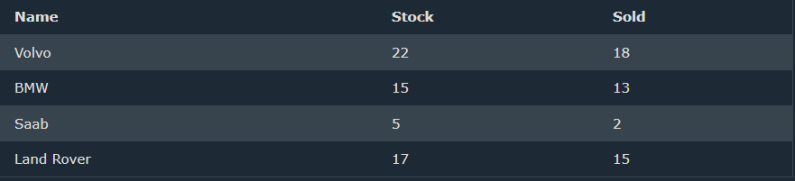
We can store the data from the table above in two-dimensional array, like this:
$cars = array (
array("Volvo",22,18),
array("BMW",15,13),
array("Saab",5,2),
array("Land Rover",17,15)
);
To get access to the elements of the $cars array must point the two indices (row & column)
Example :
echo $cars[0][0].": In stock: ".$cars[0][1].", sold: ".$cars[0][2].".<br>";
echo $cars[1][0].": In stock: ".$cars[1][1].", sold: ".$cars[1][2].".<br>";
echo $cars[2][0].": In stock: ".$cars[2][1].", sold: ".$cars[2][2].".<br>";
echo $cars[3][0].": In stock: ".$cars[3][1].", sold: ".$cars[3][2].".<br>";
Array with complex Example – overiding
If you enter a value with an index that deje exist in the array the new value will overide.
print_r(
[
0 => "Sameh",
"A" => "Ahmed",
"B" => "Basem",
"Mahmoud",
true => "Sayed",
false => "Asmaa"
]
);
// Array
// (
// [0] => Asmaa
// [A] => Ahmed
// [B] => Basem
// [1] => Sayed
// )
When you use the print_r function to print an array, it will only desplay the values that have a key associated with them.
If you want to see all the values, including the ones with automatically generated numeric keys, you can use the var_dump duncion instead :
So, the correct sequence of events is:
- 0 => "Sameh" is set
- "A" => "Ahmed" is set
- "B" => "Basem" is set
- "Mahmoud" is assigned a numeric key 1
- true => "Sayed" is set, which becomes 1 => "Sayed", overwriting the value "Mahmoud"
- false => "Asmaa" is set, which becomes 0 => "Asmaa", overwriting the original value "Sameh"
var_dump(
[
0 => "Sameh",
1 => "Asmaa",
2 => "Ahmed",
3 => "Basem",
4 => "Sayed",
2 => "Bilal",
"Mohamed",
"Lina",
"Nada"

]
);
// array(8) {
// [0]=>
// string(5) "Sameh"
// [1]=>
// string(5) "Asmaa"
// [2]=>
// string(5) "Bilal"
// [3]=>
// string(5) "Basem" "
// [4]=>
// string(5) "Sayed" p
// [5]=>
// string(7) "Mohamed"
// [6]=>
// string(4) "Lina"
// [7]=>
// string(4) "Nada"
// }
Multi dimension
dump(
[
0 => "Sameh",
1 => "Asmaa",
2 => "Ahmed",
3 => "Basem",
4 => "Sayed",
2 => "Bilal",
"Mohamed",
"Lina",
"Nada",
"Names" => ["Abdo", "Ahmed", "Hossam"=> [1,2,3]],

]
);

Array_chunk ( )
Array_chunk ( ) is a php function that splits an array into chunks of a specified size .
It takes two arguments : the input array and the size of each chunk. It returns a multidimensional array, where each sub-array is a chunnk of the original array.
$array = [1, 2, 3, 4, 5, 6, 7, 8, 9];
$chunks = array_chunk($array, 3);
print_r($chunks);
Array
// (
// [0] => Array
// (
// [0] => 1
// [1] => 2
// [2] => 3
// )

// [1] => Array
// (
// [0] => 4
// [1] => 5
// [2] => 6
// )

// [2] => Array
// (
// [0] => 7
// [1] => 8
// [2] => 9
// )

// )
Syntax :
Array_chunk( Array [Required], length [Required], Preserve_Key [Optional])
This function split an array into chunks [Return a multidimensional indexed array ]
Preserve_key
[false] => default , Reindex the keys .
[true ] = > preserve the keys
The third param , indicate if elment will be indexed bases on new sub array, or preserve it original index .

array_change_key ( Array [Required] , Case [optional])
changes the case of all keys in an array
case :
------ [CASE_LOWER => Default , Changes the keys to lowercase
------ [CASE_UPPER ] => Changes the keys to Uppercase

$array = [
'Foo' => 'bar',
'Baz' => 'qux'
];

$array_upper = array_change_key_case($array, CASE_UPPER);
print_r($array_upper);

echo "\n";

$array_lower = array_change_key_case($array, CASE_LOWER);
print_r($array_lower);

// Array
// (
// [FOO] => bar
// [BAZ] => qux
// )

// Array
// (
// [foo] => bar
// [baz] => qux
// )

Array_combine ( )
Array_combine ( ) is as php funcitn that creates an ew array by using one array for keys and onther array for values.
It takes two arg : the array of keys and the array of values :
$keys = ['name', 'age', 'city'];
$values = ['John', 30, 'New York'];

$result = array_combine($keys, $values);
print_r($result);

// Array
// (
// [name] => John
// [age] => 30
// [city] => New York
// )
Note :
The number of elements in the keys array must match the number of elements in the values array. If the arrays re of different lenfths , the excess element will be ignored ==> throw error .
Also, if here are duplicate keys, the later values will overqorte the earlier ones.
$keys = ['name', 'age', 'city', "name"];
$values = ['John', 30, 'New York',"Bilal"];

$result = array_combine($keys, $values);
print_r($result);

// Array
// (
// [name] => Bilal
// [age] => 30
// [city] => New York
// )

Array_count_values ( )
Array_count_values ( ) simply couhts how many times each value appears in an array .
Array_count_values ( Array [Required] )
It returns an array with the values as keys and the counts as values .
$array = [1, 2, 2, 2, 3, 3];
$result = array_count_values($array);

print_r($result);
// Array
// (
// [1] => 1
// [2] => 3
// [3] => 2
// )

Array_reverse ( )
Array_reverse ( ) function that reverses the order of elements in an array .
$array = [1, 2, 3, 4, 5];
$array_reversed = array_reverse($array);
print_r($array_reversed);
// Array
// (
// [0] => 5
// [1] => 4
// [2] => 3
// [3] => 2
// [4] => 1
// )
Syntax :
Array_reverser (Array[Required], Preserve [optional])
For preserving the old indexing

Array_flip ( Array [Required] )
Is a function that exchange keys with its values
$array = ['a' => 1, 'b' => 2, 'c' => 3];
$array_flipped = array_flip($array);
print_r($array_flipped);
// Array
// (
// [1] => a
// [2] => b
// [3] => c
// )
The array_flip ( ) function takes an arrays as an argumnent and return a new array where the keys and values are swappd .
Count ( )
The count ( ) functin is used to count the number of elements in an array or the number of properties in an object
$array = array('apple', 'banana', 'orange');
echo count($array); // outputs: 3
Note that count ( ) can also be used to count the number of properties in an object
$obj = new stdClass();
$obj->name = 'John';
$obj->age = 30;
echo count($obj); // outputs: 2
syntax :
count ( Array [Required], Mode [optional] )
the second parameter of the count ( ) function in php, which os the lmode parameter
the mode parameter is opitna and can be one of two values :
- COUNT_NORMAL : Counts the number of elements in the array or object
- COUNT_RECURSIVE : counts the number of lement in the array or object, including nested arrays.

$array = array(
'fruits' => array('apple', 'banana', 'orange'),
'colors' => array('red', 'green', 'blue')
);
echo count($array, COUNT_NORMAL); // outputs: 2
echo count($array, COUNT_RECURSIVE); // outputs: 5
in the example above , COUNT_NORMAL returns 2, , because it only counts thd ltop-level elements in the array .
COUNT_RECURSIVE returns 5, because it ccounts the top-level eleemtn and the nested elements in ghe fruits and colors arrays.
echo count($array, 0); // outputs: 2
echo count($array, 1); // outputs: 5
- 0 (default): Counts the number of elements in the array or object.
- 1: Counts the number of elements in the array or object, including nested arrays.

In_array ( )
In_array ( ) function checks if a value exists in an array .
It checks if a value exists in an array.
Syntax :
In_array ( ) ( Search [Required], Array [Required] , Type [optional ] )
in_array($needle, $haystack, $strict)in_array($needle, $haystack, $strict)
the function takes 3 parameter :
- $needle : the value to search for .
- $haystack : the array to search in.
- $strict : optional , default is false, if true , the function will also check the typed of the value

$search = ["1", 2,3,4];
if (in_array(1, $search)) {
echo "found";
}else{
echo "not found";
}// found
Let active strict :
$search = ["1", 2,3,4];
if (in_array(1, $search,true)) {
echo "found";
}else{
echo "not found";
}// not found , because the type of 1 is string

Array_key_existts ()
Check if a key exists , syntax :
Array_key_existts ( key [Required] , Array [Required ] )
$array = array('name' => 'John', 'age' => 30);
echo array_key_exists('name', $array) ? 'true' : 'false'; // outputs: true
echo array_key_exists('city', $array) ? 'true' : 'false'; // outputs: false

array_keys
the array_keys function that returns tall the keys of an array . it can also optinally specify a search value to return only keys that have that values.
$array = array('blue' => 1, 'red' => 2, 'green' => 3, 'blue' => 4);
$keys = array_keys($array);
print_r($keys);
output :
// Array
// (
// [0] => blue
// [1] => red
// [2] => green
// )
For searching :
$friends = ["ossama","bilal","adil","najlae","hamida"];

print_r(array_keys ($friends,"najlae"));
// Array
// (
// [0] => 3
// )
Take a look :
$friends = ["ossama","bilal","adil","najlae","hamida", 1 , "1"];

print_r(array_keys ($friends,"1"));
// Array
// (
// [0] => 5
// [1] => 6
// )
Let make it true:
print_r(array_keys ($friends,"1", false ));

// Array
// (
// [0] => 5
// [1] => 6
// )
For the third param :
Type :
False => default , no checking for type
True => check for type

Array_values
Array_values ( ) is a php funcion that return all the values of an array .
Syntax :
Array_values ( array [Required ] )
$array = array('blue' => 1, 'red' => 2, 'green' => 3);
$values = array_values($array);
print_r($values);

// Array
// (
// [0] => 1
// [1] => 2
// [2] => 3

Array_pad
Array_pad is a function that pads an array to a specified length with a specified value. If the array is shorter that the specified length, it wil be padded with the specified value.
If the array is longer tahn the spcified length, it will be truncted to the specified length.
$pad = ["A","B","C","D"];

print_r(array_pad($pad, 10, "X"));
// Array
// (
// [0] => A
// [1] => B
// [2] => C
// [3] => D
// [4] => X
// [5] => X
// [6] => X
// [7] => X
// [8] => X
// [9] => X
// )

// Negative value, put the new element before the original ones

print_r(array_pad($pad, -10, "X"));
// Array
// (
// [0] => A
// [1] => B
// [2] => C
// [3] => D
// [4] => X
// [5] => X
// [6] => X
// [7] => X
// [8] => X
// [9] => X
// )

// althoug the number is smaller than the array length, it will not delete the original elements

print_r(array_pad($pad, 2, "X"));
// Array
// (
// [0] => A
// [1] => B
// [2] => C
// [3] => D
// )

Array_product ( )
Array_product is a built in php function that calculates the product of all elements in an array .
$array = [1, 2, 3, 4];
$product = array_product($array);
echo $product; // Output: 24
calculates the product of values in an array => return int || float .

array_sum ( )
calculates the sum of values in an array .
$array = [1, 2, 3, 4];
$sum = array_sum($array);
echo $sum; // Output: 10

info :
Every Array has an interanl pointer to its “current” Element
Which is intialized to the first element.
Functions return value of array element that’s currently pointed by the internal pointer
- Current ( Array [Required] ) => Return the current Element in an array
- Next ( Array [Required] ) => advance the internal pointer
- Prev ( Array [Required] ) => rewind the internal ponter
- Reset ( Array [Required ] ) => put the internal pointer on first element
- End ( array [Requird]) => put the internal pointer on last element.

Array_merge ( )
Merge one or more array
- Later array key with the same name override the value of the previous one .
- Numeric key will be renumbered

$array1 = [1, 2, 3];
$array2 = [4, 5, 6];
$mergedArray = array_merge($array1, $array2);
print_r($mergedArray);
output :
Array
// (
// [0] => 1
// [1] => 2
// [2] => 3
// [3] => 4
// [4] => 5
// [5] => 6
// )

Array_rand ( )
Pick one or more random keys out of an array.
Array_rand ( ) is a built-in PHP function that returns one or more random keys from an array .
$array = ['apple', 'banana', 'cherry', 'date'];
$randomKey = array_rand($array);
echo $array[$randomKey]; // Output: a random fruit
syntax:
array_rand (array[required] , Replacement/S [optional])

shuffle ( )
shuffle an array
$array = ['apple', 'banana', 'cherry', 'date'];
shuffle($array);
print_r($array);
// Array
// (
// [0] => apple
// [1] => cherry
// [2] => date
// [3] => banana
// )

Array_shift ( )
Shift an element of the beginning of array
$array = ['apple', 'banana', 'cherry', 'date'];
echo array_shift($array); // apple
print_r($array);
// Array
// (
// [0] => banana
// [1] => cherry
// [2] => date
// )

This function will reset => “reset()” the input array pointer
$array = ['apple', 'banana', 'cherry', 'date'];
echo current($array)."\n";
echo next($array)."\n";
echo next($array)."\n";
echo "\n";
array_shift ($array)."\n";
echo current($array)."\n";
// apple
// banana
// cherry

// banana

Array_pop
Pop the element of the end of array
Delete the last element of an array
NOTE : this function will reset => “reset()” the input array pointer
Syntax
Array_pop ( Array [Required] )

Array_push
Push one or more elements onto the end of array
You can use $arr []

Array_unshift ( )
Add one or multiple elements at the beginning of an array
Note : this function will reset => reset the input array pointer

Array_slice
It is a built in function that extract a slice of the array .
Syntax :
Array_slice ( Array[Required] , Start [Required] , Length [optional] , Preserve_Keys [optional])
Example
$array = ["A","B","C","D","E"];
$chars_with_string_keys = ["A"=> 1 , "B"=> 2 , "C"=> 3 , "D"=> 4 , "E"=> 5];
$chars_with_numeric_keys = [0 => "A" , 1 => "B" , 2 => "C" , 3 => "D" , 4 => "E"];

print_r(array_slice ($array,2));
// using -1
echo "using -1\n";
print_r(array_slice($array,-1));
//using length
echo "using length\n";
print_r(array_slice ($array,2,3));
// using length : stop removing until index
echo "using length : stop removing until index\n";
print_r(array_slice ($array,1,-1));

start
- 0 From start
- -1 from the last Element
Length
- Negative => stop slicing until this index
- Not Set => All Elements from start position
Preserve Keys
- False => Default => reset keys
- True => proeserve keys
If array have string keys, it will alwyas preserve the keys

Array_splice ( )
Remove a portion of the array and replace it with something Else
Syntax :
Array_splice ( Arrray [Required] , start [Required], Length [optional] , Array [optional] )
start
- 0 From start
- -1 from the last Element
Length
- Negative => stop slicing until this index
- Not Set => All Elements from start position
Preserve Keys
- False => Default => reset keys
- True => proeserve keys

Array_slice ( ) is used to extracta portion of an array, starting from a specified index, and returns a new array containing the extracted element. The original array remain unchanged.
Array_splice ( ) is used to remove a portion of an array, starting from a specified elemts. The original array is modified .
$array = ['apple', 'banana', 'cherry', 'date'];
array_splice($array, 1, 2, ['grape', 'orange']);
print_r($array); // Output: Array ( [0] => apple [1] => grape [2] => orange [3] => date )

see the example below :
$nums = [10,20,30,40,50];

print_r(array_splice($nums, 2));
// Array
// (
// [0] => 30
// [1] => 40
// [2] => 50
// )

Variables

Creating (Declaring) PHP variables
In PHP, a variable a variable stars with $ sign followed by the name of the variable.

PHP variables
A variable can have a short name (like $x and $y= or a more descriptive name ($age, $carname, $total_volume)
Rules for PHP Variables:
- A Variable starts with the $ sign, followed by the name of the variable
- A variable name must start with a letter or underscore character
- A Variable name connot start with a number
- A variable name can conly contain alpha-numeric characters and underscores (A-z, 0-9 and _ )
- Variable names are case-sensitive ($age and $AGE are two different variables)

Testing Variables in Real World
<?php
$username = "Bilal"?>

<!DOCTYPE html>
<html lang="en">
<head>
<meta charset="UTF-8">
<meta name="viewport" content="width=device-width, initial-scale=1.0">
<title>PHP Page | <?php echo $username?></title>
</head>
<body>
<div>Welcome</div>
<div><?php echo $username?>, You Scroed 1000 Points</div>
<div><?php include "score.php"?></div>
</body>
</html>
Score.php :
<?php echo $username?> score
Output :
Welcome
Bilal, You Scroed 1000 Points
Bilal score

Variable Variable
$a = "Osama";
$$a = "Elzero";
$$$a = "School";

echo $a;
echo "<br>";
echo $$a;
echo "<br>";
echo $$$a;
echo "<br>";
echo $Osama;
echo "<br>";
echo $Elzero;
echo "<br>";

echo "Hello ${$a}"; // $$a
// Hello Elzero

echo "<br>";

echo "Hello ${$$a}"; // $$$a
// Hello School
Output:
Osama
Elzero
School
Elzero
School
Hello Elzero
Hello School

Assign By Value And By Reference
By Default, Variables are Always Assigned by Value.
Assigned by Reference Make Varaibles Alias or point to Another.
$a = "Osama";
$b = $a ;
$b = "Elezero";

echo $a;
echo "<br>";
echo $b;
// Osama
// Elezero
Now , let make it by reference:
$a = "Osama";
$b = &$a ;
$b = "Elezero";

echo $a;
echo "<br>";
echo $b;
// Elzero
// Elezero
Note: References are not Pointers

Pre-Defined Variables
<?php
echo $_POST['username'];
?>

<form action="" method="post">
<input type="text" name="username" id="username">
<input type="submit" value="Submit">
</form>

Constants

Introduction
Constants are like variables, except that once they are defined they cannot be changed or undefined.

PHP Constants
A constant is an identifier (name) for a simple value. The value Cannot be changed during the script.
A valid constant name starts with a letter or underscore (no $ sign before the constant name)
Note : unlike variables, constants are automatically global across the entire scritp.

Create a PHP Constant
To create constant , use the define () function
define("DB_NAME","elezero");

echo DB_NAME;

Predefined Constant & magic constant
Predefined constant are case sensitive
echo PHP_VERSION; //8.2.12

Php has nine predefined constant that change value depending on where they are used , and therefor they are called “magic constants”.
These magic constants are written with a double underscrore at the start and the end, except for the ClassName::class constant.
Note : magic constant are case insensitve
Here are the magic constants, with descriptions and examples:
_CLASS_ : if used inside a class, the class name is returned
_DIR_ : The directory of the file
_FILE_ : the file name including the full path
_FUNCTION_ : if inside a function, the function name is returned
_LINE_ : the current line number
_METHOD_ : if used inside a function that belongs to a class , both class and function name is returned.
_NAMESPACE_ : if used inside a namespace, the name of the namespace is returned .
_CassName::class : returns the name of the specified class and the name of the namespace, if any .

Operators
Operators are used to perform operations on variables and values.
Php divides the operators in the following groups:
PHP divides the operators in the following groups:
- Arithmetic operators
- Assignment operators
- Comparision operators
- Increment/Decrement operators
- Logical operators
- String operators
- Array operators
- Conditional assignment operators

Arithmetic operators
The php arithmetic operators are used with numeric values to perform common arithmetical operations, such as addition , subtraction, mltiplication et.
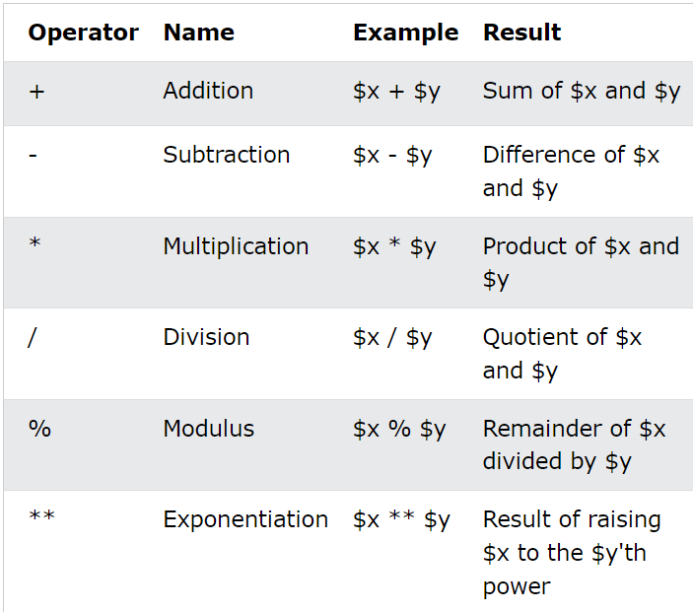

echo 2**3; // 8
echo "<br>";
echo 10%3; // 1
echo "<br>";

echo "100"; // 100
echo "<br>";
echo gettype("100"); // string
echo "<br>";
echo +"100"; // 100
echo "<br>";
echo gettype(+"100"); // integer
echo "<br>";
echo -"100"; // -100
echo "<br>";
echo gettype(-"100"); // integer
echo "<br>";
$num = "100";
echo gettype(+$num); // integer

a unary operator is an operator that takes only on operand. It is used to perform various operations such as incrementing or decrementing a value , negation a value, or converting a value from one type to another.
Look at this example :
echo -"-100"; // 100

Assignment Operators
The PHP assignment operators are used with numeric values to write a value to a variable.
The basic assignment operator in PHP is “=”. It means that the left operand gets set to the value of the assignment expression on the right.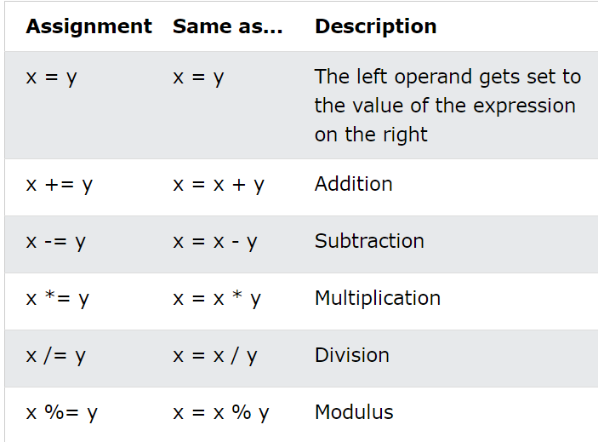

PHP Comprision operators
The PHP comparision operators are used to compare two values (number or string ) :
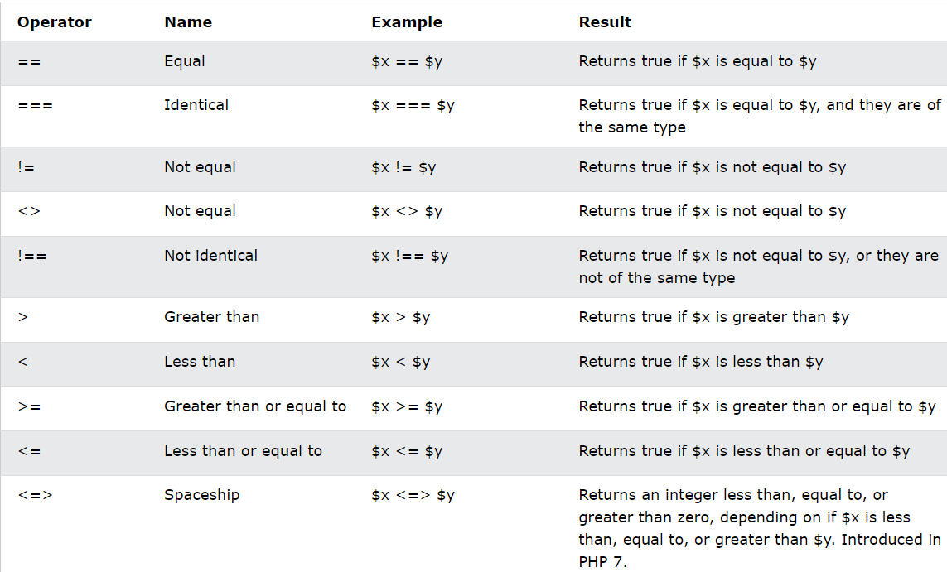

The spaceship operator <=> is a comparision operator that returns an integer value indicating the relationship between two values.
How it works :
- If $x is less than $y, it returns -1;
- If $x is equal to $y, it returns 0;
- If $x is greater than $y, it returns 1;

$x = 5;
$y = 10;

$result = $x <=> $y; // returns -1, because 5 is less than 10
It’s called the “spaceship operator” because it looks like a spaceship <=>

PHP Logical operators
The PHP logical opertors are used to combine conditinal statements. 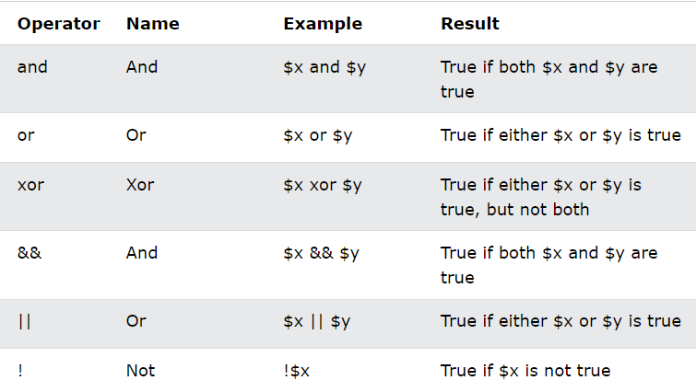

PHP String Operators
PHP has two operators that are specially designed for strings.

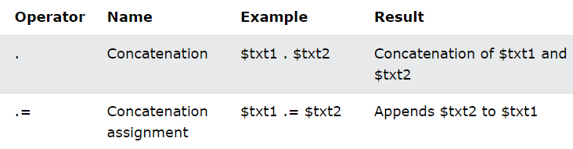
$a = "Elezero";
$b= "web";
$c = "School";

echo "$a $b $c"; // Elezero web School
echo "<br>";
echo "{$a} {$b} {$c}"; // Elezero web School
echo "<br>";
echo $a . " " . $b . " " . $c; // Elezero web School
In PHP, you can access variables, objects, functions, and constants within strings using two methods. The first method uses variable interpolation, where you simply include the variable name within the string, like echo "$a $b $c";. However, this method can cause problems if the variable name contains special characters, like spaces or curly braces. To avoid this issue, you can use the second method, which explicitly defines the variable name using curly braces, like echo "{$a} {$b} {$c}";. This method provides more control and flexibility, especially when working with complex variable names or accessing object properties and constants. By using curly braces, you can ensure that PHP treats the variable name as a separate entity within the string, avoiding potential errors and making your code more readable.
$a = "Elezero";
$b= "web";
$c = "School";
define("PI", 3.14);

echo "${a} ${b} ${c} ${PI}" ; // error

function hello() {
echo "Hello";
}
echo "${hello()}"; // error
throw error because function and constant are not variables . to fix
echo "${a} ${b} ${c} ". PI ; // Elezero web School 3.14

function hello() {
echo "Hello";
}
echo hello() . " Elezero"; // Hello Elezero
now let pass
$x = "Elezero";
$x .= " web"; // $x = $x . " web"
$x .= " school"; // $x = $x . " school"
echo $x; // Elezero web school

PHP Increment / Decrement Operators
The PHP increment operators are used to increment a variable’s value.
The PHP decrement are used to decrement a variable’s value.
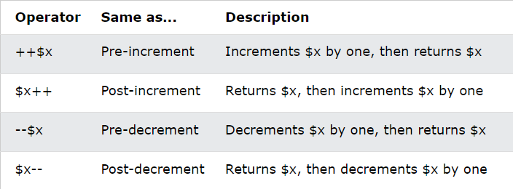
$a = 0 ;
echo ++$a; // 1
echo $a; // 1

$b = 0 ;
echo $b++; // 0
echo $b; // 1

PHP Conditinal Assignment Operators
The PHP conditinal operators are used to set a value depending on conditions:
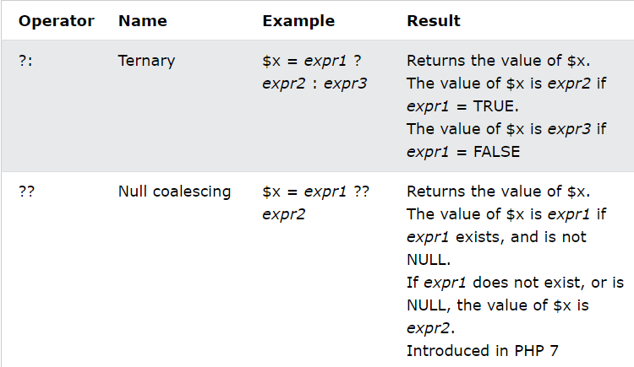

PHP Array opeartors
The PHP array operators are used to compare arrays.

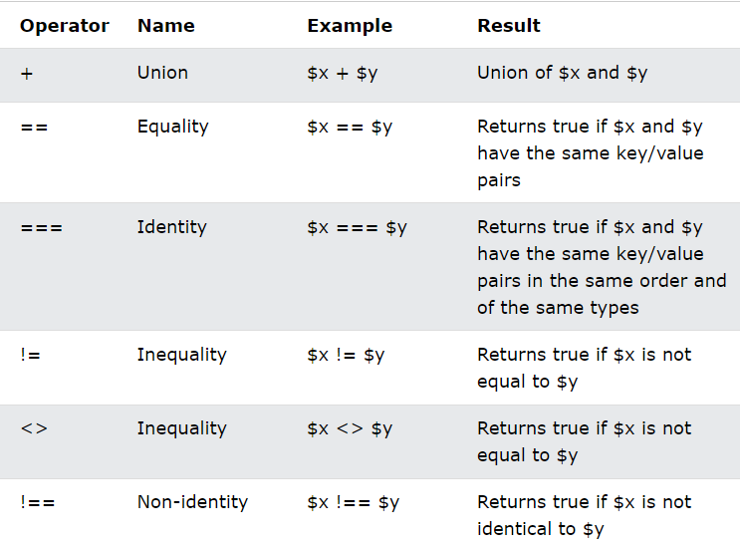
NOTE : THE <PRE> Tag in HTML is used to dispaly text as it is written, preserving spaces, line breaks, and indentation. It is ofter use to dipslay code or data that need to be formattd in a specific way.
< > is the same as !=
$arr1= [1 => "A", 2 => "B"];
$arr2= [3 => "C", 4 => "D"];

$arr3 = $arr1 + $arr2;

echo "<pre>";
print_r($arr3);
print_r($arr1 + $arr2);
echo "</pre>";

$arr4 = [1 => "10", 2 => "20"];
$arr5= [2 => 20 , 1 => 10];
var_dump($arr4 == $arr5); // true
echo "<br>";
var_dump($arr4 != $arr5); // false

echo "<br>";
var_dump($arr4 === $arr5); // false

echo "<br>";
var_dump($arr4 !== $arr5); // true
echo "<br>";

$arr6 = [1 => "100", 2 => "200"];
$arr7 = [1 => "100", 2 => "200"];

var_dump($arr6 === $arr7); // true

Error Control Operator
In PHP, the error control operator is the @ symbol.
The @ symbol is used to suppress (hadr- stop) errors and warings in PHP .
Here’s an example.
$result = @division(5, 0);
Division is user defined function not buit-in !!!
In this example, the @ symbol is used to suppress the warning message that would normally be displayed when the division() function is called with a divisor or zero.
Using the @ symbol can be useful in certain situatins, such as when you want to handle erros or wqrning in a specific way, or when you want to avoid dispalying unnecessary error messages to the user .
However, it's important to note that using the @ symbol can also make your code harder to debug and maintain, as it can hide important error messages.

Operator Precedence
Take a look, to the following code :
$a = 10 || false;
echo $a; // 1

echo "<br>";

$b = 10 or false;
echo $b; // 10

PHP if Statements
Conditional statements are used to perform different actions based on different conditions

PHP Conditional Statements
Very often when you write code, you want to perform different actions for different conditions. You can use conditional statements in your code to do this.
In PHP we have the following conditional statements:
- if statement - executes some code if one condition is true
- if...else statement - executes some code if a condition is true and another code if that condition is false
- if...elseif...else statement - executes different codes for more than two conditions
- switch statement - selects one of many blocks of code to be executed

PHP – The if Statement
The if statement executes some code if one condition is true .
$t = date("H");

if ($t < "10") {
echo "Have a good morning!";
} elseif ($t < "20") {
echo "Have a good day!";
} else {
echo "Have a good night!";
}

Real life example
<?php

$username = $_POST['username'];
$language = $_POST['lang'];

echo "Hello $username, welcome to $language";

?>

<!DOCTYPE html>
<html lang="en">
<head>
<meta charset="UTF-8">
<meta name="viewport" content="width=device-width, initial-scale=1.0">
<title>Support</title>
</head>
<body>
<form action="" method="post">
<input type="text" name="username" >
<select name="lang">
<option value="ar">Arabic</option>
<option value="en">English</option>
<option value="fr">French</option>
</select>
<input type="submit" value="Go">
</form>
</body>
</html>

Here we gonna get an error , in the first time we run .
Because username and lang will not be send yet.
if ($_SERVER['REQUEST_METHOD'] == 'POST') {
$username = $_POST['username'];
$language = $_POST['lang'];

echo "Hello $username, welcome to $language";
}
Open network in browser , do a simple reload , and then click on ur file that will apear there .
And in the playload you will find the info sending by the form

PHP Shorthand if Statement
if ($_SERVER['REQUEST_METHOD'] == 'POST') {
$username = $_POST['username'];
$language = $_POST['lang'];

echo "Hello $username, welcome to $language";
}
Else also :
if (10 > 5) echo "Good";else echo "Bad"; // Good

This technique is knonw as Ternary Operators, or Conditional Expressions
Note : you can have an entire html page inside if
if (10 > 10):
echo "first";
elseif (10 > 5):
echo "second";
else:
echo "last";
endif;

switch
The switch statement is used to perform different actions based on different conditions
The PHP switch Statement
Use the switch statement to select one of many blocks of code to be executed .
switch (expression) {
case label1:
//code block
break;
case label2:
//code block;
break;
case label3:
//code block
break;
default:
//code block
}
This is how it works :
- The expression is evaluated once .
- The value of the expression is compared with the values of each case
- If there is a match, the associated block of code is executed.
- The break keyword breaks out of the switch block
- The default code block is executed if there is no match .

$favcolor = "red";
switch ($favcolor) {
case "red":
echo "Your favorite color is red!";
break;
case "blue":
echo "Your favorite color is blue!";
break;
case "green":
echo "Your favorite color is green!";
default:
echo "Your favorite color is neither red, blue, nor green!";
}
More than one case for each block :
switch ($d) {
case 1:
case 2:
case 3:
case 4:
case 5:
echo "The weeks feels so long!";
break;
case 6:
case 0:
echo "Weekends are the best!";
break;
default:
echo "Something went wrong";
}
Note : if default is not the last block in the switch block, remeber to end the default block with a break statement.

MATH Function

Abs
Absolute value
Syntax :
Abs ( number[required])
echo abs(-10); // 10

mt-rand
generate random value via the mersenne twister random number generator algorithm .
- Mt_getrandmax () => show the largest possible random value.
Syntax :
Mt_rand ( min[optional] , max [optional] )
echo rand(5,10)."\n"; // 7

intdiv
it is a php function that perfoms integer division, which means it returns the integer part of the result of the division.
echo intdiv(10, 3); // Output: 3

fmod
fmod is abr of floating point moduls
echo 11/5;// 1
echo 11%5;// 1
echo gettype(11%5); // integer

echo fmod (11, 5); // 1
echo gettype(fmod (11, 5)); // float

note :

- / (division) and % (modulus) operators perform integer arithmitic, which means they truncate the result to an integer.
- Fmod ( ) function performs floating-point arithmetic, which means the fractinal part of the result .

Ceil
Round up to integer
echo floor (5.5); // 5

Floor
Round down to integer
echo floor (5.5); // 5

Round
Is a built-in php function that rounds a number to the nearest integer or to specified number of decimal places
Syntax:
Round (number [Required] , Precision [optional], Mode [ Optional])
Parameters
Number : the number to be rounded
Precision : the number of decimal places to round to .
Mode :
- PHP_ROUND_HALF_UP
- PHP_ROUND_HALF_DOWN
- PHP_ROUND_HALF_EVEN
- PHP_ROUND_HALF_ODD

Sqrt
Calculate the square

Min
Find the lowest value
Syntax :
Min (array [Required])
// using values
echo min(10, 20 , -30 , 50); // -30
// using arrays
echo min ([10 , -20 , [-50 , -20 , 50 , [-20,-100],3],5]) ; // -20

because min function can’t access multidimensional array, it is condider only the first the levels , and the other deep level will be ignored.

max
find the highest value
syntax :
Min (array [Required])

Filter Functions

Filter_list ( )
print_r(filter_list())."\n";

echo filter_id ('boolean')."\n";

$val = "on" ; // true || 1 || "yes" || "on"

// if (filter_var ($val, 258)){

if (filter_var ($val, FILTER_VALIDATE_BOOL)){
echo "This is true";
}else {
echo "This is false";
}

File System Functions

Disk_total_space ( )
Disk_total_space ( ) is a php function that returns the total amount of disk space available on the specified path .
Get total space in bytes => then we can get [KB,MB,GB]
From bytes to :
- Kilobytes (KB) : bytes / 1024
- Megabytes (MB ) : bytes / 1024²
- Gigabytes (GB) : bytes / ${1024}^{3}$
- Terabytes (TB ) : bytes / ${1024}^{4}$
- Petabyes (PB) : bytes / ${1024}^{5}$
This function has an alias : diskfreespace( )
echo disk_free_space('C:')." bytes \n"; // 15425241088 bytes
echo disk_free_space('C:') / 1024 ." KB \n"; // 15063712 KB
echo disk_total_space('C:')/ pow(1024, 2)." MB \n"; // 113907.015625 MB
echo disk_total_space('C:')/ pow(1024, 3)." GB \n"; // 111.23731994629 GB

file_exists
checks if a file or directory exists
syntax
file_exists ( Path )
$file = 'path/to/your/file.txt';

if (file_exists($file)) {
echo "The file exists!";
} else {
echo "The file does not exist!";
}
More :
var_dump ( file_exists ( 'file.py' ) ); // bool(true)
var_dump ( file_exists ( 'file.php' ) ); // bool(false)

the function returns a boolean value:
- True if the file or directory exists
- False if the file or directory does not exists.

Filesize ( )
Filesize ( ) is a php function that returns the size of a file in byes .
Here’s the basic syntax :
Int filesize ( string $filename )
The function takes a single argument, $filename, which is the path to the file you want to get the size of .
The function returns an integer value representing the size of the file In bytes .
Note : filesize ( ) throw error if the file does not exist , or if there is an error accessing the file .
var_dump( filesize("test.txt") ); // int (52)

is_dir
is_dir is a php function that tells if the filename is a directory
var_dump(is_dir("test")); // bool(true)
var_dump(is_dir("test.txt")); // bool(false)

mkdir
is a php built-in function that create a directory
syntax :
mkdir ( Path [Required] , Mode [Optinal] = 0777 , Recursive [optional], Context [Optional])
Note :
Permissions is ignored on windows
Permission param
- Permissions is octal number start always with 0
- Second number is => owner Permission
- Third number is => user Group Permission
- Fourth number is => others permissions
Possible values (to set mutiple permissions, add up the followig numbers )
- 1 = execute permissions
- 2 = write permissions
- 4 = read permissions
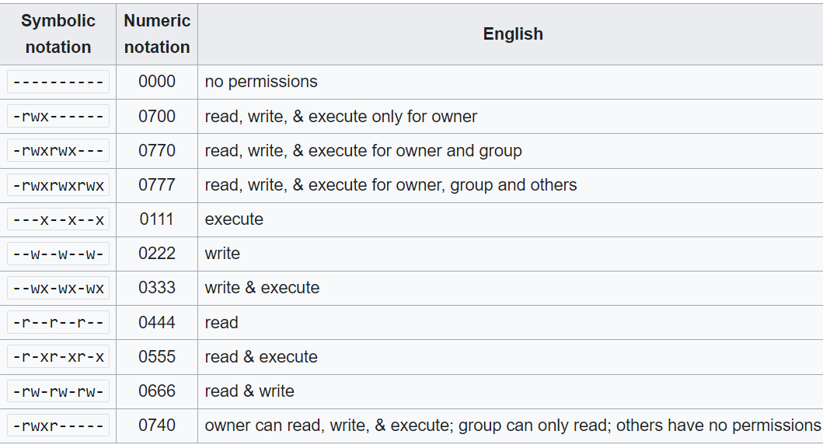
Recursive
The recursive parameter is a boolean value that indicates whehter ithe mkdir functin shoudld create the directory recursively . When set to true , the function will create any ncecessary parent directories if they do not already exist .
For example :
mkdir ('Test/Upload/Files', 0777, true);
the function will :
- Check if the Test directory esists, if it doesn’t, it will create it .
- Check if the Upload directory esists, if it doesn’t, it will create it .
- Finally, it will create the Test/Upload/Files directory
If Recursice is set to false ( or omitted, since it’s optional), the function willonl attempt to create the specified directory, and will return an error if any of the parend dir do not exist .

Rmdir
The rmdir function in php is used to remove an empty directory.
Syntax :
Rmdir ( Name [Required ] , Context [Optional])
Return Value :
The rmdir function returns true if the directory is successfully removed , and false otherwise .
Notes
The directory must ve empty befoe if can be removed . if the directory contains files or subdirectories, the function will return error .
// rmdir ("Test/Upload/Files");
// Test\Upload
// rmdir ("Test/Upload");
rmdir ("Test");
// now we delete all

The rmdir function only removes the specifired directoryn and does not recursively remove any subsirectories or files .

Chmod
The chmod function is used to change the permissions of a file or directory .
Syntax :
bool chmod ( string $filename , int $mode )
parameters :
- Filename : the path to the file or directory whose permissions are to be changed
- Mode : the new permissions for the file or directory.
Return
The chmod function returns true if the permissions are successfully changed, and false otherwise.
Chmod = change mode

Fileperms
Fileperms is a php functin that returns the permissions of a file or directory .
Return Value
The fileperms function returns an integer value representing the permissions of the file or directory.
Note : the value returned is decimal .
You can use base_convert () function to convert between numeric sytem :
// mkdir ("Y",0700);
$decimal = fileperms ("Y");
echo $decimal;// 16895

echo "\n ######## \n";

$octal = base_convert ($decimal,10,8);
echo $octal; // 40777

// the 4 mean that the number returned is a string
Look at this prolem ( test only in unix system )
// mkdir ("Y",0700);
echo fileperms("Y") . "\n"; // 448 => 0700
chmod("Y",0644);
echo fileperms("Y") . "\n"; // 448 => 0700
the system will print only the value saved in catching .

caching & Clearstatcache
caching is a technique used to improve the performance of a system by storing frequentl accessed data in as faster, more accessible locain .

what is caching ?
caching is a proccess where a copy of frequently used data is stored in a temporary storage area, alled a cache . the cache is usually located closer to the application or user, making it faster to access the data .
how does caching work ?
- Initial Request : A user or application requests data from a source, such as a database or file system.
- Cache check : before accessing the source, the system checks if a vlid copy of the requested data is already stored in the cache .
- Cache Hit : if the ata is found in the cache, it is returned directly to the user or application , bypassing the need to access te source .
- Cache Miss: if the data is not found in the cache, the system retrieved it from the source and stored a copy in the cache for future use .

// // mkdir ("Y",0700);
// echo fileperms("Y") . "\n"; // 448 => 0700
// chmod("Y",0644);
// echo fileperms("Y") . "\n"; // 448 => 0700

// this is due to caching

Clearstatcache
A function used to clear cache

PHP File Handling
File handling is an important part of any web application. You often need to open and process a file or different task

Php manipulating
Php has several functions for creating, reading, uploading, and editing files .
Be careful when manipulating files
When you are manipulating files you must be very careful
You can do a lot of damage if you do something wrong. Common errors are : editin the wrong file, filling a hard-drive with garbage data, and eleting the content of a file by accident .

Php readfile ( ) function
The readfile ( ) function reads a file and writes it to the output buffer.
Fopen ( fileName [Required] , Mode [Required] , Include¨Path[optional] , Context [optional])
Mode :
[r] : for read => pointer at the beginning
[r+] : for ead & write => pointer at the beginning
[w] : for write => pinter at the beginning + truncate to 0 length => create if not exists .
[w+] : for ead & write => pointer at the beginning + truncate to 0 length => create if no exists
$handle = fopen("test.txt","w+");

Fgets ( )
The fgets ( ) functin returns a line form an open file.
Syntax:
Fgets (File [required] , length [optional] )
$handle = fopen("test.txt","r");
$text = fgets ($handle);
echo $text;
// hello my name is bilal

Using length
$handle = fopen("test.txt","r");

$text = fgets ($handle,11);
echo $text ;
// hello my n
Length => number of bytes to read || end of line if no length .

Fread
Get a data from an open file
Syntax
Fread ( file [required] , length [required])

Fclose ( )
Fclose is a function in php that is used to close a file. It is typically used after you have finished reading or writing to a file .
The syntax for fclose is :
fclose($file_handle)
it is crucail to close any open files after completing operations to free up system resoures and ensure data integrity.
main :
readfile and fopen ( along with fread or fgets) are two different ways to read the contents of a file .
- Readfile
Readfile is afunction that reads a file and ouputs its contents directly to the browser. It is a somple and efficieent way to read a file, especially when you wqnt to display the file’s contents to the user .
echo readfile('test.txt');
// hello my is bilal
// this text is just for testing.52
- Fopen (with fread or fgets )
Fopen is a function that opens a file and returns a file handle, which can be used to read or wirte to the file. To read the file’s contents, you need to use fread or fgets in conjunction with fopen.
Key differences
Here are the main differences between readfile and fopen (with fread or fgets):
- Output: readfile outputs the file's contents directly to the browser, while fopen (with fread or fgets) returns the contents as a string, which you can then output or manipulate as needed.
- Memory usage: readfile is more memory-efficient, as it doesn't load the entire file into memory at once. fopen (with fread or fgets) loads the file into memory, which can be a concern for large files.
- Flexibility: fopen (with fread or fgets) provides more flexibility, as you can read the file in chunks, seek to specific positions, and perform other file operations.
In general, use readfile when you simply want to display a file's contents to the user, and use fopen (with fread or fgets) when you need more control over the file reading process or want to perform additional file operations.
Main :
In PHP ? fread and fgets are two functions used to read data from a file. While they share some sililarities, there are key differences between them :
Key differences
Here are the main differences between fread and fgets:
- Reading style: fread reads a specified number of bytes, while fgets reads a line from the file.
- Newline character: fgets includes the newline character at the end of the line, while fread does not.
- Length: fread requires you to specify the number of bytes to read, while fgets reads until it encounters a newline character.
- Performance: fgets is generally faster than fread when reading text files, since it uses a more efficient algorithm to read lines.

Fopen ( )
We can cover all it modes:
[r] for read => pointer at the beginning
[r+] for read & write => pointer at the beginning
[w] for write => pointer at the beginning + delete all file content
[w+] for read & write => pointer at the beginning + delete all file content
[a] for write => pinter at the end + create if not exists.
[a+] for read & write => pointer at the end + create if not exists
[x] Create + open for write => pointer at the beginning
[x+] create + open for read & write => pointer at the beginning
Pointer is just for writing
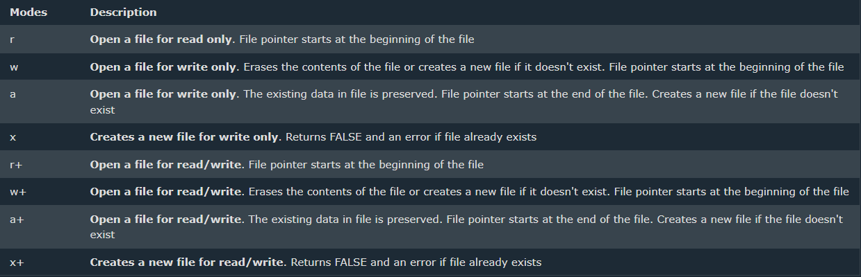

Fwrite
Fwrite is a php function that writes data to a file.
It is a function that write to an open file.
What it does :
- writes data to a file
- returns the number of bytes written
syntax :
fwrite (File [Required], String [Required], Length [optional] )
length => maximum number of bytes to write .

common Errors
- Attempting to write to a file opended in read mode will result in a write failure.
- If you try to create a file that alreading exists using mode x, it will fail

Importants notes
- When using fwrite, you can specify the length of the string to write. If omitted, it writes the entire string.
- Always check if the file opens successfully to avoid errors. If the file connot be opened, php will return warning.

$handle = fopen("test.txt", "x+");
echo fread($handle, filesize("test.txt"));
fwrite($handle, "\nHello World!");
fclose($handle);
the last mode:
[C]
* for write
* create if not exists
* No problem if its exists
* no trunction
* pointer at the beginning
[ C + ] : for read and write

File
File is a php function that reads a file into an array .
Where each element is a line from the file
Syntax:
File ( file[required] , Flag[optional], Context [optional] )
/* file :
hello my is bilal

this text is just for testing.
Hello World!
Hello World!
*/

print_r(file("test.txt"));
/* output :
Array
(
[0] => hello my is bilal

[1] =>

[2] => this text is just for testing.

[3] => Hello World!

[4] => Hello World!
) */

Feof
Feof = find end of file
It a php function that test for EDF on a file pointer
Meaning : it returns true if fgets arrive to the last line in a file

File, feop and loop practice
Foucus pls :
$handle = fopen("test.txt", "r");

$line = 1;

while (! feof($handle) ) {
echo "line $line : " . fgets($handle) . "\n";
$line++;
}
/*line 1 : hello my name is bilal

line 2 :

line 3 : this text is just for testing.

line 4 : Hello World!

line 5 : Hello World!
*/
echo "\n ############ \n";

for ($line = 1; $line <= count(file("test.txt")); $line++) {
echo "line $line : " . fgets($handle) . "\n";
}
/*
line 1 :
line 2 :
line 3 :
line 4 :
line 5 :
*/
// the pointer has already reached the end of the file, so nothing will be returned.
fclose($handle);
NB: count => return number of element in an array , in this example it retunrs the number of lines .

Ftell
Ftell is a PHP function that returns the current position of the file pointer in a file stream .
It takes a file pointer as an argument and returns ithe position of the file pointer in bytes
Just for testing :

Mb_strlen
Mb_strlen is a php function that returns the length of a string in bytes, taking into account the character encoding.
The syntax :
Int mb_strlen ( string $str , string $encoding )
Where :
- $str is the input stirng
- $encoding is the character encoding (optional, defaults to the internal ) .

$handle = fopen("test.txt", "r");

echo ftell($handle)."<br>"; // 0

echo fgets($handle)."<br>"; // Elzero web School

echo mb_strlen("Elzero web School\r\n","8bit")."<br>"; // 19
echo ftell($handle)."<br>"; // 19

echo fgets($handle)."<br>";
echo mb_strlen ("My name is\r\n","8bit") + 19 ."<br>"; // 31
echo ftell($handle)."<br>";
// 31
fclose($handle);

rewind ( )
the rewind functin in php is used to reset the file pointer to the beginningof a file
the syntax is:
bool rewind ( $handle )
echo ftell($handle)."<br>"; // 31
echo rewind($handle)."<br>"; // true: 1
echo ftell($handle)."<br>"; // 0

fseek
the fseak functin in php is used to move the file pointer to a specific positoin in a file.
The syntax is :
Fseek ( File [Required] , Offset[Required] , Whence[Optiona] = SEEK_SET )
Where :
- $offeset : this is the number of bytes to move the file pointer by. It is a required parameter.
To make it simple , is the number of bytes to move the file pointer by .
Here are some imporatant things to know about $offset :
- Positive values: if $offset is a positive number, the file pointer will move forward by that many bytes. For example, if $offset is 10, the file pointer will move 10 bytes forward from the current position
- Negative values: if $offset is a negative number, the file pointer will move backward b that many byes. For example , if $offset is -10 the file ointer will move 10 bytes backward from the current position.
- Zero value : if $offset is 0 , the function is equal to rewind, it reseting the pointer to the start of file.

$handle = fopen("test.txt", "r");

fseek($handle, 19);
echo fgets($handle)."\n"; // My name is

fseek($handle, 0);
echo fgets($handle)."\n"; // Elzero web School

fclose($handle);

When used with the $whence paramter $offset can be used to move the file pointer ot a specific position in the file , for example:
- Fseek ($ftp, 10, SEEK_SET ) : Move the file pointer to the 10th byte form the beginning of the file .
- Fseek ($ftp, -10, SEEK_END ) : Move the file ponter to the 10th bytes from the end of the file.
- Fseek ($ftp , 10 , SEEK_CUR ) : Move the ifle pointer 10 bytes froward form the current position .
Pls in example are linked with the last functions : pls just focus in the code
$handle = fopen("test.txt", "r");

fseek($handle, 24);
echo fgets($handle)."\n"; // me is

fseek($handle, 0);

fseek($handle, -7, SEEK_END);
echo fgets($handle); // Bilal
echo ftell($handle)."\n"; // 40

// do not forget that when reading bilal, the pointer
// arrived at the end

fseek($handle, -15, SEEK_CUR); // 40 - 15 = 25
echo ftell($handle)."\n"; // 25
echo fgets($handle)."\n"; // e is

fseek($handle, 11 , SEEK_SET);
echo ftell($handle)."\n"; // 11
echo fgets($handle)."\n"; // school

fclose($handle);

// just for testing or verification
echo mb_strlen("bilal\r\n","8bit"); // 7

glob
glob is a php function that finds files that match a certain pattern.
Think of it like a search tool that looks for files with a specifi name or extension.
The syntax
Array glob ( string $pattern , int $flags )
So , our function returns an array of files that match the pattern.
The pattern to search (*,.txt) .
$result = glob("*.*");
print_r($result);
/*
Array
(
[0] => index.php
[1] => moha.pdf
[2] => test.txt
[3] => test2.txt
[4] => test3.txt
[5] => testing.docx
)
*/
Let specify a specific extension:
$result = glob("*.txt");
print_r($result);
/*
Array
(
[0] => test.txt
[1] => test2.txt
[2] => test3.txt
)
*/

Rename
Rename a file or directory, move
Syntax:
Rename ( old[Required], new [required] ) => move

// rename => same place
rename ( "test.txt","test1.txt");

// rename => different place => Cut
rename ( "test1.txt","old/test1.txt");

// move to other place
rename ( "old/test1.txt","test1.txt");

copy
copy is a php functin that copiers a file.
Syntax:
Bool copy ( string $source , string $destination )
Paramters
- Source : the path to the ifle to copy
- Dest : the path to the destination file
Return value
The copy functions returns true ift the file is copied successfully, and false otherwise
// copy without rename
copy("test1.txt", "old/test1.txt");

// copy with rename
copy("old/test1.txt", "new/test1.txt");
Note:
- The copy function will overwrite the destinatino file if it already exists.
- If the source file does not exist, the function will return false.
- If the destination directory does not exist, the functoin will return false .
Unlink
Unlink is a php funcion taht detes a file .
Syntax:
Bool unlink ( string $filename)
Paramter:
- Filename: the path to the file to delte.
Return value
The unlink fnciton returns true if the ifle is deteted successfully and false otherwise.

unlink('test1.txt');
unlink('test2.txt');

Note :
- The unlink function will not delete a dirctory to delte a direecroy , use the rmdir function.
- If the file does not exist, the function will return false
- If the file is not writable, the function will return false.

File_get_content
Reads entire file into a string.
Syntax:
File_get_content ( File [required], include_path[optional], Mode [optonal , context [optional] )
Parameters
- File [Requred] : the path to the file to read
- Incude_path [optional] : whether to search for the file in the include path.
- Mode [optional] : the mode in which to open the file.
- Context [optional] : A stream context resource.
In others wrds
- You must specify the File you want to read.
- You can optionally specify whether to use the include_path to search for the file.
- You can optionally specify the Mode in which to open the file.
- You can optionally specify a context resource to use when reading the file.
Focus here :
- Include_path [optonal] : this parameter specifies whether to search for the file in the cinluce path. If set to true , php will searhc for the file int eh directories specified in the include path. If set to false, php will only search for the file int he current directory.
- Mode [optional] : this parameter specifieds the mode in whcih to open the file. The mode can be one of te following :
r: Open the file for reading only.
w: Open the file for writing only.
a: Open the file for appending only.
x: Open the file for exclusive creation.
b: Open the file in binary mode.
t: Open the file in text mode.

Note:
File_get_conetns and file are similar, but not exactly the same.
File reads a file into an array, where each line is an element in the array.
File_get_contents reads a file into a string
echo file_get_contents('text1.txt');
/*
hello my nale is bilal
how can i help you
ok it's great
*/
print_r(file ("https://facebook.com/"));
file_put_contents
file_put_contents is a php function that writes data to a file.
Syntax:
Int file_put_contents ( string $filename, string data , int flags )
Parameters
- Filename : the path to the file to write to
- Data : the data to write to the ifle.
- Flags : optonal flags to use when writing to the file.
- Context : optional context to use when wriing to the file.
Return value :
The file_put_contents funtion retunrs the number of bytes written to the file, or false on failure .
echo file_put_contents("text1.txt", "form php file", FILE_APPEND);

Directory handling
Opendir, readir, and close dir are php fucction that are use to work with directories .

Opendir
The opendir function open a directory and return a directory handle that can be used to read the content of te dirrectory
Syntax :
Resource opendir ( string $path )
Paramters
- Path : the path to the directory to open .
Return value:
The opendir function returns a directory handle ressource on success, or false on failure.
$handle = opendir("directory");
Note :
- If the directory does not exist, the funciton will return false.
- If the directory is not readable , the function wil return false.

Readdir
The readdir function reads a single entry from a directory.
Syntax :
String readdir ( ressource $handle , include )
An entry can be one of the follwing:
- File: A regular file, such as test file, image file, or executable file
- Directory : a subdirectory withing the current directory.
- Special file: a special file, such as a symbolik link , socket, or named pipe.
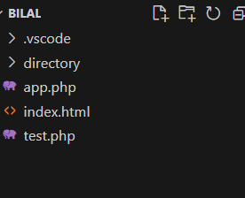
$handle = opendir(".");
$entry = readdir($handle); // .
echo $entry . "\n";
echo readdir($handle)."\n";
echo readdir($handle) . "\n";
echo readdir($handle) . "\n";
echo readdir($handle) . "\n";
echo readdir($handle) . "\n";
echo readdir($handle) . "\n";

/*
.
..
.vscode
app.php
directory
index.html
test.php
*/
You're manually calling readdir multiple times to see the entries in the directory.
Here's what's happening:
- $entry = readdir($handle); returns the first entry, which is . (the current directory).
- echo readdir($handle)."\n"; returns the second entry, which is .. (the parent directory).
- echo readdir($handle) . "\n"; returns the third entry, which is .vscode (a directory).
- echo readdir($handle) . "\n"; returns the fourth entry, which is app.php (a file).
- echo readdir($handle) . "\n"; returns the fifth entry, which is directory (a directory).
- echo readdir($handle) . "\n"; returns the sixth entry, which is index.html (a file).
- echo readdir($handle) . "\n"; returns the seventh entry, which is test.php (a file).
After the seventh call to readdir, there are no more entries in the directory, so readdir returns false.

Closedir
Closedir is a php funciton that closes a directory handle.
Syntax:
Void closedir ( resource $handle )
Parameters
- handle: the directory handle to close
closedir($handle);

PHP Loops
Often when you write code, you want the same block of code to run over and over again a certain number of times. So, instead of adding several almost equal code-lines in a script, we can use loops.
Loops are used to execute the same block of code again and again, as long as a certain condition is true.
In PHP, we have the following loop types:
- while - loops through a block of code as long as the specified condition is true
- do...while - loops through a block of code once, and then repeats the loop as long as the specified condition is true
- for - loops through a block of code a specified number of times
- foreach - loops through a block of code for each element in an array
The following chapters will explain and give examples of each loop type.

PHP while loop
The while loop – loops through a block of code as long as the specified condition is true.

The break statement
With the break statement we can stop the loop even if the condition is still true

The continue statement
With the continue statement we can stop the current iteration, and continue with the next:

Alteranative syntax
The while loop syntax can also be written with the endwhile statement like this
$i = 1 ;

while ($i <= 10) :
echo $i;
$i++;
endwhile;

php do while loop
the do...while loop – loops through a block of code once, and then repeats the loop as long as the specified condition is true .
the do…while loop always execute the block of code at least once, it will then check the condition, and repeat the loop while the spcefied condition is true.
PHP for Loop
The for loop – loops through a block of code a spcified of times.
This is how it works:
- Expression1 is evaluated once.
- Expression2 is evaluted before each iteration
- Expression3 is evaluted after each iteration .

PHP Functions
The real power of PHP comes from its functions.
PHP has more than 1000 built-in functions, and in addition you can create you own custom functions.
PHP built-in Functions
PHP has over 1000 built-in functions that can be called directly, from within a script, to perform a specific task.
Later we will see all php built-in functions .

PHP User defined Functions

Besides the built-in PHP functions, it is possible to create your own functions.
- A function is a block of statements that can be used repeatedly in a program.
- A function will not execute automatically when a pgae loads.
- A function will be executed by a call to the function.

Create a Function
A user-defined function declaration starts with the keywor function, followed by the name of the function:
function myMessage(){
echo "Hello world !";
}

Note : A function name must start with a letter or an underscore. Function names are NOT case-sensitive.
Passing Arguments by Reference
In PHP, arguments are usually passed by value, which means that a copy of the value is used in the function and the variable that passed into the function cannot be changed.
When a function is by reference, changes to the argument also change the variable that was passed in. To turn a function argument into a reference, the & operator is used.
Example :
function add_five(&$value){
$value += 5;
}

$num = 10;
add_five($num);
echo $num; // 15

Variable number of arguments
By using the … operator in front of the function parameter, the function accepts an unkonwn number of arguments. This is also called a varaidic function.
The variadic function argument becomes an array.
function sumMyNumbers (...$x){
$n = 0 ;
$len = count($x);
for ($i = 0 ; $i < $len ; $i++){
$n += $x[$i];
}
return $n;
}
$a = sumMyNumbers(5, 2,5,6,5,5,8,9,6); // 51
echo $a;
you can only have one argument with variable length, and it has to be the last argument.
function myFamily($lastname, ...$firstname){
$txt = "";
$len = count($firstname);
for ($i = 0; $i < $len; $i++){
$txt = $txt."Hi $firstname[$i] $lastname. <br>";
}
return $txt;
}

$a = myFamily("Doe", "Jane", "John", "Joey");
echo $a;
/*
Hi Jane Doe.
Hi John Doe.
Hi Joey Doe.
*/
PHP is a Loosely Typed Language
PHP automatically associates a data type to the variable, depending on its value. Since the data types are not set in a strict sense, you can do things like adding a string to an integer without causing an error.
In PHP 7, type declaraions were added. This gives us an option to specify the expected data type when declaring a function, and by adding the strict declaration, it will throw a “Fatal Error” if the data type mismaches.
To specify strict we need to set declare(strict_types=1); . This must be on the very first line of the php file.
In the following example we try to send both a number and a string to the function, but here we have added the strict declaration:
?php declare(strict_types=1); // strict requirement

function addNumbers(int $a, int $b) {
return $a + $b;
}
echo addNumbers(5, "5 days");
// since strict is enabled and "5 days" is not an integer, an error will be thrown
?>

Function Variabel and function exists
Please try to understand the following code :
function say_hello_to($someone){
echo "Hello ".$someone;
}
$a = "say_hello_to";
$a('Bilal'); // Hello Bilal
If you want to know if a functin exists use : function_exists
// function say_hello_to($someone){
// echo "Hello ".$someone;
// }
if (function_exists('say_hello_to')) {
echo "function exists";
}else {
echo "function not exists";
}
// function does not exists

Return type
function calculate($number1,$number2){
return $number1 + $number2;
}
echo calculate(5,5.5); // 10.5
echo gettype(calculate(5,5.5)); // double
but take a look now :
function calculate($number1,$number2): int{
return $number1 + $number2;
}
echo calculate(5,5.5); // 10
echo gettype(calculate(5,5.5)); // integer
?>

Anonymous Function
When we create a function we give it a name so we can call it later with that name .
Sometimes we need to create a function for specific task . so we can call it later with that name .
- Variable inherit from parent scope.
- Variable inherit by Reference from parent scope .
- Anonymous functin can be passed to a function
- Anonymous function can be return from a function.

// anonymous function
$say_hello = function(){
echo "Hello World";
};

echo $say_hello();

echo '<br> ##################### <br>';

// anonymous function with a parameter
$say_hello_to = function($someone){
echo "Hello ".$someone;
};
echo $say_hello_to('Bilal'); // Hello Bilal

echo '<br> ##################### <br>';
// inherit variable from parent scope
$msg = "HI";
$say_hi = function($someone){
return "$msg $someone";
};
echo $say_hi('Bilal');
// Undefined variable $msg in E:\COURSES\PHP\Testing\index.php on line 23

For fix it you have to use use() keyword
$msg = "HI";

$say_hi = function($someone) use ($msg) {

return "$msg $someone";
};

echo $say_hi('Bilal'); // HI Bilal
Understanding the use keyword in PHP
In PHP, when you define an anonymous function (like $say_hi in your example), it doesn't have access to the variables from the surrounding scope by default. To make those variables available to the anonymous function, you can use the use keyword.
What does use do?
The use keyword allows you to import variables from the surrounding scope into the anonymous function. In your example, use ($msg) imports the $msg variable from the outer scope into the $say_hi anonymous function.
How does it work?
When you use use ($msg), PHP creates a copy of the $msg variable and passes it to the anonymous function. This means that the anonymous function has its own copy of the variable, which is not affected by changes to the original variable outside the function.
Example :
$nums = [10,20,30,40,50];
function add_five($items){
return $items + 5;
}

$nums_after_adding = array_map('add_five', $nums);

echo "<pre>";
print_r($nums_after_adding);
echo "</pre>";
/*
Array (
[0] => 15
[1] => 25
[2] => 35
[3] => 45
[4] => 55
)
*/

Closure
What is a Closure?
A closure is a function that "remembers" the variables and values of the outer function in which it was created.
function outerFunction() {
$outerVar = 'Hello';

$closure = function() {
echo $outerVar; // outputs "Hello"
};

return $closure;
}

$closure = outerFunction();
$closure(); // outputs "Hello"

Key Points:
- A closure is a function that has access to the variables of the outer function.
- A closure can use these variables even after the outer function has finished executing.

Arrow function :
- Short syntax for anonymous function
- Automatic use variables from parent scope
Syntax :
- Function replaces with fn
- No need for curly braces
- Return is omitted .
- $say_hello = fn($name) => "Hello $name";

Higher order function
A higer-order function is a functin that takes another functin as an argument or returns a function as its result.
- Array_map ( ) : applies a callback function to each element of an array
- Array_fillter ( ) : uses a callback function to filter elements from an array .
- Array_reduce ( ) : applies a callback function to each element of an array, reducing it to a single value.
- Usort ( ) : sorts an array using a user-drfined comparision function
- Array_walk ( ) : applies a callback function to each element of an array .

Array_map ( )
Applies the callback to the element of the given arrays
Syntax :
Array_map ( Callback function [Required] , Array [Required] , other arrays [optional] )
$first_name = ["osama","ali","mohamed","ahmed","bilal"];
$last_name = ["John","Do", "Michel","Smith","Doe"];

function add_title ($fname, $lname) {
return "Hello Mr $fname $lname";
}

// let make a higher order function

$welome = array_map('add_title', $first_name, $last_name);
print_r($welome);

// we can make it using an anomymous function
$welcome = array_map(fn($fname, $lname) => "Hello Mr $fname $lname", $first_name, $last_name);
print_r($welcome);

// Array
// (
// [0] => Hello Mr osama John
// [1] => Hello Mr ali Do
// [2] => Hello Mr mohamed Michel
// [3] => Hello Mr ahmed Smith
// [4] => Hello Mr bilal Doe
// )

Return value :
A new array with the results of applying the callback function to each element of the original array.
How it works:
- array_map() iterates over each element of the input array.
- For each element, it calls the callback function, passing the current element as an argument.
- The callback function processes the element and returns a value.
- array_map() collects the returned values and creates a new array with them.
- The new array is returned as the result.

function add($a, $b, $c) {
return $a + $b + $c;
}

$numbers1 = [1, 2, 3];
$numbers2 = [4, 5, 6];
$numbers3 = [7, 8, 9];

$result = array_map('add', $numbers1, $numbers2, $numbers3);
print_r($result);

// Array
// (
// [0] => 12
// [1] => 15
// [2] => 18
// )

Array_filter ( )
Array_filter ( ) is a built-in PHP functin that filters elements from an array using a callback function .
Syntax :
Array_filter ( Array [Required], Callback Function [Required], Flag [optonal] )
Flag :
- ARRAY_FILTER_USE_KEY
- ARRAY_FILTER_USE_BOTH
- 0 Default => send value as argumets.

$nums = [
1 => 3,
6 => 4,
3 => 2,
5 => 1,
2 => 8
];

function check_nums($n){
return $n > 4 ;
}

print_r(array_filter($nums, 'check_nums'));
// Array
// (
// [2] => 8
// )

print_r(array_filter($nums, "check_nums", ARRAY_FILTER_USE_KEY));
// Array
// (
// [6] => 4
// [5] => 1
// )

function check_nums_both($n, $k){
return $n > 4 or $k > 4 ;
}

print_r(array_filter($nums, "check_nums_both", ARRAY_FILTER_USE_BOTH));
// Array
// (
// [2] => 8
// [5] => 1
// [6] => 4
// )

Array_reduce ( )
Reduce the array to a single value .
Syntax :
Array_reduce ( Array[required], callback Function [Required], Initial Value [optional])
Carry => the value of the previous iteration || initial value.
Item => the value of the currenct iteration.
Return value :
The final reduced value

$nums = [20, 50, 100, 10];

function add ($carry, $item){
echo "$carry \n";
echo "$item \n";
echo $carry + $item . "\n";
echo "########## \n";
return $carry + $item;
}

echo array_reduce($nums, "add", 0);
echo "\n\n\n\n";
echo array_reduce($nums, "add", 10);
0
20
20
##########
20
50
70
##########
70
100
170
##########
170
10
180
##########
180

10
20
30
##########
30
50
80
##########
80
100
180
##########
180
10
190
##########
190

PHP ADVANCED

PHP include files
PHP Include ( or require ) statement takes all text/code/markup that exists in the specified file and copies it into the file that uses the include statement .
Including files is very useful when you want to include the same PHP, HTML, or text on multiple pages of a website .
Php include and require statements
It is possible to insert the ontent of one php file into another php file ( before the server executes it ), with the include or require statement.
The include and require statements are identical, except upon failure :
- Require will produce a fatal error (E_COMPILE_ERROR) and stop the script.
- Include will only produce a warning (E_WARNING) and the script will continue.
So, if you want the execution to go on and show users the output, even if the includr file is missing ,use the include statemtn. Othrwise, in case of Framework, CMS, or a complex PHP application coding, always use the resuire statement to include a key file to the flow of execution. This will help avoid compromising you applicaion’s security and integrity, just in-case one key file is accidentally missing.
<?php $a = 10 ?>
Main file :
include ("test.php");
echo $a; // 10

in general :
require , excute die() function , so we wil get an error and and the code will stop excuting .
including files saves a fot of work. This means that you can create a standard header, footer, or menu file for all youweb pages.

Include once
See the following code
include "test.php";
$a = 45;
include "test.php";
echo $a; // 104

SO HERE you get a problem :
To avoid this u can use include once
include_once "test.php";
$a = 45;
include_once "test.php";
echo $a; // 45
it will not throw an error but it will not include it the socond time .

PHP OOP
From PHP5 , you can also write PHP code in an object-oriented style.
Object-Oriented programming is faster and easier to execute.

PHP What is OOP ?
OOP stands for Object-Oriented Programming.
Procecural programming is about writing procedures or functions that perform operations on the data, while object-oriented programming is about creating objects that contain both data and functions.
Object-oriented programming has several advantages over procedural programming:
- OOP is faster and easier to execute.
- OOP provides a clear structure for the programs.
- OOP helps to keep the PHP code DRY “Don’t Repeat Yourself”, and makes the code easier to maintain, modify and debug.
- OOP makes it possible to create full reusable applications with less code and shorter development time.
Tip : the “Don’t Repeat Yourself” (DRY) principle is about reducing the repetition of code. You should extract out the codes that are common for the application, and place them at a single place and reuse them instead of repeating it.

PHP – What are Classes and Objects ?
Classes and objects are the two main aspects of object-oriented programming.
Look at the following illustrations to see the difference between class and objects :
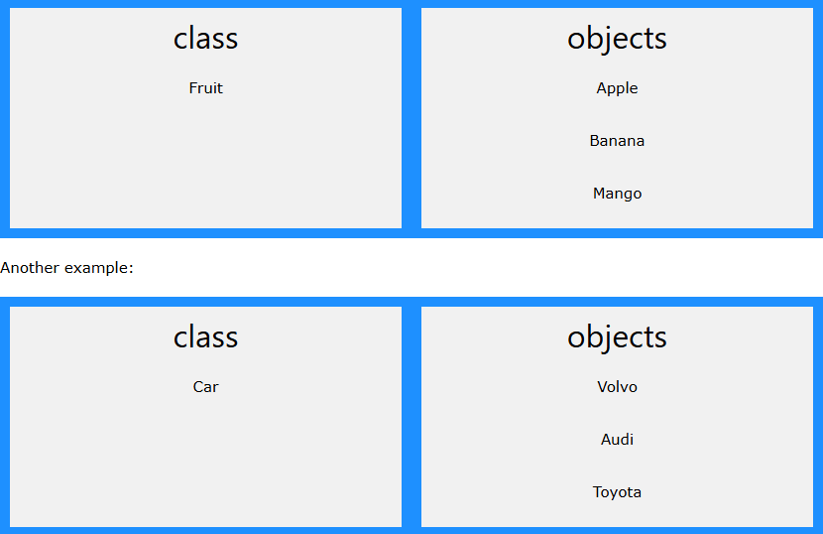
So, a class is a template for objects, and an object is an instance of a class.
When the individual objects are created, they inherit all the properities and behaviors from the class, but each object will have different values for the properities.
Look at the next chapters to learn about OOP.

PHP OOP – Classes and Objects
A class is a template for objects, and an object is an instance of class .

OOP Case
Let’s assume we have a class named Fruit. A Fruit can have properties like name, color, weight, etc. We can define variables like $name, $color, and $weight to hold the values of these properties.

Define a Class
A class is defined by using the class keyword, followed by the name of the class and a pair of curly braces ( {} ) . All its properties and methods go inside braces:
Syntax :
<?php
class Fruit {
// code goes here...
}
?>
Below we declare a class named fruit consisting of two properties ($name and $color) and two methods set_name() and get_name ( ) for setting and getting the $name property:
<?php
class Fruit {
// Properties
public $name;
public $color;

// Methods
function set_name($name) {
$this->name = $name;
}
function get_name() {
return $this->name;
}
}
?>
Note : in a class, variables are called properties and functions are called methods !

Define Objects
Classes are nothing without objects! We can create multiple objects from a class. Each object has all the properties and methods defined in the class, but they will have different property values.
Objects of a class are created using the new keyword .
In the example below, $apple and $banana are instances of the class fruit :
<?php
class Fruit {
// Properties
public $name;
public $color;

// Methods
function set_name($name) {
$this->name = $name;
}
function get_name() {
return $this->name;
}
}

$apple = new Fruit();
$banana = new Fruit();
$apple->set_name('Apple');
$banana->set_name('Banana');

echo $apple->get_name();
echo "<br>";
echo $banana->get_name();
?>
In the example below, we add two more methods to class fruit, for setting and getting the $color property :
<?php
class Fruit {
// Properties
public $name;
public $color;

// Methods
function set_name($name) {
$this->name = $name;
}
function get_name() {
return $this->name;
}
function set_color($color) {
$this->color = $color;
}
function get_color() {
return $this->color;
}
}

$apple = new Fruit();
$apple->set_name('Apple');
$apple->set_color('Red');
echo "Name: " . $apple->get_name();
echo "<br>";
echo "Color: " . $apple->get_color();
?>

PHP – The $this Keyword
The $this keyword refers to the current object, and is only available inside methods
Look at the follwing example :
<?php
class Fruit {
public $name;
}
$apple = new Fruit();
?>
So, where can we change the value of the $name property ? There are two ways:
  - Inside the class ( by adding a set_name ( ) method and use $this ) :
Example
<?php
class Fruit {
// Properties
public $name;
public $color;

// Methods
function set_name($name) {
$this->name = $name;
}
function get_name() {
return $this->name;
}
function set_color($color) {
$this->color = $color;
}
function get_color() {
return $this->color;
}
}

$apple = new Fruit();
$apple->set_name('Apple');
$apple->set_color('Red');
echo "Name: " . $apple->get_name();
echo "<br>";
echo "Color: " . $apple->get_color();
?>
  - Outside the class ( by directly changing the property value ) :
Example :
<?php

class Fruit {
public $name;
}

$apple = new Fruit();
$apple->name = 'Apple';

echo $apple -> name ;

?>

PHP – instanceof
You can use the instanceof keyword to check if an object belongs to a specific class :
Example :
<?php

class Fruit {
public $name;
}

$apple = new Fruit();

var_dump($apple instanceof Fruit); // bool (true)

?>

PHP OOP – Constructor

PHP – The _construct Function
A constructor allows you to initialize an object’s properties upon creation of the object.
If you create __construct() function, PHP will automatically call this function when you create an object from a class .
Notice that the construct function starts with two underscores (__) !
We see in the example below, that using a consturctor saves us from calling the set_name( ) method which reduces the amount of code :
<?php

class Fruit {
public $name;
public $color;

function __construct($name){
$this->name = $name;
}

function get_name(){
return $this->name;
}
}

$apple = new Fruit("Apple");
echo $apple->get_name(); // Apple

Another example :
<?php

Class Car {
public $brand;
public $model;
public $color;

public function __construct($brand, $model, $color) {
$this->brand = $brand;
$this->model = $model;
$this->color = $color;
}

function get_brand() {
return $this->brand;
}
function get_model() {
return $this->model;
}
function get_color() {
return $this->color;
}
}

$first_car = new Car("Toyota", "Corolla", "blue");
echo $first_car->get_brand();
echo $first_car->get_model();
echo $first_car->get_color();

PHP OOP – Destructor

PHP – The __destruct Function
A destructor is called when the object is destructed or the script is stopped or exited.
If you create a __destruct( ) function, PHP will automatically call this function at the end of the script.
Notice that the destruct function starts with two underscores (__)!
The example below has a __construct( ) function that is automatically called when you create an object from a class, and a __destruct() function that is automatically called at the end of the script:
<?php

class Fruit {
public $name;
public $color;

function __construct($name, $color) {
$this->name = $name;
$this->color = $color;
}

function __destruct(){
echo "The fruit is {$this->name} and the color is {$this->color}";
}
}

$apple = new Fruit("Apple", "red");
// The fruit is Apple and the color is red

?>

Observation : as we have seen, there a sentence show on screen without needing to echo it , that made using __destruct ( )
- __constuct inializes the Fruit object.
- __destruct logs a message when the object is done being used.
So yes, __destruct is a convenient place to put code that we always want to ru as we finish with an object. This way, we don’t need to remember to call it manually each time – it’s automatic !

Tip: as constructos and destructos helps reducing the amount of code, they are very useful !

PHP OOP – Access Modifiers
Properties and mthods can have access modifiers which control where they can be accessed .
So , in PHP, access modifiers are keywords that determine the visibility or accessiblity of class properties and methods. They control how the members of a class can be accessed from outside the class. There are 3 main access modifiers in PHP :
  - Public
- Members declared as public can be accessed from anywhere, both inside and outside the class .
Example :
<?php

class Fruit {
public $name;

public function setName($name) {
$this->name = $name;
}
}

// Create an instance
$apple = new Fruit();
$apple->setName("Apple");
echo $apple->name; // Accessible from outside the class
  - Protected
- Members delclared as protected can only be accessed within the class itself and by derived (child) classes. They cannot be accessed from outside the class or from instaces of the class .
Example :
class vehicle
{
protected $engine;

protected function setEngine($engine)
{
$this->engine = $engine;
}
}

$car = new vehicle();
$car->setEngine('gas');
// Fatal error: Uncaught Error: Call to protected method vehicle::setEngine() from global scope in

- Private
- Properties or methods declared as private are only accessible within the class that defines them. They cannot be accessed from outside the class or from subclasses
- Example :

class Login
{
public $username;
private $password;

public function __construct($username, $password)
{
$this->username = $username;
$this->password = $password;
}

public function __toString()
{
return $this->username . ' ' . $this->password;
}
}

$user1 = new Login('username', 'password');
echo $user1 -> username;
echo $user1 -> password;

// username
// Fatal error: Uncaught Error: Cannot access private property Login::$password in C:\xampp\htdocs\Test\welcome.php:26 Stack trace: #0 {main} thrown in C:\xampp\htdocs\Test\welcome.php on line 26

Accessing from a subclass:
class Login
{
public $username;
private $password;

public function __construct($username, $password)
{
$this->username = $username;
$this->password = $password;
}

public function __toString()
{
return $this->username . ' ' . $this->password;
}
}

class User extends Login
{
public function get_password()
{
return $this->password;
}
}

$user1 = new User('username', 'password');
echo $user1 -> username;
echo $user1 -> get_password();

// username
// Warning: Undefined property: User::$password in C:\xampp\htdocs\Test\welcome.php on line 28

PHP OOP – Inheritance

PHP – what is inheritance ?
Inheritance in OOP = When a class derives from anothr class.
The child class will inhrit all the public and protected properties and methods from the parent class.
An inherited class is defined by using the extends keyword.
Let’s look at an example :
class Fruit
{
public $name;
public $color;
public function __construct($name, $color)
{
$this->name = $name;
$this->color = $color;
}
public function intro()
{
return "The fruit is {$this->name} and the color is {$this->color}.";
}
}

// Strawberry is inherited from Fruit
class Strawberry extends Fruit
{
public function message()
{
return "Am I a fruit or a berry? ";
}
}
// Object creation
$strawberry = new Strawberry("Strawberry", "red");
// methods call
echo $strawberry->message() . "<br>";
echo $strawberry->intro(); // this method is inherited from the Fruit class

// output :
// Am I a fruit or a berry?
// The fruit is Strawberry and the color is red.

Example Explained
The Strawberry class is inherited from the Fruit class.
This means that the Strawberry class can use the public $name and $color properties as well as the public __construct() and intro() methods from the Fruit class because of inheritance.
The Strawberry class also has its own method: message().

PHP – overriding Inherited Methods
Inherited methods can be overridden by redefining the methods (use the same name) in the child class.
Look at the example below. The __contruct() and intro() methods in the cild class (strawberry) will override the __construct() and intro() methods in the parent class (Fruit) :
class Fruit
{
public $name;
public $color;

public function __construct($name, $color)
{
$this -> name = $name;
$this -> color = $color;
}

public function intro()
{
echo "The fruit is {$this -> name} and the color is {$this -> color}.";
}
}

// subclass that will override

class Apple extends Fruit
{
public $weight;

public function __construct($name, $color, $weight)
{
$this -> name = $name;
$this -> color = $color;
$this -> weight = $weight;
}

public function intro()
{
echo "The fruit is {$this -> name}, the color is {$this -> color}, and the weight is {$this -> weight}.";
}

}

$strawberry = new Apple("Apple", "green", "1Kg");
$strawberry -> intro();
// the fruit is Apple, the color is green, and the weight is 1Kg.

PHP – The final Keyword
The final keyword can be used to prevent class inheritance or to prevent method overriding.
The following example shows how to prevent class inheritance:
final class Fruit
{
// some code
}

// will result in error
class Banana extends Fruit
{
// some code
}
// Fatal error: Class Banana cannot extend final class Fruit in C:\xampp\htdocs\Test\welcome.php on line 10

The following example shows how to prevent method overriding:
class Fruit
{
final public function intro()
{
// some code
}
}

class Strawberry extends Fruit
{
// will result in error
public function intro()
{
// some code
}
}
// Fatal error: Cannot override final method Fruit::intro() in C:\xampp\htdocs\Test\welcome.php on line 14

PHP OOP – Class Constants

PHP – Class Constants
Class constants can be useful if you need to define some constant data within a class.
A class constant is declared inside a class with the const Keyword.
A constant cannot be changed once it is declared.
Class constants are case-sensitive However, it is recommended to name the constants in all uppercase letters.
We can access a constant from outside the class by using the class name followed by the scope resolution operator ( : : ) followed by the constant name, like here:

Example
class Goodbye
{
public const LEAVING_MESSAGE = "Goodbye, World!";
}

echo Goodbye::LEAVING_MESSAGE;
or, we can access a constant from inside the class by using the self keyword followed by the scope resolution operator ( : : ) followed by the constant name, like here :

Example
class Goodbye
{
public const LEAVING_MESSAGE = "Goodbye, World!";
public function byebye()
{
echo self::LEAVING_MESSAGE;
}
}

$goodbye = new Goodbye();
$goodbye->byebye(); // Goodbye, World!

PHP OOP – Abstract Classes

PHP – What are Abstract Classes and Methods ?
Abstract classes and methods are when the parent class has a named method, but need its child class(es) to fill out the tasks.
An abstract class is a class that contains at least one abstract method. An abstract method is a method that is declared, but not implemented in the code.
An abstract class or method is defined with the abstract keyword

Syntax
abstract class ParentClass {
abstract public function someMethod1();
abstract public function someMethod2($name, $color);
abstract public function someMethod3() : string;
}
When inheriting from an abstract claas, the child class method must be defined with the same name, and the same or a less restricted access modifier. So, if the abstract method is defined as protected, the child class method must be defined as either protected or public, but not private. Aslo, the type and number or required arguments must be the same. However, the child classes
May have optinal arguments in addition.
So, when a child class in inherited from an abstract class, we have the following rules:
- The Child class method must be defined with the same name and it redeclares the parent abstract method.
- The child method must be defined with the same or a less restricted access modifier.
- The number or required arguments must be the same. However, the child class may have optinal argumetns in addition

Explanation :
  - What is an abstract class ?
- An abstract class is a blueprint. You can’t create an object from it directly. Instead, you create objects form other class that extends ( or inherit from ) this blueprint.
  - Why use it ?
- Abstract classes are useful when you want to define general methods or rules but leave specific details to other classes. Think of it like setting up guidelines that every subclass must follow.
- Abstract Methods
- An abstract class can have abstract methods, which are methods that don’t have any code yet. Each class that extedns the abstract class must wirte its own version of these methods.

Simplified Example :
Here’s an example with vehicles:

abstract class vehicle
{
// Abstract method with no code inside
abstract protected function startEngine();

// Regular method with code inside
public function hello()
{
return "hello";
}

}

class car extends vehicle
{
// This class must define startEngine() since it was abstract
public function startEngine()
{
return "Car Engine Strated";
}

}

$car = new car();
echo $car->hello()."\n"; // hello
echo $car->startEngine()."\n"; // Car Engine Strated

Summary
- Abstract class = A blueprint unfinished methods.
- Abstract Methods = A placeholder for methods that mut be completed by subclasses.

More important info :
  - Forces Consistency
Suppose you have different types of animals. Every animal makes a sound, but each one sounds differernt. Using an abstract class, you can ensure that every specific animal (like Dog or Cat) has it onw sound method, even thought the sound is different .
abstract class Animal
{
abstract public function sound();
}

class Dog extends Animal
{
public function sound()
{
echo "Bark";
}
}

class Cat extends Animal
{
public function sound()
{
return "Meow";
}

}

$dog = new Dog();
echo $dog->sound(); // Bark

$cat = new Cat();
echo $cat->sound(); // Meow

in this example, if you tried to create a new animal class without a sound method, PHP would show an error. This forces all subclasses to have their own sound method.
  - Basic Code Sharing
Let’s say all animals sleep, so instead of writing a sleep method in each animal class, you can write it once in the abstract class and let each subclass inherit it automatically.
abstract class Animal
{
abstract public function sound();

public function sleep()
{
return "zzz";
}
}

class Cat extends Animal
{
public function sound()
{
return "meow";
}
}

$kitty = new Cat();
echo $kitty->sound(); // meow
echo $kitty->sleep(); // zzz

Here, we only had to define sleep once in the abstract class, and every subclass can use it without writing it again.
  - Why not just use regular classes ?
f you used regular classes, you wouldn’t get an error if you forgot the sound method in a subclass. But abstract classes help prevent this by requiring all subclasses to have certain methods.
// Using abstract class to make sure every animal has a sound
abstract class Animal
{
abstract public function sound();
}

// If we forget to implement sound(), this will cause an error
class Elephant extends Animal
{
// Missing sound method will throw an error
}

$elephant = new Elephant(); // PHP will throw an error

By making Animal abstract, PHP will ensure that all subclasses (like Elephant) have a sound method, keeping everything consistent and preventing errors.

Example:
<?php
// Parent class
abstract class Car {
public $name;
public function __construct($name) {
$this->name = $name;
}
abstract public function intro() : string;
}

// Child classes
class Audi extends Car {
public function intro() : string {
return "Choose German quality! I'm an $this->name!";
}
}

class Volvo extends Car {
public function intro() : string {
return "Proud to be Swedish! I'm a $this->name!";
}
}

class Citroen extends Car {
public function intro() : string {
return "French extravagance! I'm a $this->name!";
}
}

// Create objects from the child classes
$audi = new audi("Audi");
echo $audi->intro();
echo "<br>";

$volvo = new volvo("Volvo");
echo $volvo->intro();
echo "<br>";

$citroen = new citroen("Citroen");
echo $citroen->intro();
?>
Note : we specify the type of the returned value.
Let’s look at another example where the abstract method has an argument, and the child class has two arguments that are not defined in the parent’s abstract method:
<?php

abstract class ParentClass
{
// Abstract method with an argument
abstract protected function prefixName($name);
}

class ChildClass extends ParentClass
{
// The child class may define optional arguments that are not in the parent's abstract method
public function prefixName($name, $separator = ".", $greet = "Dear")
{
if ($name == "John Doe") {
$prefix = "Mr";
} elseif ($name == "Jane Doe") {
$prefix = "Mrs";
} else {
$prefix = "";
}
return "{$greet} {$prefix}{$separator} {$name}";
}
}

$class = new ChildClass();
echo $class->prefixName("John Doe");
echo "<br>";
echo $class->prefixName("Jane Doe");

PHP OOP – Interfaces

PHP – What are Interfaces ?
Interfaces allow you to specify what methods a class should implement.
Interfaces make it easy to use a variety of different dclasses in the same way. When one or more classes usee the same interface, it is referred to as “polymorphism”.
Interfaces are declared with the interfaces keyword :
<?php

interface InterfaceName
{
public function someMethod1();
public function someMethod2($name, $color);
public function someMethod3(): string;
}

What’s an interface ?
Think of an interface as a set or rules or guidlelines. It tells classes what methods they must have, but it doesn’t incluce any actual code for those methods. Interfaces only have method names, not the details of what each method does.

Why Use Interfaces ?
- Consistency : interfaces ensure that any class following the interface has the same methods.
- Flexibility: Different Classes can implement the same interface and still do things their own way.
- No inheritance Limit : A class can implement the multiple interfaces, which is helpful since PHP only allows a classe to inherit from one other class.

How To create an interface
Use the interface keyword . All methods in an interface are public and must be empty (no code inside )

Example of an Interface
Here’s an example of an interface with a fly method and how it can be implemented by two dfferent classes.
<?php

interface InterfaceName
{
public function someMethod1();
public function someMethod2($name, $color);
public function someMethod3(): string;
}

interface Flyable
{
public function fly(); // Just the method name, no code inside
}

class Bird implements Flyable
{
public function fly()
{
return "The bird is flying!";
}
}

class Plane implements Flyable
{
public function fly()
{
return "The plane is flying!";
}
}

$bird = new Bird();
echo $bird->fly(); // Outputs: The bird is flying!

$plane = new Plane();
echo $plane->fly(); // Outputs: The plane is flying!

Key points
  - Define Methods only : an interface has only method names, no actual code.
  - Must Implement all methods : Any class that uses (or “implements”) the interface must write all the methods listed in the interface.
  - Allows multiple implementatins: A class can use multiple interfaces if it needs to follow different sets or rules.

Quic Summary
- Interface = A list of method names that a class must follow.
- Implementing = writing the code for each method in the interface in the class.

PHP – Interfaces vs. Abstract Classes
Interfaces are similar to abstract classes in some ways, but they have important differences! Let’s compare them to make it super clear.

How Interfaces Are like Abstract Classes
  - Cannot be Instantiated : Just like abstract classes, you can’t create an object directly from an interface.
  - Provide a Blueprint: Both abstract classes and interfaces set up a structure or “rules” for other classes
  - Require certain Methods: Any class that implemetns an interface or inherits from an abstract class must define certain methods.

Key Differences Between Interfaces and Abstract Classes
- Only Method Names in Interfaces:
- Interfaces only have method names with no code. Every method in an interface is empty.
- Abstract classes can have both abstract methods (empty) and regular methods (with code.)
- Properties:
- Abstract classes can have properties (like variables), while interfaces cannot have properties. Interfaces only specify methods.
- Multiple Implementations:
- A class can implement multiple interfaces but can only inherit from one abstract class. This is useful if a class needs to follow different sets of rules.
- Use Case :
- Abstract classes are best when you want to share some actual code along with rules.
- Interfaces : are best when you just need classes to follow a specific structure, without sharing code.

Example of Interface vs Abstract Class
Let’s say we want different things to fly and swim. Here’s how both an abstract class and interfaces could work.
Using Interface :
interface Flyable
{
public function fly();
}

interface Swimmable
{
public function swim();
}

class bird implements Flyable, Swimmable
{
public function fly()
{
echo "I can fly";
}
public function swim()
{
echo "I can swim";
}
}
Using Abstract
abstract class Animal
{
abstract public function swim();
abstract public function fly();

}

class Bird extends Animal
{
public function fly()
{
echo "I can fly";
}
public function swim()
{
echo "I can swim";
}
}

When to Use Each
- Abstract Class: Use if you want to define some methods and share code (like sleep in the example).
- Interface: Use if you only need classes to have certain methods (like fly and swim), without sharing any code.

PHP OOP – Traits

PHP – What are traits ?
PHP only supports single inheritance: a child class can inherit only from one single parent.
So, what if a class needs to inherit multiple behaviours ? OOP traits solve this problem.
Traits are used to declare methods that can be used in multiple classes. Traits can have methods and abstract methods that can be used in multiple classes, , and the methods can have any access modifier (public, private, or protected)
Traits are declared with the trait keyword :
trait TraitName
{
// some code
}

To use a trait in a class, use the use keyword :
class MyClass
{
use TraitName;
}

Let’s look at an example:
trait message1
{
public function msg1()
{
echo "OOP is fun !";
}

}

class Welcome
{
use message1;
}

$obj = new Welcome();
$obj -> msg1();

Example Explained
Here, we declare one trait: message1. Then, we create a class: Welcome. The class uses the trait, and all the methods in the trait will be available in the class.
If other classes need to use the msg1() function, simply use the message1 trait in those classes. This reduces code duplication, because there is no need to redeclare the same method over and over again.

PHP – Using Multiple Traits
Let’s look at another example :
trait message1
{
public function msg1()
{
echo "OOP is fun !";
}

}

trait message2
{
public function msg2()
{
echo "OOP reduces code duplication";
}
}

class Welcome
{
use message1;
}

class Welcome2
{
use message1;
use message2;
}

$obj = new Welcome();
$obj->msg1();
echo "<br>";

$obj2 = new Welcome2();
$obj2->msg1();
$obj2->msg2();

Interface or Traits
Feature | Interface | Trait
Purpose | Set rules for classes | Share reusable code
Method Bodies | No (only method names) | Yes (methods with code)
Multiple Inclusion | Yes, a class can implement multiple interfaces | Yes, a class can use multiple traits
Use Case | Ensure structure across classes | Add functionality to classes without inheritance
When to Use Each
- Use Interfaces: When you need classes to have certain methods, without caring about how they are implemented.
- Use Traits: When you want to share the same methods or functionality across multiple classes.

PHP OOP – Static Methods

PHP – Static Methods
Static methods can be called directly – without creating an instace of the class first
Static methods are declared with the static keyword :
class ClassName
{
public static function staticMethod()
{
echo "Hello World!";
}
}

ClassName::staticMethod(); // Hello World!

What is a static Method ?
A static method is a method that belongs to the class itself, not to an object of that class. This means you can call a static method without creating an object of the class.

Why Use Static Methods?
Static methods are useful when you want a method that :
  - Doesn’t need access to specific object properties.
  - Should be accessible directly from the class,without needing to create an object.
  - Usually performs a task or calculation related to the class but doesn’t rely on instance data.

How to Create a Static Method
You use the static keyword before the method name, like this:
class MathHelper
{
public static function add($a, $b)
{
return $a + $b;
}
}

In this example, add is a static method, meaning we don’t need to create an object of MathHelper to use it.

How to call a Static Method
You can call a static mthod directly from the class using the :: operator, like this:
echo MathHelper::add(5, 10); // Outputs: 15

Static Properties
Just like static methods, you can have static properties. These are variables that belong to the class itself, not any specific object.
class Counter
{
public static $count = 0;

public static function increment()
{
self::$count++;
}
}

Counter::increment();
echo Counter::$count; // Outputs: 1

in this example, $count is a static property that we access with self::$count outside the class.
Key Points
- No $this : Since static methods don’t belong to a specific object, you cannot use $this insie them.
- Accessing Static Members: Inside a static method, use self:: to access other static methods or properties.

Example with both Static and Properties
Here’s an example using both
class BankAccount
{
private static $totalBalance = 0;

public static function deposit($amount)
{
self::$totalBalance += $amount;
}

public static function getBalance()
{
return self::$totalBalance;
}
}

// call static method without creating object
BankAccount::deposit(100);
BankAccount::deposit(250);

echo BankAccount::getBalance(); // output: 350

When to use static methods
Use static methods when :
- The method doesn’t need any object-specific data.
- The functionallity is more related to the class than individual objects

Parent
To Call a static method from a child class, use the parent keyword inside the child class. Here, the static method can be public or protected.
Ex :
class Animal
{
protected static function speak()
{
return "Some sound";
}
}

class Dog extends Animal
{
public static function speak()
{
$parentSound = parent::speak();
return $parentSound . " - specifically, Woof!";
}
}

echo Dog::speak(); // Outputs: Some sound - specifically, Woof!

Key Points :
- Use the parent keyword to call a static a static method from a parent class inside a child class
- The static method in the parent class can be public or protected.
- The parent keyword allows you to access the parent class’s static method, even if it’s overridden in the child class.

How it works
  - Access control: since the speak method in animal is protected, only Animal itself and any of its subclasses (like Dog) can access it . if speak were private Dog wouldn’t be able to access it.
  - Parent:: keyword : inside Dog, we use parent::speak() to call the speak method from Animal. This allows the child call to reuse and extend the functionality of the parent’s static method.

PHP OOP – Static Properties

PHP – Static Properties
Static properties can be called directly – without creating an instance of a class.
Static properties are declared with the static keyword:
class ClassName
{
public static $staticProp = "W3Schools";
}
To access a static property use the class name, double colon (::), and the property name:
ClassName::$staticProp;
( we will stop here, because we already speak about it, in the last chapter )

PHP Namespaces

PHP Namespaces
Namespcaces are qualifieres that solve two different problems :
- They allow for better organization by grouping classes that work together to perform a task .
- They allow the same name to be used for more than one class.
For example, you may have a set of classes which describe an HTML table, such as table, Row and cell while also having another set of classes to describe furniture, such as Table, Chair and Bed. Namespaces can be used ot organize the classes into two different groups while also preventing the two classes talble and table from being mixed up.

Declaring a Namespace
Namespaces are declared at the beginning of a file using the namespace keyword :
Syntax
<?php

namespace Html;

Note : A namespce declaration must be the first thing in the PHP file. The following code would be invalid :
-----------------------------------------BAD-------------------------------------------------------------------------------
<?php
echo "Hello World!";
namespace Html;
...
?>
Constants, classes and function declared in this file will belong to the Html namespace
Example :
Create a Table class in the Html namespace :
<?php

namespace Html;

class Table
{
public $title = "";
public $numRows = 0;
public function message()
{
echo "<p>Table '{$this->title}' has {$this->numRows} rows.</p>";
}
}

$table = new Table();
$table->title = "My table";
$table->numRows = 10;
?>

<!DOCTYPE html>
<html lang="en">

<head>
<meta charset="UTF-8">
<meta name="viewport" content="width=device-width, initial-scale=1.0">
</head>

<body>
<?php $table->message(); ?>
</body>

</html>
For further organization, ,it is possible to have nested namespaces :
Syntax :
Declare a namespace called Html inside a namespace called Code :
<?php

namespace Code\Html;

Using Namespaces

Accessing a Namespaced class
If you want to use a namespaced class, you have a few options :
- Full Path : Use the full namespace path each time you can call it.
$logger = new MyProject\Utilities\Logger();

- Use Statement : import the namespace with use, so you don’t have to write the full path each time.

use MyProject\Utilities\Logger;

$logger = new Logger();

Aliases (Shortcut Names )
You can create an alias for a class or namespace to make the code shorter
use MyProject\Utilities\Logger as Log;

$logger = new Log(); // Now "Log" is a shortcut for "MyProject\Utilities\Logger"

Global Namespace
You can create an alias for a class or namespace
use MyProject\Utilities\Logger as Log;

$logger = new Log(); // Now "Log" is a shortcut for "MyProject\Utilities\Logger"

Global Namespace
If you want to refer to a class or function outside of any namespace (PHP’s built-in classes like Exception), you can use the global namespace by adding a backslash (\) at the beginning:
$exception = new \Exception("Something went wrong!");

Example of Namespaces in Action
Here’s a more complete example to see how namespaces help :
<?php

// File: MyProject/Utilities/Logger.php

namespace MyProject\Utilities;

class Logger
{
public function log($message)
{
echo "Log message: $message";
}
}

// File: MyProject/Database/Connection.php

namespace MyProject\Database;

class Connection
{
public function connect()
{
echo "Connecting to the database.";
}
}

// Main File
use MyProject\Utilities\Logger;
use MyProject\Database\Connection;

$logger = new Logger();
$logger->log("Starting application.");

$db = new Connection();
$db->connect();

Here, both Logger and Connection are organized into different namespaces (MyProject\utilities and MyProject\Database), but we can access them easily using use.

Quick summary
- Namespace = A “folder” for organizing classes, functions, and constants.
- Use Statement = Import a namespace so you don’t have to use the full path each time
- Aliases = Shorten namespcace names with as for convenience.
- Global Namespace = Access Global PHP classes or functions with a \a .
Namespaces keep your code organized and help you avoid name conflicts in larger projects.

The Problem without Namespaces
Imagine you’re working on a big project that incluces :
- Multiple libraries : ( code written by other developers)
- Different modules in you codebase (e.g, user management, produt catalog, etc.)
In this case, it’s common to have multiple classes, functions, or constants with the same name. For example, both a User class in the User Management module and another User class in a customer module could conflict if they have the same name.
Without namespaces, if you tried to declare or use both User classes in the same project, PHP would not know which one to refer to,leading to errors.
Namespaces act like separate “folders” for classes, functions, and constants allowing identical names to coexist without conflict.

PHP Iterable

PHP – What is an Iterable ?
An iterable is any value which can be looped through with a foreach () loop.
The iterable pseudo-type was introduced in PHP 7.1, and it can be used as a data type for function argumetns and functin return values.
Iterables are data structures that you can loop through, like arrays or objects implementing the Traversable interface. They let you handle different types of collectoins with a unified approach, making your code simpler and more flexble.
An iterable in php is any value that you can loo over using foreach . it can be :
  - Arrays : Standard arrays .
  - Objects implementing Traversable : These are objects that implement either the Iterator or IteratorAggregate interfaces.
In PHP 7.1 and later, iterable is also a type hint that can be used in function parameters and return types to specify that the the value should be iterable.

Why use iterables ?
Using iterable in your function parameters or return types allows you to write functions that can handle any loopable data, not just array. This can make your code more flexible and able to hanlde a wider variety of inputs.

Basic Example of using Iterable Type Hints تلميحات حول النوع
Let’s look at a function that accepts an iterable type. It could take either an array or an object that implements Traversable (like a generator or custom iterator) .
function printItems(iterable $items)
{
foreach ($items as $item) {
echo $item. PHP_EOL;
}
}

printItems(['a', 'b', 'c']);
// output: a
// b
// c
Note: so as you see iterable is the parameter data type
// Function to print items from an iterable
function printItems(iterable $items)
{
// Loop through each item in the iterable
foreach ($items as $item) {
// Print the item
echo $item . PHP_EOL;
}
}

// Example usage of the printItems() function
$array = [1, 2, 3];
printItems($array);
// Output: 1
// 2
// 3

// Class that implements the IteratorAggregate interface
class MyCollection implements IteratorAggregate
{
// Private property to store the items
private $items;

// Constructor to initialize the items
public function __construct($items)
{
$this->items = $items;
}

// Method to get an iterator for the items
public function getIterator(): Traversable
{
// Return an iterator for the items
return new ArrayIterator($this->items);
}
}

// Example usage of the MyCollection class
$myCollection = new MyCollection([4, 5, 6]);

// Get an iterator for the items in the MyCollection instance
$iterator = $myCollection->getIterator();

// Loop through each item in the iterator
foreach ($iterator as $item) {
// Print the item
echo $item . PHP_EOL;
}
// Output: 4
// 5
// 6

In this example :
- printItmes takes an iterable parameter, so it can accept both $array and $collection.
- MyCollection is a custom class that implements Traversable using ItertorAggregate, so it can also be used as an iterble.

Returning an Iterable
You can also specify iterable as a return type, which is useful when you want to return either an array or another loopale collection.
function getItems(): iterable
{
return [1, 2, 3];
}

foreach (getItems() as $item) {
echo $item . PHP_EOL;
}

Common use Cases for iterables
  - Generators: Generators are functions tha use yield to produce values one at a time, which can save memory. Generators are iterables in PHP .

Generators
Generators in PHP provide an easy way to create iterable sequences without needing to store everything in memory. They’re like a “lazy” way to generate values, one at a time, using the yield keyword instead of return . This is super efficient when working with large data sets.

Why Use Generators ?
When you have a large amount of data to loop over, storing it all in memory at once can be inefficient or even impossible. Generators produce values one at a time as you request them, which means they save memory and can improve performance.
Basic Example of a Generator
Here’s a simple example of how a generator works:
function generateNumbers()
{
yield 1; // First time called, returns 1
yield 2; // Second time called, returns 2
yield 3; // Third time called, returns 3
}

// Using the generator
foreach (generateNumbers() as $number) {
echo $number . PHP_EOL; // Outputs 1, then 2, then 3
}

What’s Heppening Here ?
- Yield: This keyword produces a value each time the generator is called.
This of it as a “pause” that rememebers where it left off, so when the generator is called again , it resumes from the next yield.
- Foreach loop: Each time the foreach loop requests the next value, the generator runs until the next yield is reached.
So, with yield, you’re producing values one at a time without building and storing an entire array in memory.
Comparing yield with return
- Yield gives one value at a time and remembers its position for the next call
- Return would send all values back at once, which uses up memory to store everything in advance.
Using Yield in a generator is perfect for handling large or infinite sequences, such as reading lines from a big file or generating a long list of numbers.

Summary
- Generators let you loop over data one piece at a time.
- They use yield to produce valus as needed.
- They’re great for saving memory when working with large data sets.

How Generators save Memory
Suppose you need to create a function that returns numbers from 1 to 1 million. You could either:
- Use a generator to yield each number one by one.
- Use an array to store all 1 million numbers in memory and return that array.
1. How an Array Uses Memory
If you use an array to generate numbers up to 1 million, here’s what happens:
- The function creates an array with 1 million items.
- It stores each number in memory, meaning it has to allocate space for all 1 million numbers at once.
- For very large datasets, this can consume a lot of memory, potentially slowing down your program or even causing memory errors.
If you needed a function to generate numbers up to 1 million, a generztor would be fr more efficient that returning an array with a million items.
( continue searishing in vs code ai )

PHP – Using Iterables
The iterable keyword can be used as a data type of a function argument or as the return type of a function :
Example :
Use an iterable function argument

Php date and time
The PHP date ( ) function is used to foramt a date and/or a time.

The PHP date ( ) function
The PHP date ( ) function formats a timestamp to a more readable date and time.
Syntax :
Date ( format , timestamp )
Parameter | Description
format | Required. Specifies the format of the timestamp
timestamp | Optional. Specifies a timestamp. Default is the current date and time.

A timestamp is a sequence of characters, denoting the date and/or time at which a certain event occurred.

Get a Date
The required format parameter of the date() function specifies how to format the date ( or time )
Here are some characters that are commonly used for dates :

- d – Represents the day of the month (01 to 31 )
- m – Represents a month (01 to 12 )
- Y – Represents a year (in four digits )
- l (lowercase ‘L’) – Represents the day of the week

Others characters, like ‘/’, “.” Or “-“ can also be inserted between the characters to add additional formatting.
The example below formats today’s date in 3 different ways :
// it like a simple text and Y d m are variabes to be repleced inti .

echo "Today is ". date("Y d m")."\n"; // Today is 2024 18 11
echo "Today is ".date('l')."\n"; // Today is monday
echo "Today is ".date('L'); // Today is 1

Get a Time
Here are some characteres that are commonly used for times:
- H – 24-hour foramt of an hour (00 to 23)
- H – 12-hour format of an hour with leading zeros (01 to 12 )
- i - Minutes with leading zeros ( 00 to 59 )
- s – Seconds with leading zeros ( 00 to 59 )
- a – Lowercase Ante meridiem and Post meridiem (am to pm )
The example below outputs the current tme in the specified format :
echo "The time is ". date("h:i:s A")."\n"; // The time is 12:30:07 PM

echo "The time is ". date("h:i:s a")."\n"; // The time is 12:30:43 pm

echo "The time is ".date("H:i")."\n"; // 12:33

Note that the php date () functin will return the curent date/time of the server !

Get Your Time zone
If the time you got back from the code is not correct, it’s probably because you server is in another country or set up for a different timezone.
So , if you need the time to be corrent accorinding to a specific location, you can set the timezone you want to use.
The example below sets the timezone to “America/New_York”, then outputs the current time in the specified format:
date_default_timezone_set("America/New_York");
echo "Today date : ".date("h:i"); // 06:45
// not my qu time is 12:45

Create a Date With mktime ( )
The optional timestmp parameter in the date() function specifies a timestamp. If omitted, the current date and time will be used ( as in the examples above ) .
The PHP mktime ( ) function returns the Unix timestamp for a date. The Unix timestamp contains the number of seconds between the Unix Epoch (January 1 1970 00:00:00 GMT) and the time specified.
Syntax
mktime(hour, minute, second, month, day, year)
The example below create a date and time with date()

Elzro notes

/*

- date_default_timezone_get()

- date_default_timezone_set(timezone [Required])

- date_create(Date/Time[optional], Timezone[optional])
---- * Time: Date/Time String || Current Time If NULL
---- * Timezone: Timezone String || Current Timezone If NULL
------ > returns DateTime object

- Timezone List: http://php.net/manual/en/timezones.php

- timezone_open(Timezone)
---- > returns Timezone Object

- checkdate(M, D, Y) ==> All Required
---- Validate Date
---- syntax : checkdate(month, day, year)
------> returns Boolean

*/

// Get Timezone
echo date_default_timezone_get()."<br>";

// Print Date and Time

echo date("Y-m-d H:m:s") . "<br>"; // not my time, so set the time zone

// setting time zone , i live in tangier morocco

date_default_timezone_set("Africa/Casablanca");

echo date_default_timezone_get()."<br>"; // Africa/Casablanca

echo date("Y-m-d H:m:s")."<br>";

// create date object

$d = date_create("", timezone_open("America/New_York"));

// Echo date with format

echo date_format($d, "Y-m-d H:m:s")."<br>";

// check date

var_dump(checkdate(2, 30, 2024));
// bool(false) -- invalid date , february has only 29 days
echo "<br>";
var_dump(checkdate(10, 30, 2024)); // bool(true)

Cookies

What are cookies
Cookies are small files stored on your device by websites you visit. They help websites remember information about you, like your login details, preferences, and items in your shopping cart. This makes your browsing experience smoother and more personalized. There are different types of cookies, including:
- Session Cookies: Temporary and deleted when you close your browser.
- Persistent Cookies: Remain on your device for a set time.
- First-party Cookies: Created by the site you're visiting.
- Third-party Cookies: Set by other sites, often for tracking and advertising.

Types of Cookies in Detail
- Session Cookies
  - Duration: Temporary; erased when you close your browser.
  - Use Case: Online shopping sites use them to keep track of items in your cart while you’re still shopping.
- Persistent Cookies
  - Duration: Remain on your device for a specified period, even after closing the browser.
  - Use Case: Websites like social media platforms keep you logged in for weeks or months using persistent cookies.
- First-party Cookies
  - Origin: Set by the domain you’re visiting.
  - Use Case: A news website might use first-party cookies to remember which articles you’ve read.
- Third-party Cookies
  - Origin: Set by domains other than the one you’re visiting, often used for advertising and analytics.
  - Use Case: If you see an ad for shoes on one site and then later see similar ads on other sites, that’s due to third-party cookies.

Managing Cookies
You can manage cookies through your web browser settings. Here’s how:
- View Cookies: Most browsers allow you to see what cookies are stored.
- Delete Cookies: You can clear cookies from your browser, either selectively or all at once.
- Block Cookies: You can set your browser to block third-party cookies, which can enhance privacy.
- Incognito Mode: Using this mode can prevent cookies from being saved after your browsing session ends.

Types of Cookies examples
- Session Cookies
  - Example: When you log into your bank account, a session cookie keeps you logged in while you navigate the site. Once you close the browser, the cookie disappears.
- Persistent Cookies
  - Example: If you select your language preference on a website, a persistent cookie saves that choice for future visits, so you don’t have to set it every time. It stays on your device for a set period.
- First-party Cookies
  - Example: If you visit an online store and it remembers your shopping cart items, that’s a first-party cookie from that store.
- Third-party Cookies
  - Example: When you see ads on a website that follow you to other sites, those ads use third-party cookies to track your interests and activity across the web.

Why Are They Useful?
- Convenience: Cookies remember your login info and preferences, saving you time.
- Personalization: They help websites show you relevant content and ads based on your past behavior.

What is a Domain?
A domain is the web address you use to access a website. It helps people find websites easily without remembering long numbers..

Key Points About Domains
- Structure:
  - A domain typically consists of two main parts:
    - Second-Level Domain (SLD): This is usually the name of the organization or website (e.g., example in example.com).
    - Top-Level Domain (TLD): This is the extension that follows the SLD (e.g., .com, .org, .net).
- Hierarchy:
  - Domains are organized hierarchically. For example, in sub.example.com, sub is a subdomain of example.com.
- Function:
  - Domains translate into IP addresses, which are numerical labels that identify devices on a network. This translation is done by the Domain Name System (DNS).
- Examples:
  - Website Domain: www.example.com (accessing the main site).
  - Subdomain: blog.example.com (accessing a specific section of the site).
- Domain Registration:
  - Domains need to be registered through a domain registrar. Once registered, the owner has control over that domain and can create websites, set up email addresses, etc.

Summary
A domain is essentially the address you type into a web browser to reach a website. It makes it easier for users to find and remember websites compared to using numerical IP addresses. If you have more questions or need further clarification, let me know!

Using a Domain vs. Full URL

Domain:
  - A domain (like example.com) is the main part of the web address.
  - It usually points to the homepage of a website.

Full URL:
  - A full URL (like https://www.example.com/page1) includes the domain plus additional details (like the specific page or resource).
  - It directs you to a specific location on the website.

When to Use Each
- Use the Domain:
  - When you want to go to the homepage or when you’re sharing the website with someone (e.g., telling them to visit example.com).
- Use the Full URL:
  - When you want to link to a specific page or resource within the site (e.g., linking directly to a blog post).

Summary
- A domain is simpler and easier to remember for general access, while a full URL provides specific directions to a certain part of a website. Let me know if you have more questions!

Setting a cookie
Creating cookies in php is strighforward! You uset the setcookie ( ) functin . here’s how can do it :
setcookie(name, value, expiration, path, domain, secure, httponly);
Parameters :
Name : the name of the cookie.
Value : the value of the cookie
Expiration: the time the cookie expires ( in seconds since th unix epoch). Use time ( ) + seconds for a future date.
Path : the path on the server where the cookie is availiable. Use ‘/’ for the entire domaine.
Domaine : the domain that the cookie is available to .
Secure : if true, the cookie is only sent over secure connectins (HTTPS )
Httponly : if true, the cookie is acccessible only through the HTTP protocol, o via js
Example :
setcookie("style","dark");
this cookie will be deleted after session end, because time is setted to 0 .(it the default value).
Note : the cookie well not be lost if a option is on in google, on startup :
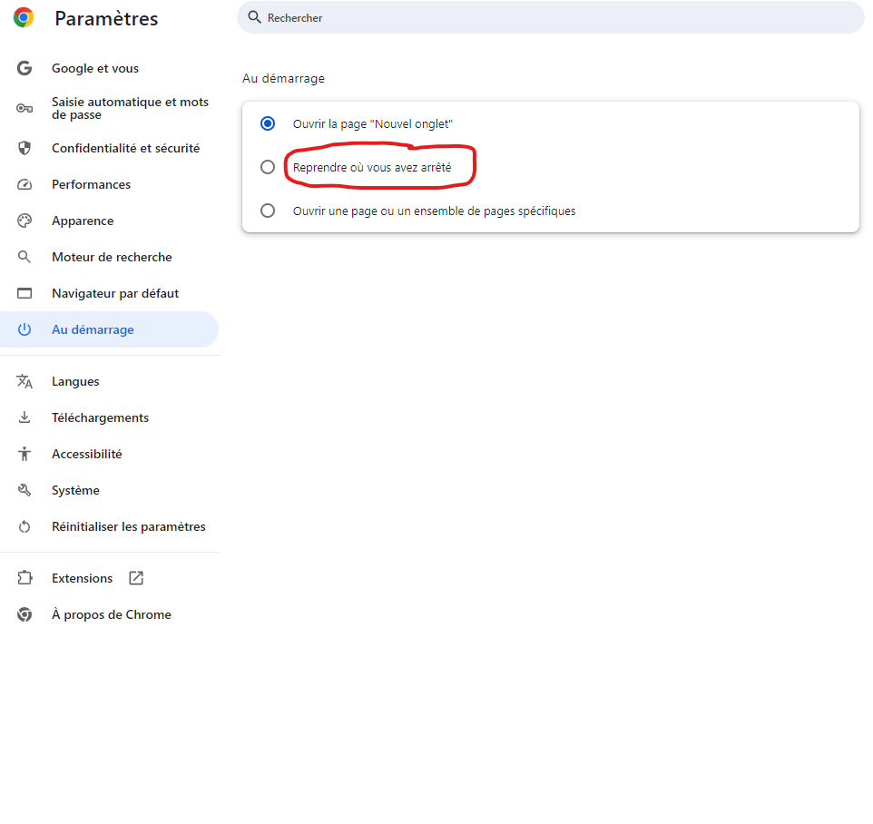

Accessing a website cookie
To accesse the cookies file of a website , f12 then applicatoin then cookies 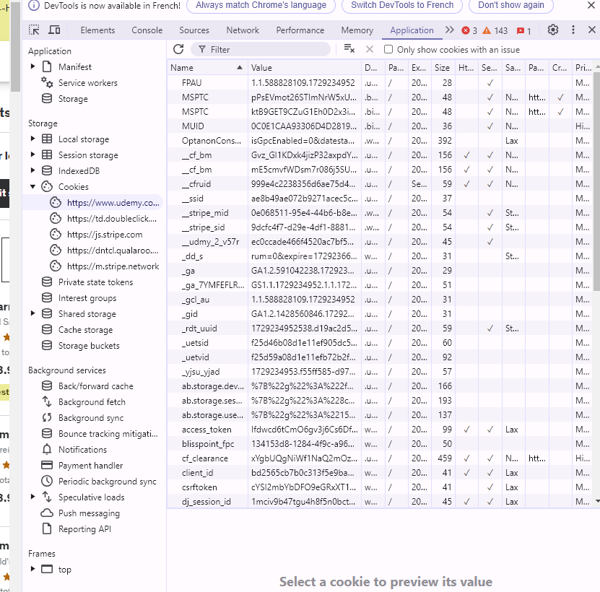

Cookies well understand :
Look well :
setcookie("style","dark");

echo "<pre>";
print_r($_COOKIE);
echo "</pre>";

echo $_COOKIE['style'];

// Array
// (
// )

// Warning: Undefined array key "style" in C:\xampp\htdocs\Test\index.php on line 16

The reason of seiing this behabiour is because of how cookies work in php.
When you call setcookie (“style”, “dark”); , you’re instructing the browser to set a cookie name “style” with the value “dark”. However, this doesn’t immediately set the cookie in the $COOKIE superglobal array.
The $_COOKIE array is populated by PHP based on the cookie that are sent by the broser in the request headers. When you call setcookie ( ) , you’re only sending a resoponse header to the browser, telling it to set the cookie. The cookie isn’t actually set until the browser receives the response and stores the cooie.
In you case, when you call print_r($_COOKIE); immediately after setcookie(‘style”, “dark”), the browser hasn’t had a chance to receive the response and store the cookie.
When you try to access $_COOKIE[“style”] , php throws a warning because the key ‘style’ doesn’t exist in the $COOKIE array yet .
To see the cookie value, you need to refresh the page or make another requet t the server. This willl allow the browser to send the cookie back to the server, and the $_COOKIE array will be populated with the cookie value.
setcookie("style", "dark");

// Refresh the page or make another request to the server
header("Refresh:0");

echo "<pre>";
print_r($_COOKIE);
echo "</pre>";

echo $_COOKIE['style'];

modify
// the cookie is already exist

// setcookie("style", "dark");

// now let modify the cookie
setcookie("style", "light",strtotime("+1 day"));
and also the modify applied after reloading:

deleting
to delet a cookie in php, you can use the setcookie() functin with an expiration time in the past. This will instuct the browser to delete the cookie

setcookie("style", "", time() - 3600);
the concept is : for deleting a cookie is simply with making it expiration date have passed.

Adding array
Look :
setcookie("style[font-size]", "20px", time() + 3600);
setcookie("style[color]", "red", time() + 3600);
setcookie("style[background-color]", "yellow", time() + 3600);
setcookie("style[font-family]", "Arial", time() + 3600);

setcookie("userInfo[gender]","male", time() + 3600);
setcookie("userInfo[age]","25", time() + 3600);
setcookie("userInfo[city]","karachi", time() + 3600);

echo "<pre>";
print_r($_COOKIE);
echo "</pre>";

// Array
// (
// [style] => Array
// (
// [font-size] => 20px
// [color] => red
// [background-color] => yellow
// [font-family] => Arial
// )

// [userInfo] => Array
// (
// [gender] => male
// [age] => 25
// [city] => karachi
// )

// )

Isset
The isset ( ) function in php is used to check if a variable is set and is not NULL . it returns TRUE if the variable is set , and false otherwise;
$a = 'hello';
$b = NULL;

var_dump(isset($a)); // bool(true)
echo "<br/>";
var_dump(isset($b)); // bool(false)

observation
chat gpt told me , that is a clever observaton hhhh .
when you clear cookies from the console application, you’re onl clearing the cookies that are sotred in the browser’s memory. However, when you refresh the page, the browser sends a new request to the server, and the server may be setting the cookies again.

Cookies practice :
if (isset($_COOKIE["backgound"])) {
echo "<style>body{background-color:" . $_COOKIE["backgound"] . "}</style>";
}

if ($_SERVER["REQUEST_METHOD"] == "POST") {
setcookie("backgound", $_POST["bg-color"], strtotime("+1 year"));
header("Location: ". $_SERVER["REQUEST_URI"]);
exit();
}

?>

<form action="app.php" method="post">
<input type="color" name="bg-color">
<input type="submit" value="Choose color">
</form>

Sessions

What are sessions
Sessions are a way to store and retrieve data across multiple requests for a specific use. They allow you ro maitain user-specific information througout their interaction with your website or application.

How do session work ?
When a session is started, PHP generates a unique session ID and stores it in a cookie on client-side. This sesssion ID is used to identify the session on subsequent request. The session data is stored on the server-side by default, but you can configure it to use other storage methods like a database or memcached
Here’s a high-level overview of how sessions work:
    - The user requests a page that requires session data
    - If a session ID cookie is not present, PHP generates a new session ID and sends it as a cookie to the user’s browser.
    - If a session ID cookie is present, PHP retieves the session data associated with that session ID
    - The session data is stored on the server side, and php uses the sesson id to retrieve and store data.
    - Subsequnet request from the same user include the session ID cookie, allwing PHP to retrive the session data.
    - You can store and retrive data in the session using the $_SESSION superglobal array.

Session security
Session security : it’s important to consider seesion seccurity t protect user data some besg practices include :
- Regenrating session IDs to prevent session hijacking
- Validation session data to prevent tampering
- Using secure cookies and HTTPS to protect session data in transit
- Destoring sessions when they are no longer needed .

Session management function
Session management functions : PHP provides various funcitons for managing sessions , including :
- Session_start ( ) : initiales a session or resumes an exisring one.
- Session_destroy ( ) : desgroy the curent
- Session_unset() : unsets all session variables
- Session_is_registred ( ) : checks if a session variable is set.
Session security in a Nutshell :
    - Regenerate session IDs: change the session ID after a user logs in to prevent session hijacking
    - Use secure cookeis : set he secure falg on seesion cookies to ensure the’re trasmitted over HTTPS
    - Use HTTPS : encrypt data in transit to prevent eavesdropping.
    - Validate session data : check session data for tampering or corruption. تلاعب أو فساد
    - Destroy sessoin : ends sessions when user log out or after oa periosd of inactivity .
That it
session_start();// Regenerate session ID after login
session_regenerate_id(true);

// Set secure cookie flag
session_set_cookie_params(0, '/', '', true, true);

// Validate session data
if (!isset($_SESSION['username']) || $_SESSION['username'] !== 'expected_value') {
// Handle invalid session data
}

// Destroy session on logout
session_destroy();

what is hijacking ?
“Hijacking” is a term used to describe the act of taking cntrol of something, usually without permission or authority. In the contect of session security, “session hijacking” refers to the act of an attacker taking control of a fuser’s session, usually by stealing or guessing the session ID
Here’s a simple example:
  - A user logs in to a websit eand is assigned a session ID.
  - An attacker intercepts or guesses the session ID
  - The attacker uses the stolen session ID to access the user’s account, pretending to be the legitimate user.
Hypothetical exaple:
Let’s say yo hve a website with a login system , and a user , john, logs in with his credentials. The website assigns john a seesion ID, which is tored in a cookie on his browser.
The session ID might look something like this : PHPSESSID=1234567890abcdef
An attacker, let’s call him “Malicious mike مايك الخبيث”
Want to take control of john’s session. Mike might try to do the follwing:
- Steal the session ID : mike could try to setel the session id from joh’s browser using various methods, such as :
- Phishing: mike sends john a fake email or link that tricks him into revealing his session ID .
- Malware: mike infects john’s computer with malware that caputres the session ID;
- Sniffing : mike uses a network sniffer to capture the sesion id as it’s transmitted betwenn john’s browser and the webstie.
- Use the session ID : once mike has the session ID , he can try to use it to access john’s account. Mike might send a request to the website with the stolen sessoin ID, pretending to be john .

Session practice
// app.php
session_start();
$_SESSION['name'] = 'bilal';
$_SESSION["id"] = 1979;

echo "<pre>";
print_r($_SESSION);
echo "</pre>";

echo "<a href='test.php'>test</a>";
observation :

session_start();

echo session_id();

echo "<br>";
even if I refrech I get the same ID :
when you call session_start( ), PHP checks if a session already exists. If it does, it resumes that session. If it doesn’t, it creates a new one.
The session_id() function returns the ID of the current session.
When you refresh the page, php checks for an existing session again. Since the session already exist (because you didn’t close it or destroy it) , PHP resumes the same session, and therefore returns the same sessoin ID.
This is how sessions work: they allwo you to store data across multiple requests, ad the sesson ID is used to identify the session.
If you want to test that the session is working coorectly, you can try storing some data in the sesion and thern rerieving it on the next request .
session_start();
echo session_id()."<br>"; // kljmhlif3j3nepegbj1i1o1g34

if (!isset($_SESSION['user'])) {
$_SESSION['user'] = 'Bilal';
}
echo "welcome " . $_SESSION['user']; // welcome Bilal
echo "<br>";
session_destroy();
// start new session
session_start();
echo session_id()."<br>"; // kljmhlif3j3nepegbj1i1o1g34
echo "welcome " . $_SESSION['user']; // warning : undefined array kay “user”
as you have seen , although I destroy the session, I get the same sesson ID.
The session ID is stored in a cookie on the client’s browser. This cookie is called the “session cookie” or “PHPSESSID” cookie.
When you call seession_start()j, php checks if a session exists on the client’s browser. If it does, PHP uses the session ID stored in the cookie to resume the session. If it doesn’t, PHP generates a new sessoin ID, creates a new session, and sets the session cookie on the client’s browser.
The session cookie typically has the following characterstics:
- Name : PHPSESSID (or a custom name set by the PHP configuration)
- Value: the sessoin ID
- DOMAIN: the of the website
- Path : the path of the website
- Expires: the expiration date of the cookie (usually set to a short perios, such as 30 min )

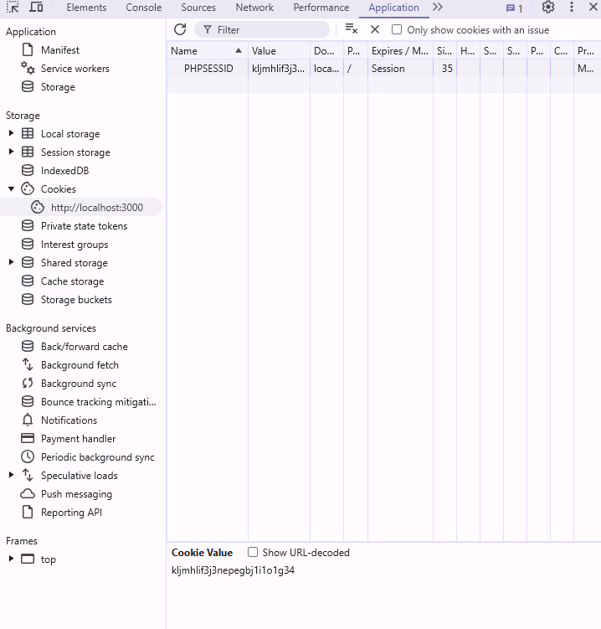
But as you saw, even If we destroy we reconect the same sessoin, but when I tries to access a data stored in the old sessoin I get an error.
Because the session data is not persistng لا يستمر after calling session_destroy().
When you call session_destroy(), it destroys the session and all associated sesson data. However, the sessoin cookie remain on the clien’s brower.
If you want to ensure that a new session is created, you can call session_regenerate_id(true) after calling session_destroy( ) . this will generate a new session ID and update the session cookie.
Here’s an example :
session_start();
echo "Session ID : ".session_id() . "<br>";
// Session ID : 8vpbs6hh692kc61rvke0dpf2ai
session_destroy();

// _____________________________________

session_start();
session_regenerate_id(true);
echo "Session ID : ".session_id() . "<br>";
// Session ID : nfc7o9aj0lhm11au11sjr7othv
session_destroy();

You can enter urself session ID :
// before session start, you can specify session id yourself
session_id("5654g45sg4gq5");
session_start();
echo "Session ID : ".session_id() . "<br>";
// Session ID : 5654g45sg4gq5
Practice :
Calculate number of views:
Index:
session_start();
isset($_SESSION['username']) ? $_SESSION['username'] : $_SESSION['username'] = "Guest";
echo "Seesson id: " . session_id() . "<br>";

isset($_SESSION['views']) ? $_SESSION['views']++ : $_SESSION['views'] = 1;
echo "Hello " . $_SESSION['username'] . ", you have visited this page " . $_SESSION['views'] . " times.";

echo "<br> <a href='about.php'>about</a>";
about:
session_start();
echo "Seesson id: " . session_id(). "<br>";
isset($_SESSION['views']) ? $_SESSION['views']++ : $_SESSION['views'] = 1;
echo "Hello " . $_SESSION['username'] . ", you have visited this page " . $_SESSION['views'] . " times.";
echo "<br> <a href='index.php'>Home</a>";
note :
we didn’t destroy the session , for that we can access data saved on it after refreshing.
When you’re using XAMPP on windows, the session ID is stored in a file on your local machine .
By default, XAMPP stores session files in the follwing directory :
C:\xampp\tmp
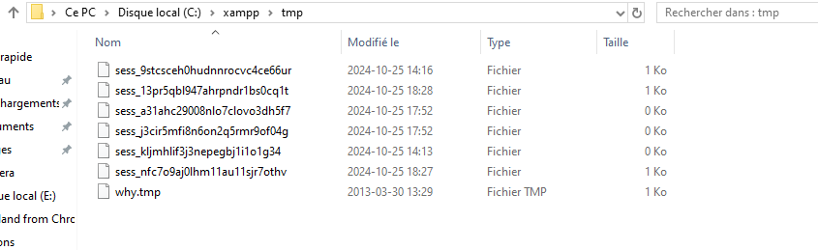
This file contain session data :
views|i:3;username|s:5:"Guest";

session_unset( )
session_unset ( ) is used to unset all session variables. It clears all the data stored in the session, but it does not destroy the session itself
when you call session_unset(), it:
  - Unsets all session variables
  - Leaves the session id intact
  - Does ot destroy the session file on the serer

Login simulation

Header
“Raw HTTP” refers to a direct message from the server to the browser, telling it what to do next. It’s like plain text instruction that conrols thing like:
- Redirects: “go to this other page instead”
- Content type : “this page is an image, not HTML”
- Authentification: “you need to log in to access this page”
- Caching : “don’t store this page in your cache”
These messages are sent before the browser loads the page, and they help the browser understand how to handle the page’s content.
Think of it like a set of instructions that the server sends to the browser, saying things like :
- “Hey, go to this other URL instead of the one you requested”
- This page is a PDF , not an HTML page, so render it accordingly”
- You need to log in before you can access this page”
- “don’t store this page in you cache, because it’s informatiion”
Raw HTTP headers are an important part of how the web works , and they help ensrue that pages are loaded correctly and securely.
In PHP, the header() function is used to send a raw HTTP header to the client.
Header :
- Send RAW HTTP Header to Client to manipulate info sent by web server Before any output
- You can use to control cache or force fille dowload.
Syntax:
Header( Header [Required], Replace[optional] = True, response_code[optoinal])
There are many types of headers that can be set using the header () function.
Let’s take some examples :
header ( "HTTP/1.0 404");
this sends a raw HTTPS header to the client, specifying the HTTP version (HTTP/1.0) and the status code (404). This indicates that the
header ( "HTTP/1.0 404");
this sends a raw HTTP header to the client, specifying the HTTP version (HTTP/1.0) and the staus code (404). This indicates that the requested page could not be found
header("cache control: no-cache, must-revalidate");
this sets the cache-control header, which controls how the client caches the response. In this case:
- No-cache : tells the client not to cache the response.
- Must-revalidate: tells the clinet to always revalidate the response with the server, even if it has a valid cache entry.
In short this header tells the clinet : “don’t cache this response, and always check with the server for the latest version”
header("Expires: Mon, 26 Jul 1997 05:00:00 GMT");
this sets the Expires header, which specifies the date and time after which the response is considered stale. In this case, the date is set to a point in the past( Mon, 26 Jul 1997 05:00:00 GMT).
The date header("Expires: Mon, 26 Jul 1997 05:00:00 GMT"); e is in the past, wich means that the response is already expired.
Think of it like a food expiration date. If a food has an expiration date. If a foodhas an expiraton date of 1997, it’s already past its expiraton, and you wouldn’t want to eat it .
( I did not understand )

Header : redirect
- When you use an anchor tag (<a href='test.php'>test</a>), the browser will create a new entry in its history, so you can use the back button to go back to the previous page.
- When you use the header() function to redirect (header("Location: test.php");), the browser will not create a new entry in its history, so you cannot use the back button to go back to the previous page.
This is because the header() function redirects the browser to a new URL without creating a new page in the browser's history. The browser simply replaces the current page with the new one, without keeping a record of the previous page.
So, if you want to allow the user to go back to the previous page, using an anchor tag is a better option. But if you want to redirect the user to a new page without allowing them to go back, using the header() function is a better option.
Here's a summary:
- Anchor tag: creates a new entry in browser history, allows back button navigation
- header() function: does not create a new entry in browser history, does not allow back button navigation

echo "<a href='test.php'>test</a>";
header("Location: test.php");
look at this:
header('Refresh:2 ; url=test.php');
The header('Refresh:2 ; url=test.php'); line of code sends a raw HTTP header to the client's web browser, telling it to refresh the current page after a 2-second delay, and then navigate to test.php.
Here's what each part of the line means:
- header('Refresh:2 ; url=test.php');
  - Refresh:2 specifies the number of seconds to wait before refreshing the page. In this case, 2 seconds.
  - url=test.php specifies the URL to navigate to after the refresh. In this case, test.php.
When this line of code is executed, the server sends a Refresh header to the browser, along with the specified delay and URL. The browser then waits for the specified delay (2 seconds in this case), and then navigates to the specified URL (test.php).
Note that the header() function must be called before any output is sent to the client, otherwise it will throw an error.

Exit & security

PHP Global Variables – Superglobals
Superglobals were introduced in PHP 4.1.0, and are built-in variables that are always available in all scopes.

PHP Global Variables – Superglobals
Some predefined variables in PHP are “superglobals”, which means that they are always accessible, regradless of scope – and you can access them from any function, class or file without having to do anything special.
The PHP superglobal varialbes are :
- $GLOBALS
- $_SERVER
- $_REQUEST
- $_POST
- $_GET
- $_FILES
- $_ENV
- $_COOKIE
- $_SESSION
The next chapters will explain some of the superglobals, and the rest will be explained in later chapters.

PHP $GLOBALS
$GLOBALS is an array that contains all global variables.
echo "<pre>";
print_r($GLOBALS);
echo "</pre>";

// Array
// (
// [_GET] => Array
// (
// )

// [_POST] => Array
// (
// )

// [_COOKIE] => Array
// (
// )

// [_FILES] => Array
// (
// )

// [_SERVER] => Array
// (
// [DOCUMENT_ROOT] => E:\COURSES\PHP\Testing\test2
// [REMOTE_ADDR] => ::1
// [REMOTE_PORT] => 24742
// [SERVER_SOFTWARE] => PHP 8.2.12 Development Server
// [SERVER_PROTOCOL] => HTTP/1.1
// [SERVER_NAME] => localhost
// [SERVER_PORT] => 3000
// [REQUEST_URI] => /index.php
// [REQUEST_METHOD] => GET
// [SCRIPT_NAME] => /index.php
// [SCRIPT_FILENAME] => E:\COURSES\PHP\Testing\test2\index.php
// [PHP_SELF] => /index.php
// [HTTP_HOST] => localhost:3000
// [HTTP_CONNECTION] => keep-alive
// [HTTP_CACHE_CONTROL] => max-age=0
// [HTTP_SEC_CH_UA] => "Chromium";v="130", "Google Chrome";v="130", "Not?A_Brand";v="99"
// [HTTP_SEC_CH_UA_MOBILE] => ?0
// [HTTP_SEC_CH_UA_PLATFORM] => "Windows"
// [HTTP_UPGRADE_INSECURE_REQUESTS] => 1
// [HTTP_USER_AGENT] => Mozilla/5.0 (Windows NT 10.0; Win64; x64) AppleWebKit/537.36 (KHTML, like Gecko) Chrome/130.0.0.0 Safari/537.36
// [HTTP_ACCEPT] => text/html,application/xhtml+xml,application/xml;q=0.9,image/avif,image/webp,image/apng,*/*;q=0.8,application/signed-exchange;v=b3;q=0.7
// [HTTP_SEC_FETCH_SITE] => none
// [HTTP_SEC_FETCH_MODE] => navigate
// [HTTP_SEC_FETCH_USER] => ?1
// [HTTP_SEC_FETCH_DEST] => document
// [HTTP_ACCEPT_ENCODING] => gzip, deflate, br, zstd
// [HTTP_ACCEPT_LANGUAGE] => en-US,en;q=0.9,fr-FR;q=0.8,fr;q=0.7
// [REQUEST_TIME_FLOAT] => 1729957632.7814
// [REQUEST_TIME] => 1729957632
// )

// [path] => /index.php
// [relativePath] => .
// [fullPath] => E:\COURSES\PHP\Testing\test2./index.php
// )

Global Variables
Global variables are varaibles that can be accessed from any scope.
Variables of the outer most scope are automatically global varialbes, and can be used by any scope, e.g. inside a function.
To use a global variable inside a function you have to either define them as global with the global keyword, or refer to them by using the $GLOBALS syntax.
Global variables are typically used to store data that needs to be accessible by multiple functions or classes withing a script. They can be used to store configuration settings, database connnections, or any other data that needs to be shared across different parts of the script.
Defining a Global Variable in PHP
In PHP, you can define a global variable by simply declaring it outside of any function or class. Here are few ways to define a global variable:
  - Using the global keyword:
function myFunction() {
global $myGlobalVariable;
$myGlobalVariable = "Hello, world!";
}
myFunction();
echo $myGlobalVariable;

  - Using the $GLOBALS superglobal :
function myFunction() {
$GLOBALS['myGlobalVariable'] = "Hello, world!";
}
myFunction();
echo $myGlobalVariable;
note :
avoid using global varaibles whenever possible: while global variables can be convenient, they can make you code harder to understand and maintain. It’s generally considered best practice to use function arguments and return values instead of global varialbes.

PHP - $_SERVER

$_SERVER
$_SERVER is a PHP super global variable which holds information about headers, paths, and script locations.
The exaple below show how to use some of the elements in $_SERVER :
echo $_SERVER['PHP_SELF']; // /index.php
echo "<br>";
echo $_SERVER['SERVER_NAME']; // localhost
echo "<br>";
echo $_SERVER['HTTP_HOST']; // localhost:3000
echo "<br>";
echo $_SERVER['HTTP_REFERER'];
echo "<br>";
echo $_SERVER['HTTP_USER_AGENT']; // Mozilla/5.0 (Windows NT 10.0; Win64; x64) AppleWebKit/537.36 (KHTML, like Gecko) Chrome/130.0.0.0 Safari/537.36
echo "<br>";
echo $_SERVER['SCRIPT_NAME']; // /index.php
SO : the $_SERVER superglobal is an array that contains information about the server and the current request. It is a built-in PHP variable that is always available, and it provides a wealth of information about the server environment, the current request, and the client’s browser.
the following table list the most imporatant elements that can go inside $_SERVER :
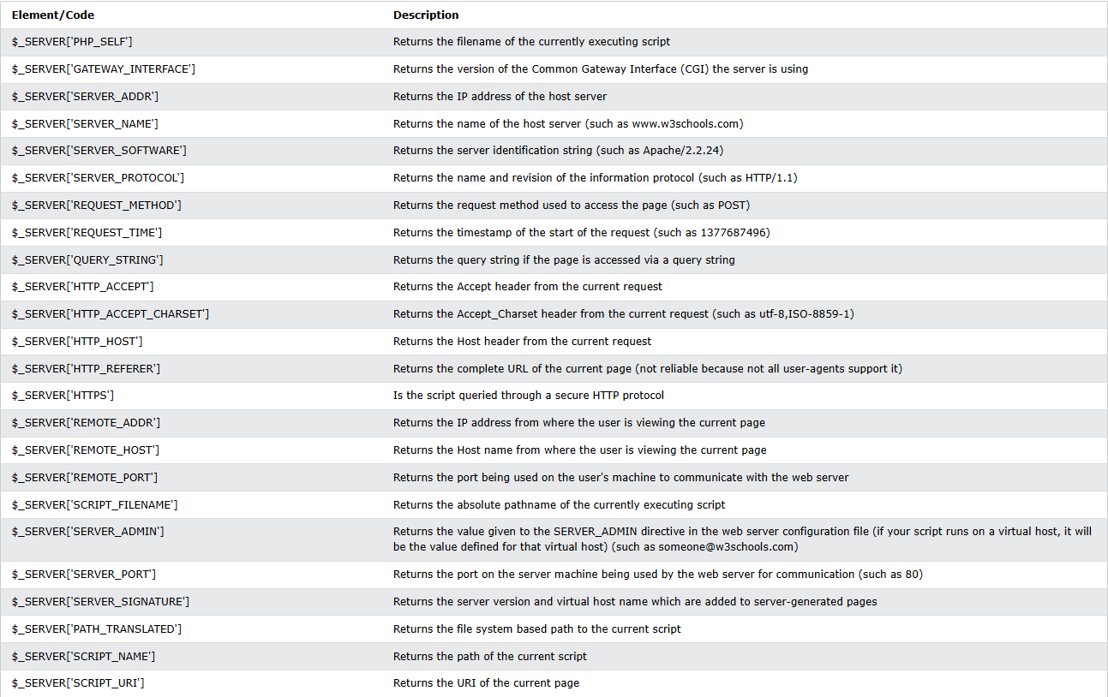

echo "PHP_SELF: " . $_SERVER['PHP_SELF'] . "<br>";
echo "SCRIPT_NAME: " . $_SERVER['SCRIPT_NAME'] . "<br>";
echo "SCRIPT_FILENAME: " . $_SERVER['SCRIPT_FILENAME'] . "<br>";
echo "DOCUMENT_ROOT: " . $_SERVER['DOCUMENT_ROOT'] . "<br>";
echo "HTTP_HOST: " . $_SERVER['HTTP_HOST'] . "<br>";
echo "HTTP_USER_AGENT: " . $_SERVER['HTTP_USER_AGENT'] . "<br>";
echo "REMOTE_ADDR: " . $_SERVER['REMOTE_ADDR'] . "<br>";
echo "REMOTE_PORT: " . $_SERVER['REMOTE_PORT'] . "<br>";
echo "REQUEST_METHOD: " . $_SERVER['REQUEST_METHOD'] . "<br>";
echo "REQUEST_URI: " . $_SERVER['REQUEST_URI'] . "<br>";

// PHP_SELF: /index.php
// SCRIPT_NAME: /index.php
// SCRIPT_FILENAME: E:\COURSES\PHP\Testing\test2\index.php
// DOCUMENT_ROOT: E:\COURSES\PHP\Testing\test2
// HTTP_HOST: localhost:3000
// HTTP_USER_AGENT: Mozilla/5.0 (Windows NT 10.0; Win64; x64) AppleWebKit/537.36 (KHTML, like Gecko) Chrome/130.0.0.0 Safari/537.36
// REMOTE_ADDR: ::1
// REMOTE_PORT: 56663
// REQUEST_METHOD: GET
// REQUEST_URI: /index.php

PHP - $_REQUEST

$_REQUEST
$_REQUEST is a php super global variable which contains submitted from data, and all cookie data.
In other words, $_REQUEST is an array containing data from $_GET , $_POST, and $_COOKIE .
You can access this data with the $_REQUEST keyword followed by the name of the form field, or cookie, like :

Action attribute :
The action attribute specifies the URL of the form processor, which is the scrpt that handle the form data when the form is submitted .
- If the action attribute is empty ( action =” “ ), the form will submit to the same URL that the form is currently on. This known as a “self-posting” form.
- If the action attribute is set to a URL ( action=”process.php”), the form will submit to that specific URL .

Method Attribute:
The method attribute specifies the HTTP request method that will be used to send the form data to the server .
- Method =”get”: the form data will be sent to the server using HTTP GET request method. The data will be appended to the URL as a query string (e.g., example.com?name=John&age=30).
- Method = “post”: the form data will be send to the sever using the HTTP POST request method. The data will be send in the request body, and will not ve visible in the URL.

Here are some key differences between GET and POST :
- Visibility : GET requests are visible in the URL, while POST requests are not.
- Data size: GET requests have a limited data size (typically around 2048 characters), While POST requests can handle much larger amounts of data.
- Security: POST requests are generally considered more secure than GET requests, since the data is not visible in the URL;
In general, use :
- Method=”get” for simple forms that retrive data, such as search forms
- Method=”post” for forms that send data to the server, such as login forms, registration forms, or forms that update data.
Example:
if ($_SERVER['REQUEST_METHOD'] === 'POST') {
$username = $_POST['username'];
$password = $_POST['password'];

// Perform your authentication logic here
// For example, you can check if the username and password match a database record

if ($username === 'admin' && $password === 'password') {
// Start a session
session_start();

// Store the username in the session
$_SESSION['username'] = $username;

// Redirect to a different page if the authentication is successful
header('Location: test.php');
exit;
} else {
// Redirect back to the login page with an error message
header('Location: error.php');
exit;
}
}
?>

<!-- Self-posting form with POST method -->
<form action="" method="post">
<input type="text" name="username" placeholder="Username">
<input type="password" name="password" placeholder="Password">
<input type="submit">
</form>

Understand the concept JS and PHP :
PHP is a server-side language, which means that it runs on the server and waits for requests from the client (usually a web browser). When a user submits a form or makes a request to a php page, the php code is executed on the server, and the resulting ouput is send back to the client.
In contrast, javascript is a client-side language, which means it runs on the client’s web browser. Js code is executed immediately whe the page is loaded, and it can respond to user interactions (such as click, keyboard input, etc) in rea-time.
HERE ARE some KEY DIFFERENCES between PHP and js :
PHP:
- Runs on the server
- Waits for requests from the client
- Executes code on the server
- Sends output back to the client
- Can access server-side resources (e.g, databases, file , systems)
- Can perfor server-side tasks (e.g, authentification, validation)
Js :
- Runs on the client (web browser)
- Executes code immeditely when the page is lodaded
- Responds to user interactions (e.g, clicks, keybord inputs)
- Can access client-side task (e.g, form validation, animations)

PHP - $_POST
$_POST contains an array of varaibles received via the HTTP POST method.
There are two main ways to send varialbes via the HTTP POST method:
- HTML forms
- Javascript HTTP requests

$_POST in HTML Forms
A HTML form submits information via the HTTP POST method if the form’s method attribute is set to “POST” :
<?php

echo "<pre>";
print_r($_POST);
echo "</pre>";

// Array
// (
// [name] => Bilal Elemrani
// [email] => elemranibilal2006@gmail.com
// )

?>

<!-- form.html -->
<form action="" method="post">
<label for="name">Name:</label>
<input type="text" id="name" name="name"><br><br>
<label for="email">Email:</label>
<input type="email" id="email" name="email"><br><br>
<input type="submit" value="Submit">
</form>
When a user clicks the submt button, the form data is sent to a PHP file specifed in the action attribute of the <form> tag.
In the action nfile we can use the $_POST variable to collect the value of the input field.

Javascript HTTP requests

Js :
function submitForm() {
// Get form data
const form = document.getElementById("myForm");
const formData = new FormData(form);

// Send HTTP request using Fetch API
fetch("app.php", {
// Replace with your PHP file's path
method: "POST",
body: formData,
})
.then((response) => response.text()) // Parse the response as text
.then((data) => {
console.log(data); // Display the response from the server
form.reset(); // Clear form fields after successful submission
})
.catch((error) => {
console.error("Error:", error);
});
}

HTML
<!DOCTYPE html>
<html lang="en">
<head>
<meta charset="UTF-8" />
<meta name="viewport" content="width=device-width, initial-scale=1.0" />
<title>testing</title>
</head>
<body>
<form id="myForm" action="" method="post">
<label for="name">Name:</label>
<input type="text" id="name" name="name" /><br /><br />
<label for="email">Email:</label>
<input type="email" id="email" name="email" /><br /><br />
<input type="button" value="Submit" onclick="submitForm()" />
</form>

<script src="app.js"></script>
</body>
</html>

Php
<?php
// Check if POST data is received
if ($_SERVER["REQUEST_METHOD"] == "POST") {
// Retrieve data from $_POST
$name = isset($_POST['name']) ? $_POST['name'] : '';
$email = isset($_POST['email']) ? $_POST['email'] : '';

// Display received data (for debugging purposes)
echo "<pre>";
echo "Name: " . htmlspecialchars($name) . "\n";
echo "Email: " . htmlspecialchars($email) . "\n";
echo "</pre>";

// Optionally, you could save this data to a database, send an email, etc.

// Send a success response
echo "Form submitted successfully!";
} else {
// Handle cases where the request method is not POST
echo "Invalid request method.";
}
?>

Let explain Js
Step 1: HTML Form
The HTML form collects user input for the name and email fields.
• Purpose: The form is simply a structure to get user input.
• Fields: name and email.
• Button: The submit button (<input type="button" value="Submit">) has an onclick attribute that triggers the JavaScript function submitForm() when clicked.
Step 2: JavaScript Function to Handle Form Submission
JavaScript will handle sending the form data to the server without reloading the page, thanks to the submitForm() function. Let’s look at it line by line.
function submitForm() {
// Step 1: Get form data
const form = document.getElementById('myForm');
const formData = new FormData(form);
- Explanation:
  - document.getElementById('myForm'): This finds the form by its ID (myForm) so JavaScript can access it.
  - new FormData(form): FormData is a JavaScript object that collects all the data from the form automatically.
Next, we send this formData to the server with the fetch function:
// Step 2: Send HTTP request using Fetch API
fetch("http://127.0.0.1:5500/app.php", { // Adjust the URL to match your PHP file's location
method: "POST",
body: formData
})
- Explanation:
  - fetch: This is a built-in JavaScript function to make network requests.
  - "http://127.0.0.1:5500/app.php": This is the URL where our PHP script lives. fetch will send data to this PHP file.
  - method: "POST": This tells fetch to send the data as a POST request.
  - body: formData: The form data collected earlier is attached to the request.
Step 3: Handle the Server’s Response
After sending the data, we can check the server’s response.
.then(response => response.text()) // Parse the response as text
.then(data => {
console.log(data); // Display the response from the server
})
.catch(error => {
console.error("Error:", error);
});
}
- Explanation:
  - .then(response => response.text()): This converts the server response to plain text (e.g., "Form submitted successfully!").
  - .then(data => { console.log(data); }): This logs the server’s response in the browser console. You could also display this message to the user.
  - .catch(error => { console.error("Error:", error); }): If there’s an error (like the server is down), it logs the error.
Step 4: PHP Script (Server Side)
The PHP script receives the data sent from JavaScript, processes it, and then responds.
<?php
if ($_SERVER["REQUEST_METHOD"] == "POST") {
$name = $_POST['name'] ?? '';
$email = $_POST['email'] ?? '';

echo "Name: " . htmlspecialchars($name) . "<br>";
echo "Email: " . htmlspecialchars($email);
} else {
echo "Invalid request method.";
}
?>
Explanation:
- $_SERVER["REQUEST_METHOD"] == "POST": This checks if the request method is POST, ensuring it’s the right kind of request.
- $name and $email: PHP retrieves data using $_POST, which gets values from the form.
- echo: PHP responds back with this message. This is what JavaScript will receive in the data variable from earlier.

Let explain php

PHP Code Explanation
- Check the Request Type:
php
Copy code
if ($_SERVER["REQUEST_METHOD"] == "POST")
  - This line checks if the form was submitted with a POST request. If not, it skips to the error message at the end (Invalid request method).
- Retrieve Form Data:
php
Copy code
$name = $_POST['name'] ?? '';
$email = $_POST['email'] ?? '';
  - $_POST is an array that holds all form data sent to the PHP file.
  - $name and $email store the form data, or default to an empty string if fields are missing.
- Display the Data:
php
Copy code
echo "<pre>";
echo "Name: " . htmlspecialchars($name) . "<br>";
echo "Email: " . htmlspecialchars($email) . "<br>";
echo "</pre>";
  - echo "<pre>"; and echo "</pre>"; help keep the text formatting clean.
  - htmlspecialchars() protects against HTML injection by converting any special characters in user input to HTML-safe characters.
  - This part is optional but can help with debugging by showing what data was received.
- Send a Success Message:
php
Copy code
echo "Form submitted successfully!";
  - This message is sent back to JavaScript, where it can be displayed to the user.
- Handle Non-POST Requests:
php
Copy code
echo "Invalid request method.";
  - This message is displayed if the request isn’t a POST request (e.g., if someone visits app.php directly).
This PHP script receives data from JavaScript, processes it, and sends back a response that JavaScript can use to confirm the form submission worked!

HTML INJECTION

What is HTML Injection?
HTML injection is a type of security vulnerability where an attacker injects malicious HTML code into a web application. If the application does not properly validate and sanitize user input, this injected code could be displayed on the page, altering its appearance, structure, or functionality. In some cases, HTML injection can lead to Cross-Site Scripting (XSS), where the attacker injects JavaScript that executes in other users' browsers, potentially stealing information or changing page behavior.
Example of How HTML Injection Works
- User Input: An attacker enters HTML or JavaScript code into a form field that accepts text, such as:
<h1>Injected Heading</h1>
or
<script>alert("Injected JavaScript");</script>
- Vulnerable Application: If the application displays this input on a webpage without filtering out HTML tags, the browser will interpret this input as HTML or JavaScript, allowing it to be executed. This could lead to unauthorized changes to the page’s structure, style, or behavior.
- Impact: HTML injection can manipulate the appearance of a page or introduce harmful scripts, potentially compromising user data or site functionality.
How to Perform HTML Injection (in a Controlled Environment)
To test for HTML injection vulnerabilities safely:
- Prepare a Test Form:
  - Create a simple HTML form with text inputs.
  - Ensure the form submits to a PHP script that displays user input without escaping it.
- Input Injection Code:
  - Enter HTML or JavaScript code directly into form fields.
  - For example, in a "Name" field, enter:

DataBase & Connecting

With PHP, you can connect to and maniplulate databases.
MySQL is the most popular database system used with PHP.

What is MySQL ?
- MySQL is a database system used on the web.
- MySQL is a database system that runs on a server.
- MySQL is ideal for both small and large applications
- MySQL is very fast, reliable, and easy to use
- MySQL uses standard SQL
- MySQL compiles on a number of platforms
- MySQL compiles on a number of platforms
- MySQL is free to download and use.
- MySQL is developed, distributed, and supported by Oracle Corporation.
- MySQL is named after co-founder Monty Widenius’s daughter: My
The data in a MySQL database are stored in tables. A table is a collection or related data, and it consists of columns and rows.
Databases are useful for storing information categorically. A comapany may have with the following tables:
- Employees
- Products
- Customers
- Orders

PHP + MySQL Database System
- PHP combined with MySQL are cross-platform ( you can develop in Windows and serve on a Unix platform )
Meaning :
PHP and MySQL work well together to create dynamic, database-driven websites, and they are both cross-platform. This means you can develop a PHP application with a MySQL database on a Windows machine and deploy it to a Unix-based server (like Linux) without major changes. Their compatibility and flexibility make them popular choices for web development, offering an efficient way to build applications that can run smoothly across different operating systems.

Database Queries
A query is a question or a request .
We can query a database for spcecific information and have a recordset returned .
Look at the following query ( using standard SQL ) :
SELECT LastName FROM Employees
Before starting , NOTE :
- SQL (Structured Query Language): This is a language used to interact with databases. It includes commands to create, read, update, and delete data (often called CRUD operations). SQL is the standard language for relational database management.
- MySQL: This is a database management system (DBMS) that uses SQL as its language for querying and managing data. It’s software that lets you store, manage, and retrieve data in a structured way.
In other words, SQL is the language, while MySQL is a specific system that implements this language to manage a database. Other database systems like PostgreSQL, Oracle, and Microsoft SQL Server also use SQL as their query language.

We’ve zommed in one PHP extension spcecifically, which is the piece of software that PHP uses to connect to a MySQL database. This conversation has learned into the tools within PHP ( the MySQL and MysQLi extensions) rather than the MySQL database itself.
To recap simply:
- MySQL: this is the database system where your data is stored .
- PHP Extension (MySQL , MySQLi, PDO) : These are tools built into PHP that let you connect to and interact with MySQL database.
So, while MySQL is where your data lives, PHP extensions like MySQLi or PDO are what PHP uses to talk to that database.

MySQLi (MySQL Impoved) is an updated PHP extension introduced to provide more functionality, and security when interacting with MySQL databases compard to the older MySQL extension. Here’s how they differ :
  - Enhaced Features:
- MySQLi supports prepared statements, which are more secure and prevent SQL injection by separating query structure from data.
- It also supports transactions (allowing you to commit or rollback changes) and stored procedures (predefined SQL statements saved in the database for reuse ).
- MySQL (normal) extension lacks these advanced features, making it less secure and less flexible for complex database operations.

- Programming Styles :
- MySQLi offers both procedural and object-oriented programming styles, so developers have more coding flexibility.
- The old MySQL extension only provides a procedural style, limiting coding options.

- Performance :
- MySQLi is optimized for newer version of MySQL and offers better performance for complex queries and transactions.
- The MySQL extension doesn’t fully support modern MySQL features, and it was deprecated in PHP 5.5 and removed in PHP 7 .

In short, MySQLi is a more modern, secure, and feature-rich option for interacting with MySQL databases in PHP, while the old MySQL extension is outdated and no longer supported.

PHP Connect to MySQL
PHP 5 and later can work with MySQL database using :
- MySQLi extension ( the “i” stands for improved)
- PDO (PHP Data objects )
Earlier versions of PHP used the MySQL extension. However, this extension was deprecated in 2012.

Should I Use MySQLi or PDO ?
If you need a short answer, it would be “whatever you like”
PDO will work on 12 differenet database systems, PDO makes the process easy. You only have to change
So, if you have to switch your project to use another database, PDO makes the process easy. You only have to change the connection string and a few queries. With MySQLi, you will need to rewrite the entire code – quries included.
Both are object-oriented, but MySQLi also offers a procedural API .
Both support Prepared Statements. Prepared Statements protect from SQL injection, and are very important for web application security.
MySQL Examples in Both MySQLi and PDO Syntax
In this, and in the following chapters we demonstrate 3 ways of woring with PHP and MySQL :
- MySQLi (object-oriented )
- MySQLi (procedural)
- PDO

MySQLi Installation
For Linux and windows: the MySQli extenision is automatically
Installed in most cases, when php5 mysql package is installed.
For installation details, go to :
http://php.net/manual/en/mysqli.installation.php
PDO Installation
For installation details, go to :
http://php.net/manual/en/pdo.installation.php

Open a Connection to MySQL
Before we can access data in the MySQL database, we need to be able to connect to the server :

Example (MySQLi Object-Oriented)
<?php
// Example (MySQLi Object-Oriented)

// Database credentials
$servername = "localhost";
$username = "root"; // Default MySQL user
$password = ""; // Leave empty as default in XAMPP
0$dbname = "students"; // Your database name

// Create connection
$conn = new mysqli($servername, $username, $password, $dbname);

// Check connection
if ($conn->connect_error) {
die("Connection failed: " . $conn->connect_error);
}
echo "Connected successfully";
?>

Note on the object-oriented example above :
$connect_error was broken until PHP 5.2.9 and 5.3.0. if you need to ensure compatibility with PHP versions prior to 5.2.9 and 5.3.0, use the follwing code instead
// Check connection
if (mysqli_connect_error()) {
die("Database connection failed: " . mysqli_connect_error());
}

Example (MySQLi Procedural)
<?php
// Example (MySQLi Procedural)

$servername = "localhost";
$username = "root";
$password = "";

// Create connection
$conn = mysqli_connect($servername, $username, $password);

// Check connection
if (!$conn) {
die("Connection failed: " . mysqli_connect_error());
}
echo "Connected successfully";

?>

Key difference : MySQLi Procedural & MySQLi Object-Oriented
The key difference between MySQLi Procedural and MySQLi Object-Oriented is how you write the code to interact with the MySQL database.
Here’s a quick breakdown :
  - MySQLi procedural:
- Uses functions to interact with the database.
- Each action (like connecting, querying, etc ) is done with individual functions.
- Code structrue is simpler and more similar to older PHP code.
Example :
$conn = mysqli_connect("localhost", "username", "password", "database");
$result = mysqli_query($conn, "SELECT * FROM users");

- MySQLi object-oriented :
- Uses objects and methods (object-oreinted programming)
- Involves creatng a MySQLi object that hadles all database actions.
- Code can be more organized and reusable in larger applications.
Exemple:
$conn = new mysqli("localhost", "username", "password", "database");
$result = $conn->query("SELECT * FROM users");
Summary :
- Procedural: Uses mysqli_connect () and mysqli_query ( )
- Object-oriented : Uses $conn = new my sqli( ) and $conn -> query ( ) .
The functionality is the same. Only the style of coding changes.

Example (PDO )

<?php

// Example (PDO)

$servername = "localhost";
$username = "root";
$password = "";

try {
$conn = new PDO("mysql:host=$servername;dbname=students", $username, $password);
// set the PDO error mode to exception
$conn->setAttribute(PDO::ATTR_ERRMODE, PDO::ERRMODE_EXCEPTION);
echo "Connected successfully";
} catch(PDOException $e) {
echo "Connection failed: " . $e->getMessage();
}

?>

Note : in the PDO example above we have also specified a database (myDB) PDO require a valid database to connect to . if no database is specified, and exception is thrown.
Tip : A great benefit of PDO is that is has an exception class to handle any problems that may occur in our database queries. If an exception is thrown within the try { } block, the script stops executing and flows dirctly to the first catch () { } block.

Close the Connection
The connection will be closed automatically when the script ends. To close the connection before, use the following:
MySQLi Object-oriented :
$conn->close();

MySQLi Procedural :
Mysqli_close ( $conn)

PDO
$conn = null;

PHP Create a MySQL Database
A database consits of one or more tables.
You will need special CREATE privileges امتيازات to create or to delete a MySQL database.

Create a MySQL Database Using MySQLi and PDO .
The CREATE DATABASE statement is used to create a database in MySQL .
The following examples create a database named “myDB”:

Example (MySQLi Object-oriented )
<?php

// Create a MySQL DATABASE
// Example (MySQLi Object-Oriented):

$servername = "localhost";
$username = "root";
$password = "";

// Create connection
$conn = new mysqli($servername, $username, $password);

// Check connection
if ($conn->connect_error) {
die("Connection failed: " . $conn->connect_error);
}

// Create database
$sql = "CREATE DATABASE myDB";
if ($conn->query($sql) === TRUE) {
echo "Database created successfully";
} else {
echo "Error creating database: " . $conn->error;
}

$conn->close();

?>

Note : when you create a new database, you must only specify the first 3 arguments to mysqli object (servername, username and password ) .
Tip: if you have to use a specific port, add an empty string for the database-name argument, like this: new mysqli (“localhost” , “username”, “password”, “”, port)

Example (MySQLi Procedural)
<?php

// Create database
// Example (MySQLi procedural)

$servername = "localhost";
$username = "root";
$password = "";

// Create connection
$conn = mysqli_connect($servername, $username, $password);
// Check connection
if (!$conn) {
die("Connection failed: " . mysqli_connect_error());
}

// Create database
$sql = "CREATE DATABASE myDB2";
if (mysqli_query($conn, $sql)) {
echo "Database created successfully";
} else {
echo "Error creating database: " . mysqli_error($conn);
}

mysqli_close($conn);
?>

Example (PDO )
Note : the follwing PDO example create a database named “myDBPDO”
<?php

// create database
// Example (PDO):

$servername = "localhost";
$username = "root";
$password = "";

try {
$conn = new PDO("mysql:host=$servername", $username, $password);
// set the PDO error mode to exception
$conn->setAttribute(PDO::ATTR_ERRMODE, PDO::ERRMODE_EXCEPTION);
$sql = "CREATE DATABASE myDBPDO";
// use exec() because no results are returned
$conn->exec($sql);
echo "Database created successfully<br>";
} catch(PDOException $e) {
echo $sql . "<br>" . $e->getMessage();
}

$conn = null;
?>
Tip: A great benefit of PDO is that it has exception class to handle any problems that may occur in our database queries. If an exception is thrown within the try{ } block, the script stops executing and flows directly to the first catch(){ } block. In the catch block above we echo the SQL statement and the generated error message.

PHP MySQL Create Table
A database table its own unique name and consists of columns and rows.

Create a MySQL Table Using MySQLi and PDO
The CREATE TABLE statement is used to create a table in MySQL .
We will create a table named “MyGuests”, with the five columns “id”, “firstname” , “lastname”, “email” and “reg_date” :

CREATE TABLE MyGuests (
id INT(6) UNSIGNED AUTO_INCREMENT PRIMARY KEY,
firstname VARCHAR(30) NOT NULL,
lastname VARCHAR(30) NOT NULL,
email VARCHAR(50),
reg_date TIMESTAMP DEFAULT CURRENT_TIMESTAMP ON UPDATE CURRENT_TIMESTAMP
)

Notes on the table above :
The data type specifies what type of data the column can hold. For a complete reference of all the available data types, go to our Data Types Reference .
After the data Type, you can specify other optional attributes for each column :
After the data type, you can specify other optional attributes for each column:
- NOT NULL – Each row must contain a value for that column, null values are not allowed.
- DEFAULT value – Set a default value that is added when no other value is passed .
- UNSIGNED – Used for number types, limits the stored to positive numbers and zero.
- AUTO INCREMENT – MySQL automatically increases the value of the filed by 1 each time a new record is added .
- PRIMARY KEY – used to uniquely identify the rows in a table. The column with PRIMARY KEY setting is often an ID number, and is often used AUTO_INCREMENT
Each table should have a primary key column (in this cas: the “id” column) . its value must be unique for each record in the table.
The following examples shows how to create the table in PHP :

Example (MySQLi Object-oriented )

